Micro bible 2.0

Game theory
Underlying axioms:

Rational choice assumption: A player fully understands the decision problem by knowing:
All possible actions, A
All posible outcomes, X
Exactly how each action affects which outcome will materialize
His rational preferences over payoffs

Definitions:
Rationality:
A person maximizes his utility

Def 2,1: A simple lottery over outcomes $X=\{x_{1},…,x_{k}\}$ is simply the probability distribution $p$
Which has $p\left(x_{i}\right)≥0,\sum_{i=1}^{k}{p(x_{i}})=1$

Def 2,2: A simple lottery over $X=[x_{1},x_{2}]$ is simply a probability distribution given by the CDF $F:X→[0,1]$ with $F\left(\hat{x}\right)=P(x≤\hat{x})$

Note: any weird combination of these lotteries is also a lottery

Def 2.3: Expected payoff: given utility function $u(x)$ and discrete lottery p
$$E\left[u\left(x\right) | p\right\}=\sum_{i=1}^{n}{p\left(x_{i}\right)·u(x_{i})}$$
Def 2.4: expected payoff: given utility function $u(x)$ and contionus lottery p with density $f:\left[x_{1},x_{2}\right]→R$
$$E\left[u\left(x\right) | p\right\}=\int_{x_{1}}^{x_{2}}{u\left(x\right)f\left(x\right)dx}$$
2.5 rationality under uncertainty: an agent is rational if and only if he chooses an action which maximises his expected utility
He chooses
$$a^{⋆}∈argmax E\left[u\left(x\right) | p,a\right\}$$

Static games of complete information (tabelis ch 3,4,5,6)
Notation:
$N=\{1,…,n\}$set of agent players
$S_{i}$ set of pure strategies available to player i
$s_{i}∈S_{i}$ strategies of player i
$S=S_{1}×…×S_{n}$ strategy space, the set of all possible combinations of strategies
$s∈S$ pure strategy profile
$s_{-i}$ profile of “other peoples moves”
$u_{i}:S→R$ player I’s utility function
$u:S→R^{n}$ $u(s)=(u_{1}\left(s\right),…,u_{n}\left(s\right))$
$Δ\left(S_{i}\right):$ all probability distributions over pure strategies (ie mixed strategies)
$σ_{i}∈Δ(S_{i})$ a mixed strategy
$σ:$ mixed strategy profile
$σ_{-i}$: all others mixed strategy profiles
$Σ=ΔS_{1}×…×ΔS_{n}$ the set of all possible mixed strategies profiles

Assumptions of Games of complete information:

the following are common knowledge:
All possible actions of all players
All possible outcomes
How each combination in the action set translates into outcomes
The preferences of each player over the outcomes

Def 3.1 common knowledge: An event E is common knowledge if (1) everyone knows,(2) everyone knows that everyone knows, and so on and so on forever

Def 3.2 pure strategy: a deterministic action taken by the player i $s_{i}∈S_{i}$

Def 3.3 a normal form game: includes 3 elements:
Set of players $N=\left\{1,…,n\right\}$
The collection of pure strategy sets $\left\{S_{1},…,S_{n}\right\}$
The utility functions $\left\{u_{1},…,u_{n}\right\}$ with $u_{i}:S→R ∀i∈N$
In this game each player moves simutaniously as everyone has equal information
We can write it as
$$Γ=〈N,{\left\{S_{i}\right\}}_{i=1}^{n},{\left\{u_{i}\right\}}_{i=1}^{n}〉$$

3.4 a finite game is a game with finite number of players and finite number of strategies for every player
This implies a limited number of pure strategy profiles

For 2 player games this means we can write it in matrix form

A\B | L | R
U | (2,1) | (3,2)
D | (2,2) | (0,0)

Assumptions for solutions of normal form games:
- Players are rational(utility maximizers)
- Players are “intellegent”(know everything about the game)
- Common knowledge of these 2 fact and common knowledge of this common knowledge
- Any EQ/solution must be self enforcing

Def 3.5 pareto domination:
$s∈S$ pareto dominates $s^{'}∈S⇔$ $u_{i}\left(s^{'}\right)≤u_{i}\left(s\right)∀i∈N$ and $∃j∈N:u_{j}\left(s^{'}\right)<u_{j}(s)$
A strategy is pareto optimal if

Def 4.1 strictly dominated strategy a strategy $s_{i}∈S_{i}$ strictly dominates $s_{i}^{'}∈S_{i}$
$$⇔u\left(s_{i},s_{-i}\right)>u\left(s_{i}^{'},s_{-i}\right) ∀s_{-i}∈S_{-i}$$
We write that
$$s_{i}≻s_{i}'$$
Def 4.1.1 weakly dominant: $s_{i}∈S_{i}$ weakly dominates $s_{i}^{'}∈S_{i}$
$⇔$ $u\left(s_{i},s_{-i}\right)≥u\left(s_{i}^{'},s_{-i}\right) ∀s_{-i}∈S_{-i},∃s_{-i}∈S_{-i}:u\left(s_{i},s_{-i}\right)>u\left(s_{i},s_{-i}^{'}\right)$
We can write that
$$s_{i}≽s_{i}'$$

Claim 4.1 a rational player will never play a strictly dominated strategy

Def 4.2 strictly dominant strategy: $s_{i}∈S_{i}$ is a strictly dominant strategy
$$⇔u\left(s_{i},s_{-i}\right)>u\left(s_{i}^{'},s_{-i}\right) ∀s_{i}^{'}∈S_{i}:s_{i}≠s_{i}^{'} ,∀s_{-i}∈S_{-i}$$

Def 4.3 strictly dominant strategy EQ:
$s^{D}∈S$ is a strictly dominant strategy EQ
$$⇔s_{i}^{D}∈S_{i} is a strictly dominant strategy ∀i∈N$$
Prop 4.1 a strictly dominant strategy eq is a unique dominant strategy EQ
This is simple as any other EQ is never rational

IESDS:
Step 1: $S_{i}^{0}=S_{i}$ $∀i∈N$, set $k=0$
Step 2: are there any strictly dominated strategies for any player? If yes go to step 3 if not go to step 4
Step 3: for every player, remove all strictly dominated in $s_{i}∈S_{i}^{k}$and go back to step 2
Step 4: the remaining strategies are reasonable predictions of behavior

In practice cross out actions in the matrix

Def 4.4 iterated elimination EQ :
we call any strategy $s^{ES}=(s_{1}^{ES},…,s_{n}^{ES})$ that survives IESDS an iterated elimination EQ
in slides notation $s^{ES}$ is rationalizable

prop 4.2 $s^{⋆}is a strict dominant strategy EQ⇒s^{⋆} uniquely survives IESDS$
def 2.7 NASH EQ
$s^{⋆}$ is a nash EQ $⇔∀i∈N:∀s_{i}∈S_{i}:u_{i}\left(s_{i}^{⋆},s_{-i}^{⋆}\right)≥u_{i}\left(s_{i},s_{-i}^{⋆}\right)$
i.e $s_{i}$ is a best respond given belief of other players actions $s_{-i}^{⋆}$
(in words: there is no incentive to deviate given beliefs)

Def 2.7.1 Strict nash EQ
$s^{⋆}$ is a strict nash EQ $⇔∀i∈N:∀s_{i}∈S_{i}:u_{i}\left(s_{i}^{⋆},s_{-i}^{⋆}\right)>u_{i}\left(s_{i},s_{-i}^{⋆}\right)$

Obviously:
$$s^{⋆} is strict NE⇒s^{⋆} is NE$$

Prop 2.8:
$$σ^{⋆} is NE⇒all s_{i} used in σ^{⋆} are rationalizable(survives IESDS)$$

Prop 2.9:
$$s^{⋆} is unique surviver of IESDS⇒s^{⋆} is a strict NE$$

Def V-N-M utility:

Def 4.7 Best-Responses
$BR_{i}\left(s_{-i}\right)⊂S_{i}$ is the set of player I’s best acrions given a belief of opponents action $s_{-i}$

Def 4.8 $s_{i}∈S_{i}$ is never a best respons if there are no beliefs $s_{-i}∈S_{-i}:s_{i}∈BR_{i}(s_{-i})$
Or
$$s_{i}∈S_{i} is never a best respons⇔∀s_{-i}∈S_{-i}∃s_{i}^{'}∈S_{i}:u_{i}\left(s_{i}^{'},s_{-i}\right)>u_{i}(s_{i},s_{-i})$$

This is basically the same as normal form games and IESDS just in more general terms

Prop 5.1
$$s^{⋆}is unique survivor of IESDS or s^{⋆} is a strict dominant strategy EQ$$
$$or the unique rationalizable strtegy profile⇒s^{⋆}is the unique NE$$
Prop 5.2
In a cournot game there is only one NE: $p_{1}=p_{2}=…=p_{n}=c=MC$

Def 6.1mixed strategy:
Let $S_{i}$ be pleyer I’s finite set of pure strategies $ΔS_{i}$ is the simplex of $S_{i}$
Which is the set of all possible probability distributions over $S_{i}$
$$σ_{i}∈ΔS_{i}$$
$$σ_{i}=\left\{σ_{i}\left(s_{i,1}\right),…,σ_{i}\left(s_{i,m}\right)\right\}$$
$$σ_{i}\left(s_{i}\right)≥0∀s_{i}∈S_{i}$$
$$\sum_{s_{i}∈S_{i}}{σ_{i}(s_{i})}=1$$
Def 6.2 the support:
Given strategy $σ_{i}, s_{i}∈S_{i}$
$$s_{i}∈supp\left(σ_{i}\right)⇔σ_{i}\left(s_{i}\right)>0$$

Def 6.3 mixed strategy on interval:
Let $S_{i}=[x_{1},x_{2}]$ a mixed strategy is then defined på the CDF $F\left(x\right)=P(s_{i}≤x)$
If $F$ is differentiable then $s_{i}∈supp\left(F_{i}\right)⇔f_{i}\left(s_{i}\right)>0$

Def 6.4 belief:
A orbability distribution player I assigns the other players
$$π_{i}∈ΔS_{-i}$$

Def 6.5 expected payoff:
Since the 2 distributions are independent
$$E\left[u_{i}\left(σ_{i},σ_{-i}\right)\right]=\sum_{s_{i}∈S_{i}}{}\sum_{s_{-i}∈S_{-i}}{σ_{i}\left(s_{i}\right)σ_{-i}\left(s_{-i}\right)u_{i}(s_{i},s_{-i})}$$

Def 6.6 mixed strategy Nash Equilibrium:
$$σ^{⋆} is a NE⇔∀i∈N:u\left(σ_{i}^{⋆},σ_{-i}^{⋆}\right)≥u\left(σ_{i},σ_{-i}^{⋆}\right)∀σ_{i}∈ΔS_{i}$$

Prop 6.1
let $σ^{⋆}$ be NE then
$$s_{i}∈supp\left(σ_{i}^{⋆}\right)⇒u\left(s_{i},σ_{-i}^{⋆}\right)=u(σ_{i}^{⋆},σ_{-i}^{⋆})$$

Def 6.7 strict domination:
$$σ_{i}∈ΔS_{i}, s_{i}^{'}∈S_{i}$$
$$σ_{i} strictly dominates s_{i}^{'}⇔u\left(σ_{i},s_{-i}\right)>u\left(s_{i}^{'},s_{-i}\right)∀s_{-i}∈S_{-i}$$

Def 6.8 never best respons:
$$σ_{i}∈ΔS_{i} is never a best response⇔∀σ_{-i}∈ΔS_{-i}∃σ_{i}^{'}∈ΔS_{i}:u\left(σ_{i}^{'},σ_{-i}\right)>u(σ_{i},σ_{-i})$$

Prop 6.2 for a 2 player game:
$$σ_{i} is strictly dominated⇔σ_{i} is never a best response$$

Nash Existence theorem: any n player normal form game with finite strategy set $S_{i}$ for all players has a NE in mixed strategies (pure strategies is a subset of mixed strategies)

Brouwers fixed point theorem
$$f:\left[0,1\right]→\left[0,1\right] continous⇒∃x^{'}∈\left[0,1\right]:f\left(x^{'}\right)=x'$$

Def 6.9 BR mapping
$BR=BR_{1}×…×BR_{n}$ maps $BR:ΔS→ΔS$
Takes every $σ$ and converts it to $BR\left(σ\right)⊆ΔS$

Fact:
$$σ^{⋆} is NE⇔σ^{⋆}∈BR(σ^{⋆})$$

Theorem 6.1 a correspondance $C:X→X$ has a fixed point if 2 thing are satisfied:
- X is convex, compact and non-empty
- C(x) is non empty $∀x∈X$ and Convex and Closed

EQ refinements:
Players avoid EQ which are pareto inefficeient

Players avoid involving weakly dominated strategies

Players prefer strategies which are still “good” when others make mistakes in play

Trembeling hand principle:
If $σ_{i}$ is still optimal given $σ_{-i}^{⋆} optimal with$
$$\left\|σ_{-i}-σ_{-i}^{⋆}\right\|≥ϵ for ϵ>0$$

typeopgaver:
the indifference principle:
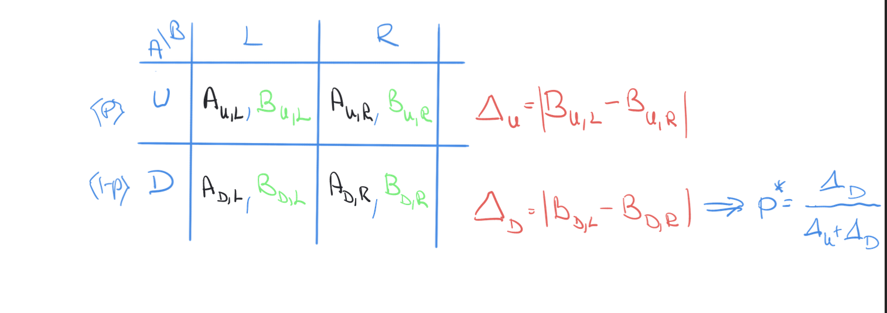
And same for the other axis

Best response diagrams

Dynamic games of complete information (tadelis 7,8)
Extensive form game reuquirements:
Set of players N
Players payoff functions ${\left\{u_{i}\left(·\right)\right\}}_{i=1}^{n}$
Order of moves
Actions of players when they can move
Knowledge of each player when they can move
Probability distributions over moves by nature
The structure of the game is common knowledge (everything is common knowledge)

Def 7.1 a game tree: the structure of the game drawn
Example
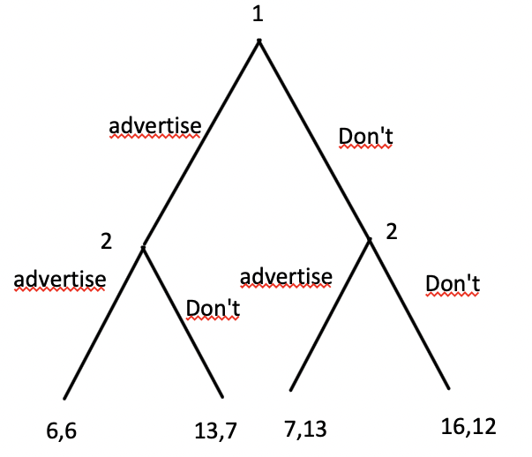

Def 7.2 informationsets:
Every player has a collection of informationsets $h_{i}∈H_{i}$ that partitions the nodes of the games where he moves these have properties:
If $h_{i}$ is a singlton $h_{i}=\{x\}$ then player I knows that he is in node x

If $h_{i}$is not a singleton $x∈h_{i},x^{'}∈h_{i},x≠x'$ then player I does not know which node of the 2 he is in. then we must also have $A_{i}\left(x\right)=A_{i}(x^{'})$ where $A_{i}(x)$ is the set of posible actions at node x

Def 7.3 game of perfect information:
A game of complete information where every informationset is a singleton and there are no moves of nature is a game of perfect information
Otherwise we call it a game of imperfect information

Def 7.4 pure strategy:
A mapping $s_{i}:H_{i}→A_{i}$ which assigns an action $s\left(h_{i}\right)∈A_{i}(h_{i})$ for every information set
We denote $S_{i}$ as the set of all pure strategy mappings $s_{i}∈S_{i}$
A consequence is that this things size is quite big as we define a move even in informationsets we never reach.
$$\left\|S_{i}\right\|=m_{1}·…·m_{k}$$
As the number of possible pure strategies
Here $m_{i}$ is the number of possible actions in information set $h_{i}$

Def 7.5 mixed strategy
A mixed strategy is simply a probability distribution over his pure strategies $s_{i}∈S_{i}$

Def 7.6 behavioral strategy: a behavioral strategy denotes independent probability distributions for actions in each information set.
$$σ_{i}:H_{i}→ΔA_{i}\left(h_{i}\right)$$
$σ_{i}\left(a_{j}\left(h_{k}\right)\right)$ is the probability that player I plays action j in information set k

Def 7.7 perfect recall: a game where no player ever forgets information that he has previously known.

Def 7.8 NE:
Let $σ^{⋆}$ be a NE profile of behavioral strategies in the extensive form game, an information set is on the EQ path if it is reached with positive probability.
A node is of EQ path if it is reached with probability 0.

Def 8.1 sequential rationality:
$$given σ_{-i}∈ΔS_{-i}$$
$$σ_{i} is sequentionally rational⇔player i plays a best respons in every information set$$
These solutions can be found via backwards induction

Prop 8.1
Any finite game of perfect information has a backward induction solution

Prop 8.1.1a finite game of perfect information with no terminal nodes with same payoff has a unique backwards induction solution

Collary 8.1
Any finite game of perfect information has at least one sequentially rationalizable NE in pure strategies

If all terminal nodes are different this one is unique

Def 8.2 subgame: a proper subgame G of an extensive form game $Γ$ consists of a single node and all its succesors in $Γ$

Example:

Def 8.3 subgame perfect NE (SPNE)
Let $Γ$ be a n-player extensive form game
$$σ^{⋆} is SPNE of Γ⇔σ^{⋆} restricted to G is NE for G ∀G proper subgames of Γ$$
Fact: for any finite game of perfect information
$$σ^{⋆} survives backwards induction⇔σ^{⋆} is SPNE$$
Typeopgaver:
Find NE (write up extended matrix and do best responses)
Reduce to subgame perfect (solve game tree)

Bargaining (tadelis 11)
Setting:
Prop 11.1 in the bargaining game fo division of surplus with $T=1$, $x∈[0,1]$ $(u_{1},u_{2})=(x.1-x)$
Any $x∈[0,1]$ can be a NE

Prop 11.2 with T=1 the game has a unique SPE with player 1 offering $x=1,$player 2 accepting any offer $x≤1$

Prop 11.3
Any SPNE must terminate in the first round

(look slides good shit)

Repeated games (tadelis 9,10)

Def $Γ^{T}$ be a sequence of games where $Γ$ is repeated t times

Prop 9.1 consider sequence of games $Γ^{T}$: $let σ^{t⋆ }be NE for game t$
$$σ^{1⋆},…,σ^{T⋆}$$

Prop 9.2:
If $σ^{⋆}$ is NE of the multistage game consisting of subgames $G_{1},…,G_{T}$ then the restriction of $σ^{⋆}$ to $G_{T}$ must be NE:
Think about it in stage T there are no consequences

Prop 9.3 if a finite stage multigame consists of stage games with NE
Then the multigame has a SPNE ecxactly with playing this NE in every stage game

If NE are unique this SPNE is unique

Def 9.1 one stage unimprovable:
A strategy $σ_{i}$ is one stage unimprovable

Theorem 9.1: a one stage unimprovable strategy must be optimal

Must have strategy in every subgame(these might depend on outcome of other games)

Def 10.2 given common discount factor and
$$Γ^{T} with T=∞$$
$$u_{i}=u_{i}^{1}+δ·u_{i}^{2}+δ^{2}u_{i}^{3}+…=\sum_{t=1}^{∞}{u_{i}^{t}δ^{t-1}}$$
$$if u_{i}^{t}=k ∀t∈N$$
$$⇒u_{i}=\frac{k}{1-δ}$$
For finite
$$δ·u_{i}=k·\frac{1-δ^{T+1}}{1-δ}$$
10.3 average payoff: for $δ∈[0,1)$

$${\overline{v}}_{i}=\left(1-δ\right)\sum_{t=1}^{∞}{δ^{t-1}v_{i}^{t}}$$

Def 10.4 pure strategies:
Let $H_{t}$ be the set off ALL possible histories at time t
$$H=\bigcup_{i=1}^{∞}{H_{i}}$$
A pure strategy is a mapping
$s_{i}:H→S_{i}$ from all histories defines an action to take also works for mixed strategies
$σ_{i}:H→ΔS_{i}$

Def 10.5 SPE: a profile of pure strategies $(s_{1}^{⋆}\left(·\right),…,s_{n}^{⋆}\left(·\right))$: $s_{i}:H→S_{i}$
$∀i∈N$is subgame perfect EQ if the restriction $(s_{1}^{⋆}\left(·\right),…,s_{n}^{⋆}\left(·\right))$ is a NE in every continuation of the game (I will never want to deviate from this strategy)
Same for mixed $(σ_{1}^{⋆}\left(·\right),…,σ_{n}^{⋆}\left(·\right))$

Prop 10.2
For $σ^{⋆}$ is NE for the game $Γ$ then the combination of strategies $σ_{i}^{⋆}\left(h\right)=σ_{i}^{⋆}∀h∈H∀i∈N$
$(σ_{1}^{⋆}\left(·\right),…,σ_{n}^{⋆}\left(·\right))$ is SPE $∀δ>1$

Prop 10.3 in infinitely repeated games $Γ^{∞}$ with $δ∈(0,1)$
Then $σ^{⋆}$ is SPE $⇔no player ever has incentive to deviate ie there are no histories where a player wants to deviate$

Def 10.6 convex combination of 2 vectors…

Def 10.7 convex hull

Theorem 10.1 the Folk Theorem let $Γ$ be a finite simultanous move game of complete information, let $(v_{1}^{'},…,v_{n}^{'})$ denote the payoffs in a NE of $Γ$

Folk statement(any convex combination of payoffs in the base game are feasible)

Let $v$ be a feasible payoff, if $v_{i}>v_{i}^{'}$ and $δ$ close enough to 1 then there exists a SPE that gets an average payoff arbitrarily close to $v$

Static games of incomplete information (tadelis 12,13)
The idea is that now we don’t know the other players types byt we do know the probaility distribution of different types this means that we can now transform the game to a game of complete information with the introduction of a move by nature

Example:
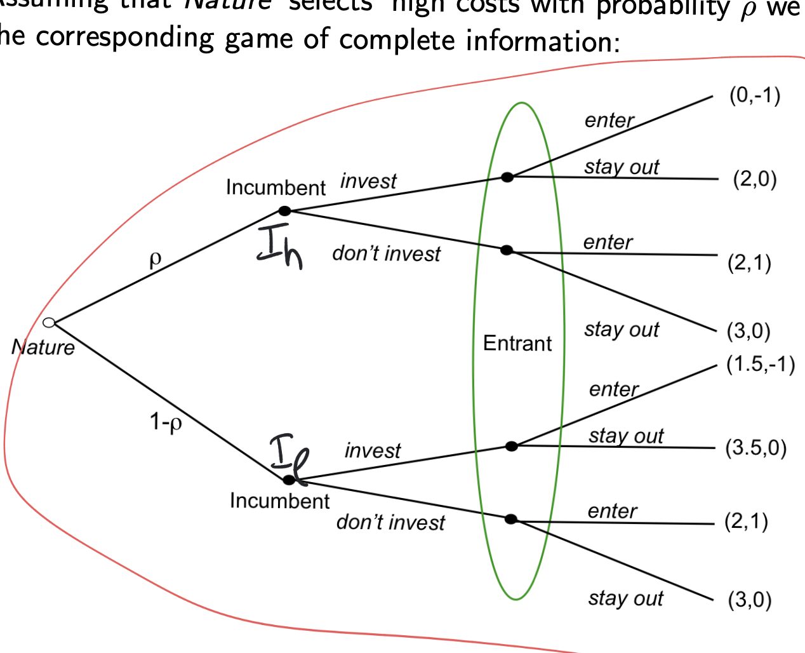
We then apply usual EQ concepts

Baysian game:

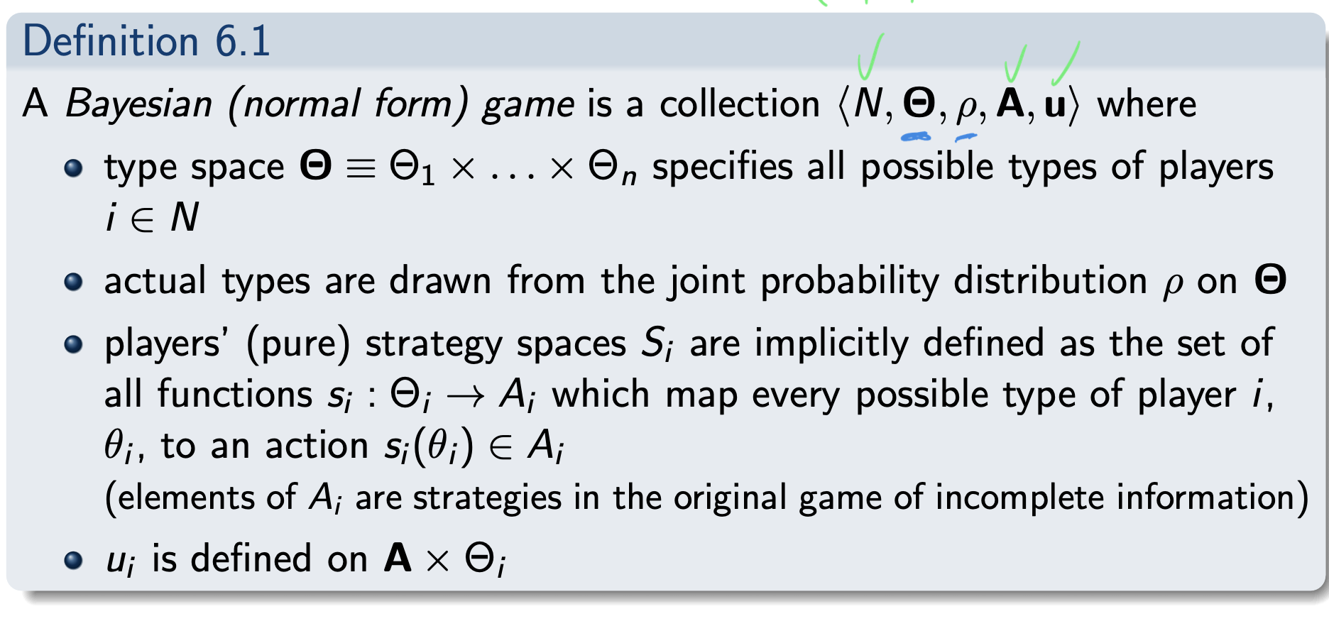
Baysian Nash EQ(BNE):
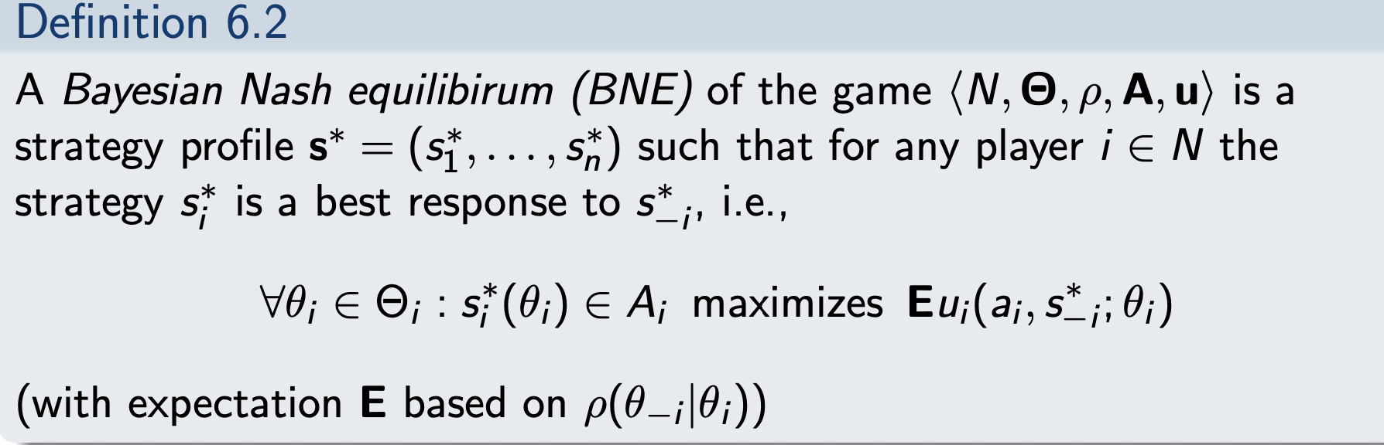
With mixed strategies analogous
Just like with normal NE there “always” exists a BNE
Typeopgaver:

Dynamic games of incomplete information (tadelis 15,16)
Extending the thory to extended form games

Perfect baysian EQ(PBE)
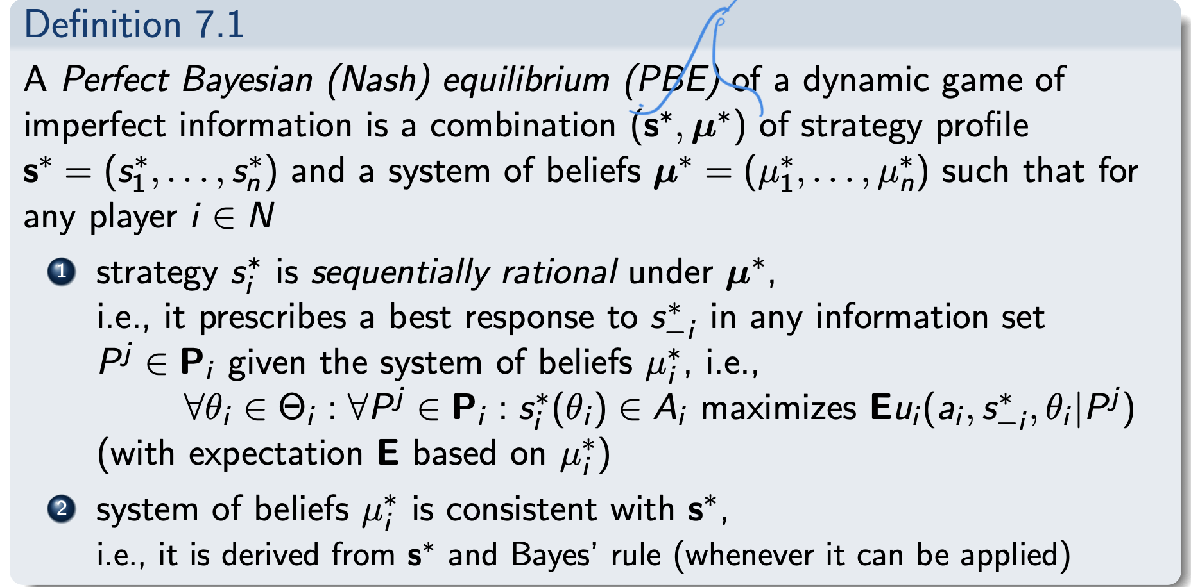
In words
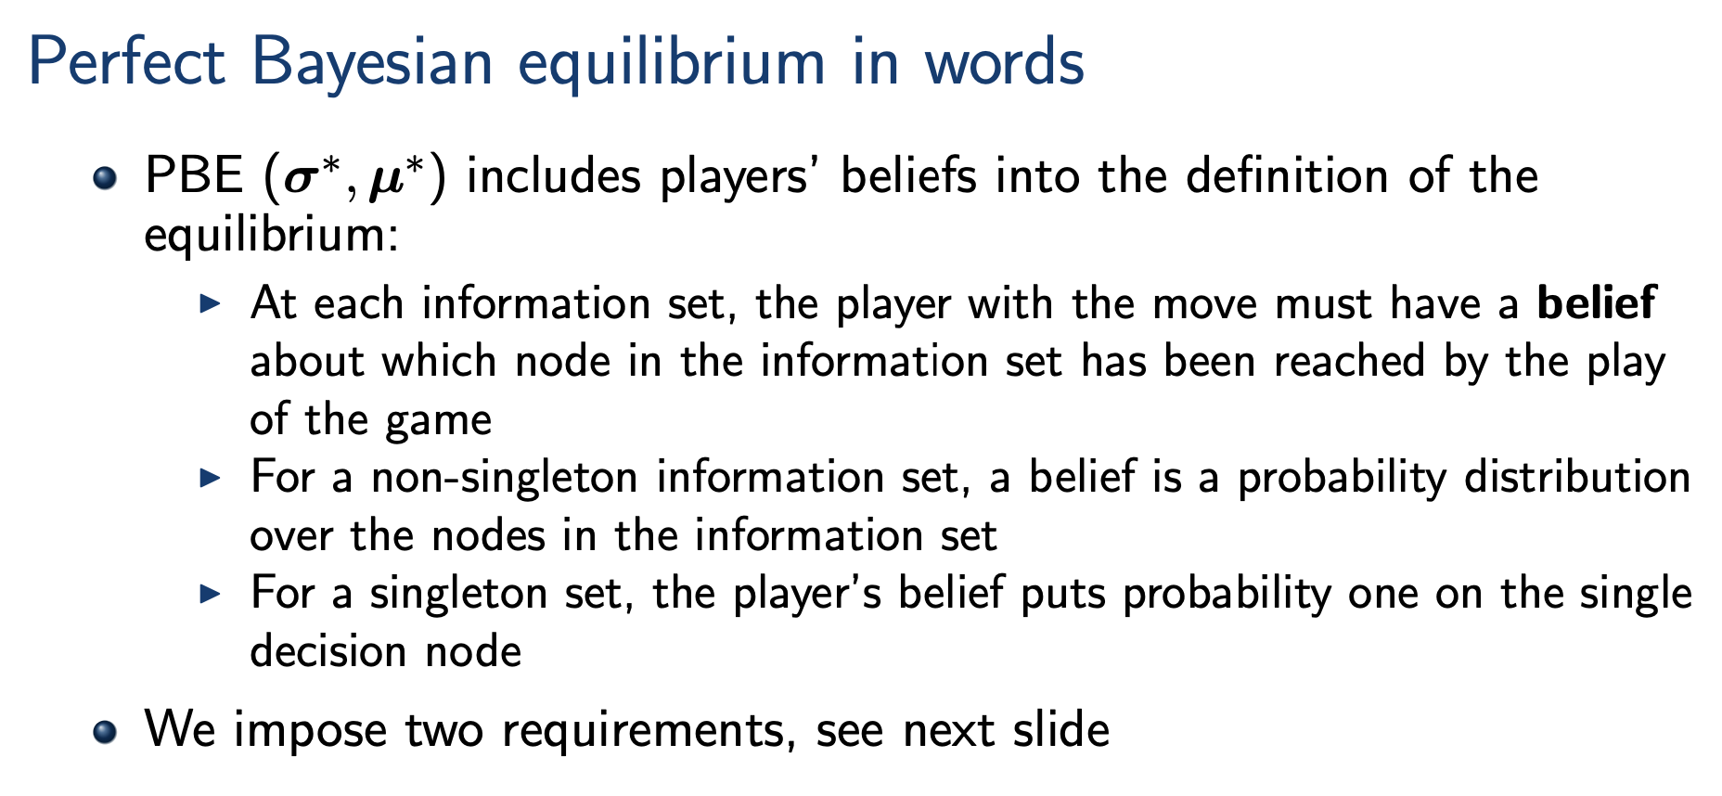
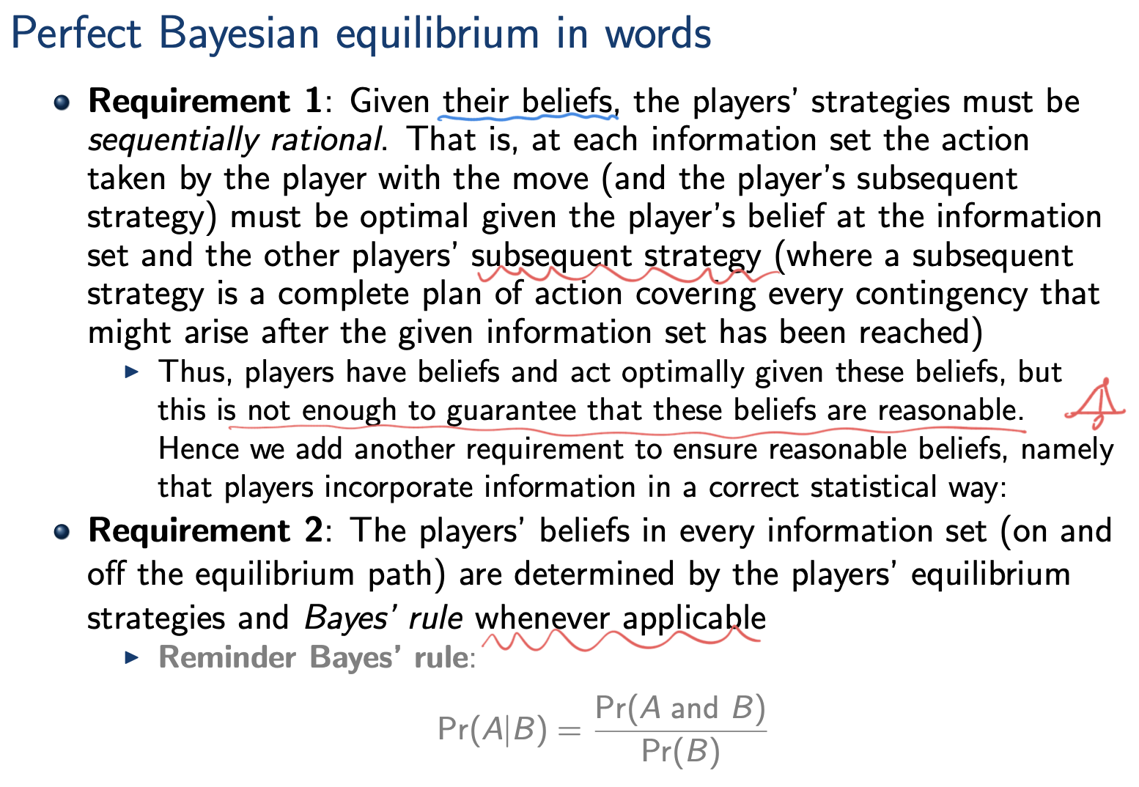
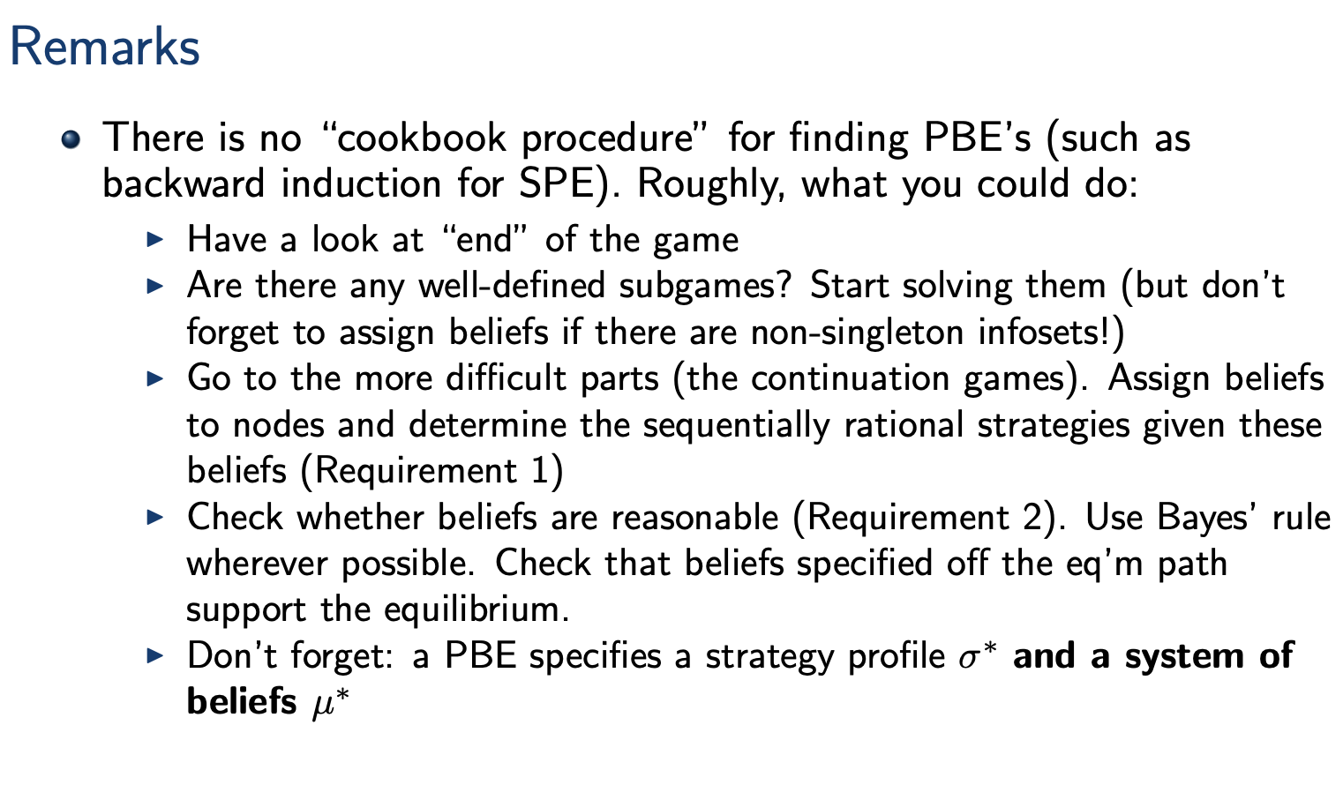

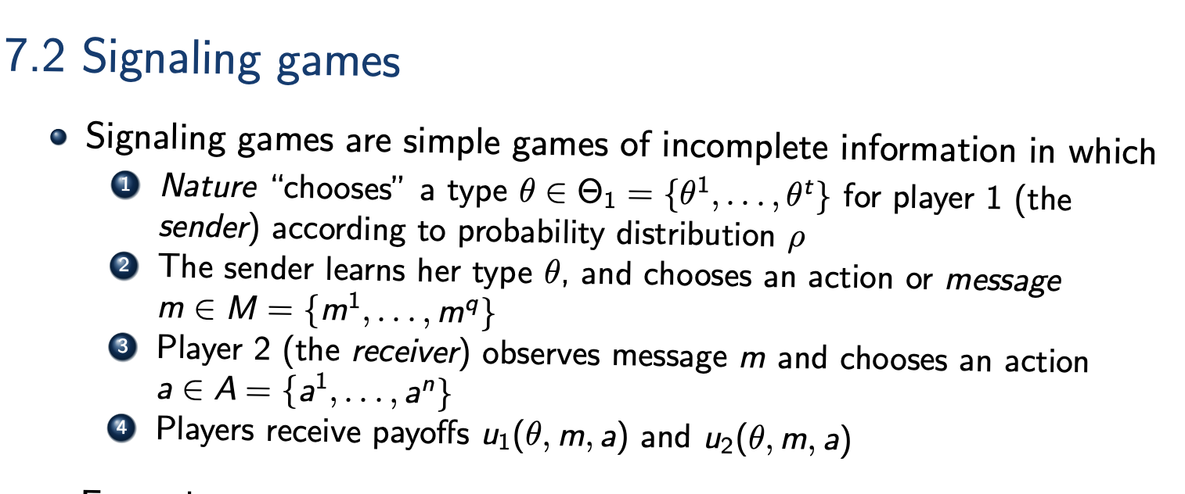
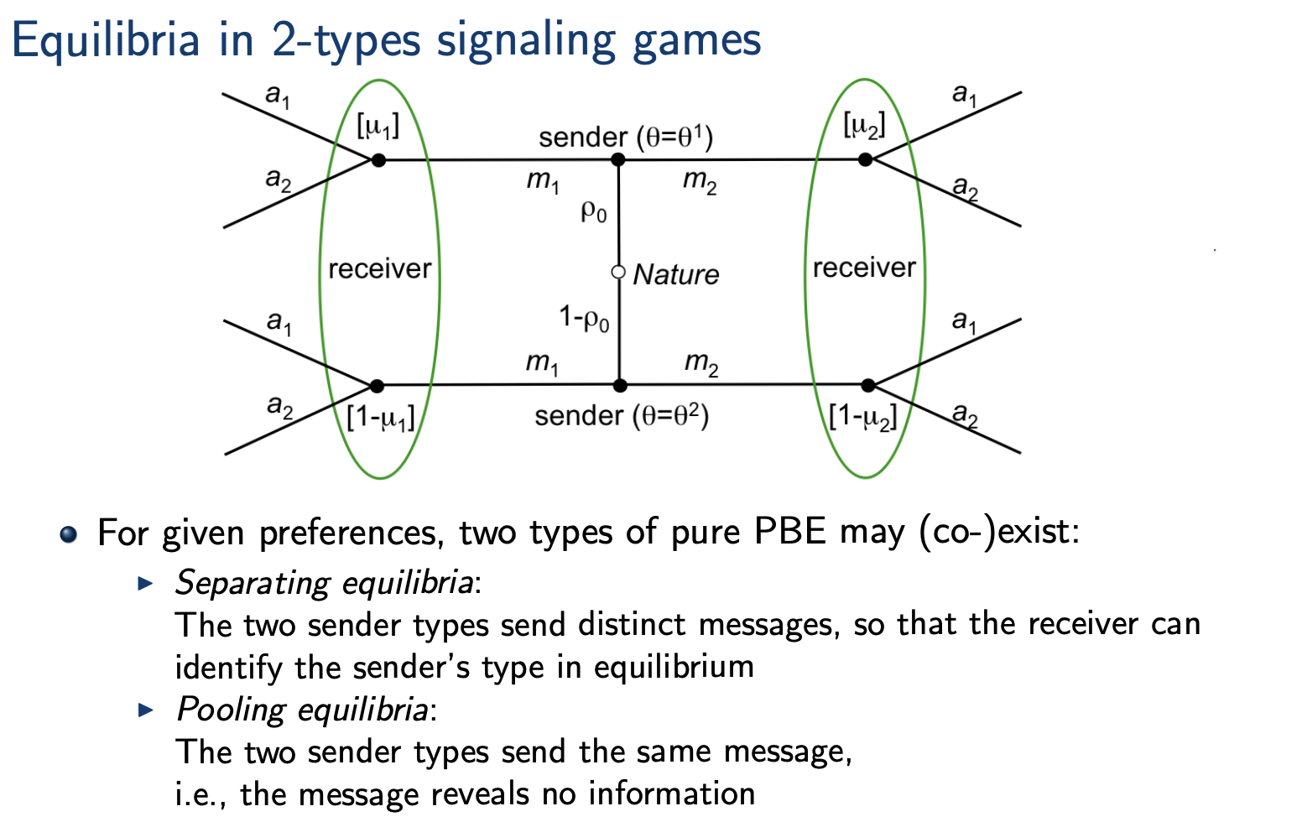
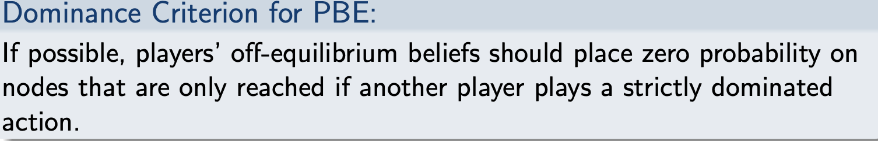
if a player plays a strictly dominating strategy he will never do anything else

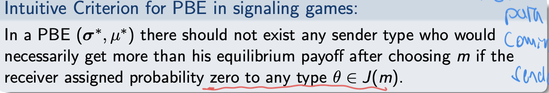
Stronger dominance criterion
Fix
Typeopgaver:

Contract theory

Risk aversion

VNM-utility:
Prices $X=\{x_{1},…,x_{n}\}$
And lottery $P=\{p_{1},…,p_{n}\}$ with $p_{i}=P(X=x_{i})$
Then the VNM utility is defined
$$V\left(p\right)=\sum_{x_{i}∈supp(P)}{p\left(x_{i}\right)·x_{i}}$$
This gives us a way to evaluate preferences over lotteries
$$p∼q⇔p∼p·α+q\left(1-α\right)∀α∈R$$
This means that indiffrence cureves are linear in probabilities
We only permit affince transformations of the vNM utility function
$$a·V\left(p\right)+b$$
With $a>0,b∈R$
Numbers matter!!
Utility is not ordinal!!

Certaintyequivalent: let $δ_{x}$ be the lottary that always pays x
Then the certainty equivalent $c\left(p\right)=x$
If $δ_{x}∼p$

Risk premium:
How much is the agent willing to pay to avoid he gamble
$$R\left(p\right)=E_{p}\left[X\right]-c(p)$$
With risk averse agents this will be positive
Neutral will be 0

Coefficent of absolute risk aversion:
$$λ\left(w\right)=-\frac{u^{''}\left(w\right)}{u^{'}\left(w\right)}$$

First best bench mark
Assumptions: everyone are utility maximisers

Set up:
We have a firm and an agent the agent has the option to take a contract offered by the firm or not, the rincipal wants to offer a contract where the agent wants to yield a certain amount of effort. This effort determines the lottery.

The agent has an outside option with netting utility $\overline{u}$
The Principal has utility function $B\left(x,w\right)=B(x-w)$with
$$B^{'}>0,B^{''}≤0$$
(if $B^{''}=0⇒risk neutrality B^{''}<0⇒risk aversion)$
These assumptions are to make sure the utility function is concave such that KT works

The agent has bernulli utility function
$$U\left(w,e\right)=u\left(w\right)-v(e)$$
With $u^{'}\left(w\right)>0,u^{''}\left(w\right)≤0,v^{'}\left(e\right)>0,v^{''}\left(e\right)≥0$
Again these assumption are to make sure constraints are concave
Then f,g concave,X convex $⇒KT-1 gives global\max{}$

First best: principal observes everything meaning he can define wages accordingly
$$P chooses optimal e^{'}and sets w\left(e\right)=\left\{\begin{aligned}w^{'} if e=e^{'} \\ -∞ otherwise\end{aligned}\right.$$
We write up the maximisation problem
$$\max_{e,{\left\{w_{i}\right\}}_{i=1}^{n}}{\sum_{i=1}^{n}{p_{i}\left(e\right)·B\left(x_{i}-w_{i}\right)}}$$
$$s.t. \sum_{i=1}^{n}{p_{i}\left(e\right)·u\left(w_{i}\right)}-v\left(e\right)≥\overline{u}$$
In solution constraint is increasing in wages and obj is decreasing in w implying that we will always have equality in the constraint
The function is not “nice in e” on a general note so for a finite number of effort levels we can optimize and take the best solution fix $e'$
Thus we can write up the lagrangian
$$L=\sum_{i=1}^{n}{p_{i}\left(e'\right)·B\left(x_{i}-w_{i}\right)}+λ\left(\sum_{i=1}^{n}{p_{i}\left(e'\right)·u\left(w_{i}\right)}-v\left(e'\right)-\overline{u}\right)$$
FOC:
$$\frac{∂L}{∂w_{i}}=-p_{i}\left(e^{'}\right)·B^{'}\left(x_{i}-w_{i}\right)+λ·p_{i}\left(e^{'}\right)·u^{'}\left(w_{i}\right)=0$$
$$⇔λ=\frac{B^{'}\left(x_{i}-w_{i}\right)}{u^{'}\left(w_{i}\right)}∀i$$
$$\frac{B^{'}\left(x_{i}-w_{i}\right)}{u^{'}\left(w_{i}\right)}=λ>0$$

$$λ·\frac{∂L}{∂λ}=0⇔\frac{∂L}{∂λ}=0⇔\sum_{i=1}^{n}{p_{i}\left(e'\right)·u\left(w_{i}\right)}-v\left(e'\right)=\overline{u}$$

First best solution is pareto optimal since no player can reach higher utility without another being worse off
In this case P is optimising for himself over everything

2 interesting cases:
$$P risk neutral and A risk averse$$
$$B^{'}\left(x_{i}-w_{i}\right)=k$$
$$⇒\frac{B^{'}\left(x_{i}-w_{i}\right)}{u^{'}\left(w_{i}\right)}=λ⇔\frac{1}{u^{'}\left(w_{i}\right)}=\frac{λ}{k}∀i∈\{1,…,n\}$$
$$⇒w_{i}=w_{j} ∀i,j$$
Meaning that the agent has constant income and the principal is holding all the risk
$$A risk neutral P risk averse$$
$$u^{'}=k$$
$$⇒B^{'}\left(x_{i}-w_{i}\right)=λ·k$$
$$⇒x_{i}-w_{i}=x_{j}-w_{j}$$
Meaning that the principal has constant income and the agent is holding all the risk

If both are risk neutral there are many solutions

If both are risk averse then everything just takes a while…
By differantiating the solutions
$$\frac{B^{'}\left(x_{i}-w_{i}\right)}{u^{'}\left(w_{i}\right)}=λ$$
Let $w_{i}^{0}(x_{i})$ be sych that $\frac{B^{'}\left(x_{i}-w_{i}^{0}(x_{i}\right)}{u^{'}\left(w_{i}^{0}(x_{i})\right)}=λ$
Then differantiante FOC 1
$$-B^{''}\left(x_{i}-w_{i}^{0}\left(x_{i}\right)\right)\left(1-\frac{dw_{i}}{dx_{i}}\right)+λ·u^{''}\left(w_{i}^{0}\left(x_{i}\right)\right)\frac{dw_{i}^{0}}{dx_{i}}=0$$
plug in $\frac{B^{'}\left(x_{i}-w_{i}^{0}(x_{i}\right)}{u^{'}\left(w_{i}^{0}(x_{i})\right)}=λ$ and divide by $B^{'}\left(x_{i}-w_{i}^{0}(x_{i}\right)$
$$-\frac{B^{''}\left(x_{i}-w_{i}^{0}\left(x_{i}\right)\right)}{B^{'}\left(x_{i}-w_{i}^{0}\left(x_{i}\right)\right)}\left(1-\frac{dw_{i}}{dx_{i}}\right)+\frac{u^{''}\left(w_{i}^{0}\left(x_{i}\right)\right)}{u^{'}\left(w_{i}^{0}\left(x_{i}\right)\right)}*\frac{dw_{i}^{0}}{dx_{i}}$$
We can write this as
$$r_{P}·\left(1-\frac{dw_{i}^{0}}{dx_{i}}\right)-r_{A}·\frac{dw_{i}^{0}}{dx_{i}}=0$$
$$⇔\frac{dw_{i}^{0}}{dx_{i}}=\frac{r_{P}}{r_{A}+r_{P}}$$

Moral hazard
Introduction of incomplete information changes the problem as we need the Agent to have incentive to choose the effort level e as that is what is no longer observed.

In this model it is important that there s a conflict of interest otherwise the first best solution will still be viable and thus optimal

This gives us the general problem
$$\max_{e,{\left\{w_{i}\right\}}_{i=1}^{n}}{\sum_{i=1}^{n}{p_{i}\left(e\right)·B\left(x_{i}-w_{i}\right)}}$$
$$s.t. \sum_{i=1}^{n}{p_{i}\left(e\right)·u(w_{i},e)}≥\overline{u}$$
$$e∈\arg{\max_{\hat{e}}{\sum_{i=1}^{n}{p_{i}\left(\hat{e}\right)u(w_{i},\hat{e})}}}$$

We set up a siplified version.
$$B=x-w$$
$$u(w,e)=v\left(w\right)-c(e)$$
With $v^{'}>0,v^{''}<0$
2 effort levels $e=1,e=0$
With $x_{s}>x_{f},P\left(X=x_{s} | e=1\right)>P(X=x_{s}|e=0)$
2 steps:
find the optimal wages encentivising each level of effort
then choose whichever is best

in first best this gives us a nice solution

$$w_{s}=w_{f}=\overline{w}\left(e\right)=v^{-1}\left(\overline{u}+c\left(e\right)\right)$$
Choose whichever e gives higher profit
2. best
we still want to maximize the same problem we find the 1. Best solution and then check if it is incentive compatable
under constant wage the agent will always choose low effort
if low effort is prefered in first best it is incentive compatable and also optimal in 2.best
2 options: implement low effort with constant wage or implement high effort with variable wage

For high effort
$$\max_{e,w_{s},w_{f}}{p_{s}\left(e\right)\left(x_{s}-w_{s}\right)+p_{f}\left(e\right)\left(x_{f}-w_{f}\right)}$$
$$s.t p_{s}\left(e\right)v\left(w_{s}\right)+p_{f}\left(e\right)v\left(w_{f}\right)-c\left(e\right)≥\overline{u}$$
$$p_{s}\left(e\right)v\left(w_{s}\right)+p_{f}\left(e\right)v\left(w_{f}\right)-c\left(e\right)≥p_{s}\left(\hat{e}\right)v\left(w_{s}\right)+p_{f}\left(\hat{e}\right)v\left(w_{f}\right)-c\hat{\left(e\right)}∀\hat{e}∈E$$
For 2 options
$$p_{s}\left(e^{h}\right)v\left(w_{s}\right)+p_{f}\left(e^{h}\right)v\left(w_{f}\right)-c\left(e^{h}\right)≥p_{s}\left(e^{l}\right)v\left(w_{s}\right)+p_{f}\left(e^{l}\right)v\left(w_{f}\right)-c\left(e^{l}\right)$$
$$⇔\left(p_{s}\left(e^{H}\right)-p_{s}\left(e^{L}\right)\right)\left(v\left(w_{s}\right)-v\left(w_{f}\right)\right)≥c\left(e^{H}\right)-c(e^{L})$$

Setting up the lagrangian
$$L=p_{s}\left(e^{H}\right)\left(x_{s}-w_{s}\right)+p_{f}\left(e^{H}\right)\left(x_{f}-w_{f}\right)+λ\left(p_{s}\left(e\right)v\left(w_{s}\right)+p_{f}\left(e\right)v\left(w_{f}\right)-c\left(e\right)-\overline{u}\right)+μ·\left(\left(p_{s}\left(e^{H}\right)-p_{s}\left(e^{L}\right)\right)\left(v\left(w_{s}\right)-v\left(w_{f}\right)\right)-c\left(e^{H}\right)+c\left(e^{L}\right)\right)$$
Foc:
$$\frac{∂L}{∂w_{s}}=-p_{s}\left(e^{H}\right)+λ·p_{s}\left(e^{H}\right)·v^{'}\left(w_{s}\right)+μ·\left(p_{s}\left(e^{H}\right)-p_{s}\left(e^{L}\right)\right)·v^{'}\left(w_{s}\right)=0 (1)$$
$$\frac{∂L}{∂w_{f}}=-\left(1-p_{s}\left(e^{H}\right)\right)+λ·\left(1-p_{s}\left(e^{H}\right)\right)·v^{'}\left(w_{f}\right)-μ·\left(p_{s}\left(e^{H}\right)-p_{s}\left(e^{L}\right)\right)v^{'}\left(w_{f}\right)=0 (2)$$
$$\left(2\right)⇒λ>0 otherwise \frac{∂L}{∂w_{f}}≠0$$
$$\frac{∂L}{∂λ}=0⇔p_{s}\left(e\right)v\left(w_{s}\right)+p_{f}\left(e\right)v\left(w_{f}\right)-c\left(e\right)=\overline{u}$$
We show $μ>0$
$$AFC μ=0$$
$$⇒$$
$$-p_{s}\left(e^{H}\right)+λ·p_{s}\left(e^{H}\right)·v^{'}\left(w_{s}\right)$$
$$-\left(1-p_{s}\left(e^{H}\right)\right)+λ·\left(1-p_{s}\left(e^{H}\right)\right)·v^{'}\left(w_{f}\right)=0$$
$$⇒\frac{1}{v^{'}\left(w_{s}\right)}=λ=\frac{1}{v^{'}\left(w_{f}\right)}$$
$$⇒w_{s}=w_{f}$$
$$⇒\left(p_{s}\left(e^{H}\right)-p_{s}\left(e^{L}\right)\right)\left(v\left(w_{s}\right)-v\left(w_{f}\right)\right)=0≥c\left(e^{H}\right)-c\left(e^{l}\right)$$
$$⇔c\left(e^{l}\right)≥c\left(e^{H}\right)$$
Which is a contradiction thus $μ>0$
$$μ·\frac{∂L}{∂μ}=0⇔\left(p_{s}\left(e^{H}\right)-p_{s}\left(e^{L}\right)\right)\left(v\left(w_{s}\right)-v\left(w_{f}\right)\right)=c\left(e^{H}\right)-c\left(e^{L}\right)$$
This means that for this type of problem we can simple solve a system of equations
$$\left(p_{s}\left(e^{H}\right)-p_{s}\left(e^{L}\right)\right)\left(v\left(w_{s}\right)-v\left(w_{f}\right)\right)=c\left(e^{H}\right)-c\left(e^{L}\right)$$
$$p_{s}\left(e^{H}\right)v\left(w_{s}\right)+p_{f}\left(e^{H}\right)v\left(w_{f}\right)-c\left(e\right)=\overline{u}$$
is second best pareto optimal?
If implementing 1. Best then yes
If not since the agent still gets $\overline{u}$ as PC is still binding he is worse of if the firm has lower profits than in first best then it is not PARETO since the 1. Best solution will give him higher utility without giving the Agent lower utility

Risk neutral agent: if the Agent and the Principal are risk there are many solutions to the problem
One of them is
P selling A the firm for a fixed K such that A gets his reservation utility and A gets a fixed income K
This requires that A has enough money…

Adverse selection 1
Problems of adverse selection stem from asymmetric information that is present already before contracts are offered and accepted.
Akerlof’s market for lemons: consider a market for used cars, only the seller knows the actual quality of the cars. So there is hidden information
- Quality is either good or bad (lemon)
- At given price the seller only sells if the car is equally bad or worse quality. So bad quality drives out good quality.
- The trade only happens if the buyers value the cars higher than the sellers. Otherwise complete market breakdown.
Example of market for used cars: 150 cars total, 50 good and 100 bad. 160 potential buyers(so more buyers than cars) outside option for buyers is $\overline{u}=0$.
Condition of the car | Value for buyer | Value for seller | share
Good | 24.000 | 18.000 | 1/3
Bad | 12.000 | 6.000 | 2/3
Market with complete and symmetric information: each car is worth more to the buyer than the seller, so all should be sold. Efficient because all cars are sold.
Market with incomplete but symmetric information ISI: neither seller nor buyer knows the quality of a car.
Expected value of car for buyer: $24·\frac{1}{3}+12·\frac{2}{3}=16$
Expected value of car for seller: $18·\frac{1}{3}+6·\frac{2}{3}=10$
So any car listed between these two should sell, so they all sell for 16 as the sellers set the price. This is still efficient as all cars are sold as we would expect, even though some pay more or less than they would like to.
Market with asymmetric information: only the seller knows the quality of the cars.
The supply function is
$$S\left(p\right)=\left\{\begin{aligned}0, if p<6.000 \\ 100, if 6.000≤p≤18.000 \\ 150, if p≥18.000\end{aligned}\right.$$
The demand function is dependent on the price. The buyer know only bad cars are sold for lower prices. Buyers value expected car as 16 so for anything over this they will not buy a car. And they know only bad cars are set for sale under 16, but they value them at 12, so only if the price is under 12 will they buy a car that they know is a bad car, but it is okay as it fits with their value of the car, so the demand function is
$$D\left(p\right)=\left\{\begin{aligned}160, if p≤12.000 \\ 0, if p>12.000\end{aligned}\right.$$
Equilibrium price: is then 12.000 where only the bad cars are sold, so this is an inefficient solution. The good cars are not sold because of the existence of the bad cars.
Adverse selection: when the existence of bad quality forces the good quality out of the market. Can cause a market to break down.
Market breakdown with asymmetric information: example, if quality is a continuous variable, so not just two qualities. Sellers with mass 1, and buyers with mass $I>1$. Quality $q\sim U\left(0,1\right)$ so the density function is $f\left(q\right)=1$ on $\left[0,1\right]$. Buyers valuation of car is $\frac{3}{2}·q$. So if buyer buys a car at price p and quality q their utility is $U^{B}=\frac{3}{2}·q-p$, otherwise 0 if no car is bought. If a seller sells at price p their utility is p, if they do not sell their utility is the quality of the car q. so sellers sell if $p≥q$. The average quality at given price p is
$$E\left(q | q≤p\right)=\frac{\int_{0}^{1}{\left(q·f\left(q\right)\right)dq}}{F\left(q=p\right)}=\frac{1}{2}·p$$
So the expected value for the buyer at price p is
$$EU^{B}=\frac{3}{2}·E\left(q | q≤p\right)-p=\frac{3}{2}·\frac{1}{2}·p-p=-\frac{1}{4}·p<0=\overline{U}$$
So no cars, except $q=0$, are sold as they are valued too low for the buyers to buy.

Adverse selection and screening
The game:
Nature moves choosing type of the agent
$$P\left(A=G\right)=q, P\left(A=B\right)=1-q$$
P designs contract/contracts and offers to A
A accepts or rejects
A supplies verifiable effort
Nature decides payoff dependent on effort
Outcome

(the unknown information is about the type of A not the amount of effort)
Principal:
$$U_{P}=Π\left(e\right)-w$$
$$Π\left(e\right),Π^{'}>0,Π^{''}<0$$
The principal is risk neutral in money(profit-wage)

Agent:
$$U_{G}\left(w,e\right)=u\left(w\right)-v(e)$$
$$U_{B}\left(w,e\right)=u\left(w\right)-k·v(e)$$
With
$$u^{'}>0, u^{''}<0, v^{'}>0, v^{''}>0, v\left(0\right)=0, k>1$$
Outside option giving $\overline{u}$(can be different)

First best:
P observes the type and offers accordingly

$$\max_{w_{G},e_{G},w_{B},e_{B}}{q·\left(Π\left(e_{G}\right)-w_{G}\right)+(1-q)(Π(e_{B})}-w_{B})$$
$$s.t u\left(w_{G}\right)-v\left(e_{G}\right)≥\overline{u}$$
$$u\left(w_{B}\right)-v\left(e_{B}\right)≥\overline{u}$$
PC will be binding for both otherwise simply decrease wage or increase effort
We can simply maximize each part
Giving
$$u\left(w_{A}\right)-v\left(e_{A}\right)={\overline{u}}_{A}$$
$$Π^{'}\left(e_{A}\right)=\frac{v^{'}\left(e_{A}\right)}{u^{'}\left(w_{A}\right)}$$
For each type A

2. best
$$\max_{w_{G},e_{G},w_{B},e_{B}}{q·\left(Π\left(e_{G}\right)-w_{G}\right)+(1-q)(Π(e_{B})}-w_{B})$$
$$\begin{aligned}s.t u\left(w_{G}\right)-v\left(e_{G}\right)≥\overline{u}\#\left(PC_{G}\right)\end{aligned}$$
$$\begin{aligned}u\left(w_{B}\right)-k·v\left(e_{B}\right)≥\overline{u}\#\left(PC_{B}\right)\end{aligned}$$
$$\begin{aligned}u\left(w_{G}\right)-v\left(w_{G}\right)≥u\left(w_{B}\right)-v\left(w_{B}\right)\#\left(IC_{G}\right)\end{aligned}$$
$$\begin{aligned}u\left(w_{B}\right)-k·v\left(w_{B}\right)≥u\left(w_{G}\right)-k·v\left(w_{G}\right)\#\left(IC_{B}\right)\end{aligned}$$
We argue that some constraints are non-binding
$$\left(PC_{B}\right),\left(IC_{G}\right)⇒PC_{G}$$
The 2 IC contraints give
$$v\left(e_{G}\right)-v\left(e_{B}\right)≤u\left(w_{G}\right)-u\left(w_{B}\right)≤k·\left(v\left(e_{G}\right)-v\left(e_{B}\right)\right)$$
Since $k>1$ this implies that $v\left(e_{G}\right)≥v\left(e_{B}\right)⇒e_{G}≥e_{B}$

2 possibilities:
$$e_{G}=e_{B}⇒w_{G}=w_{B}$$
$$e_{G}>e_{B}$$
We investigate these with KT
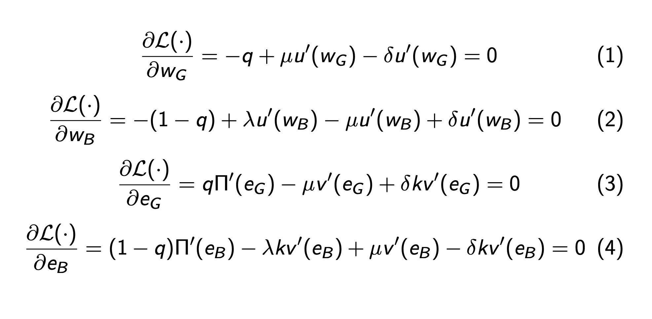

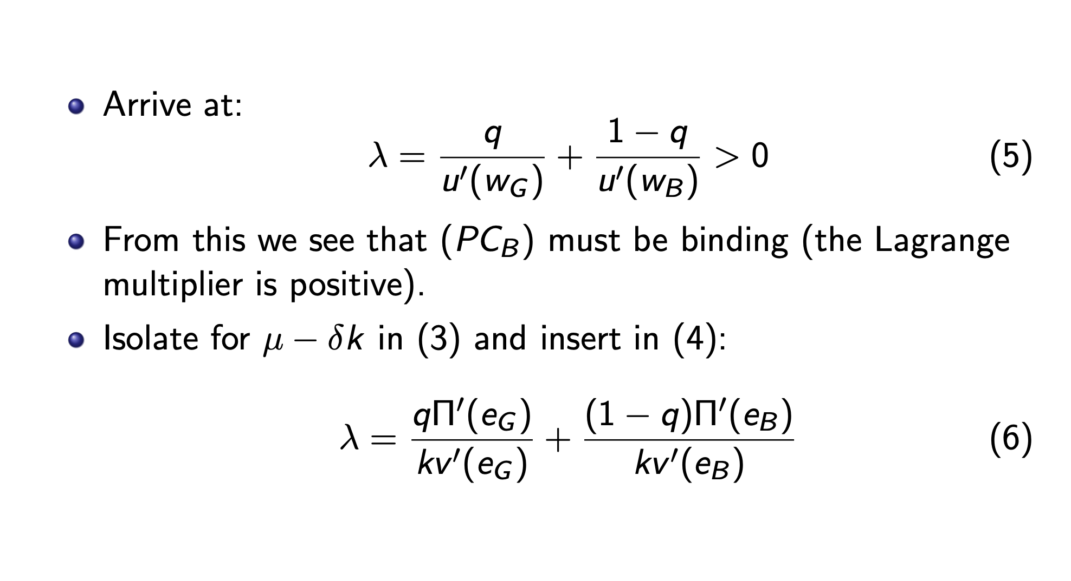
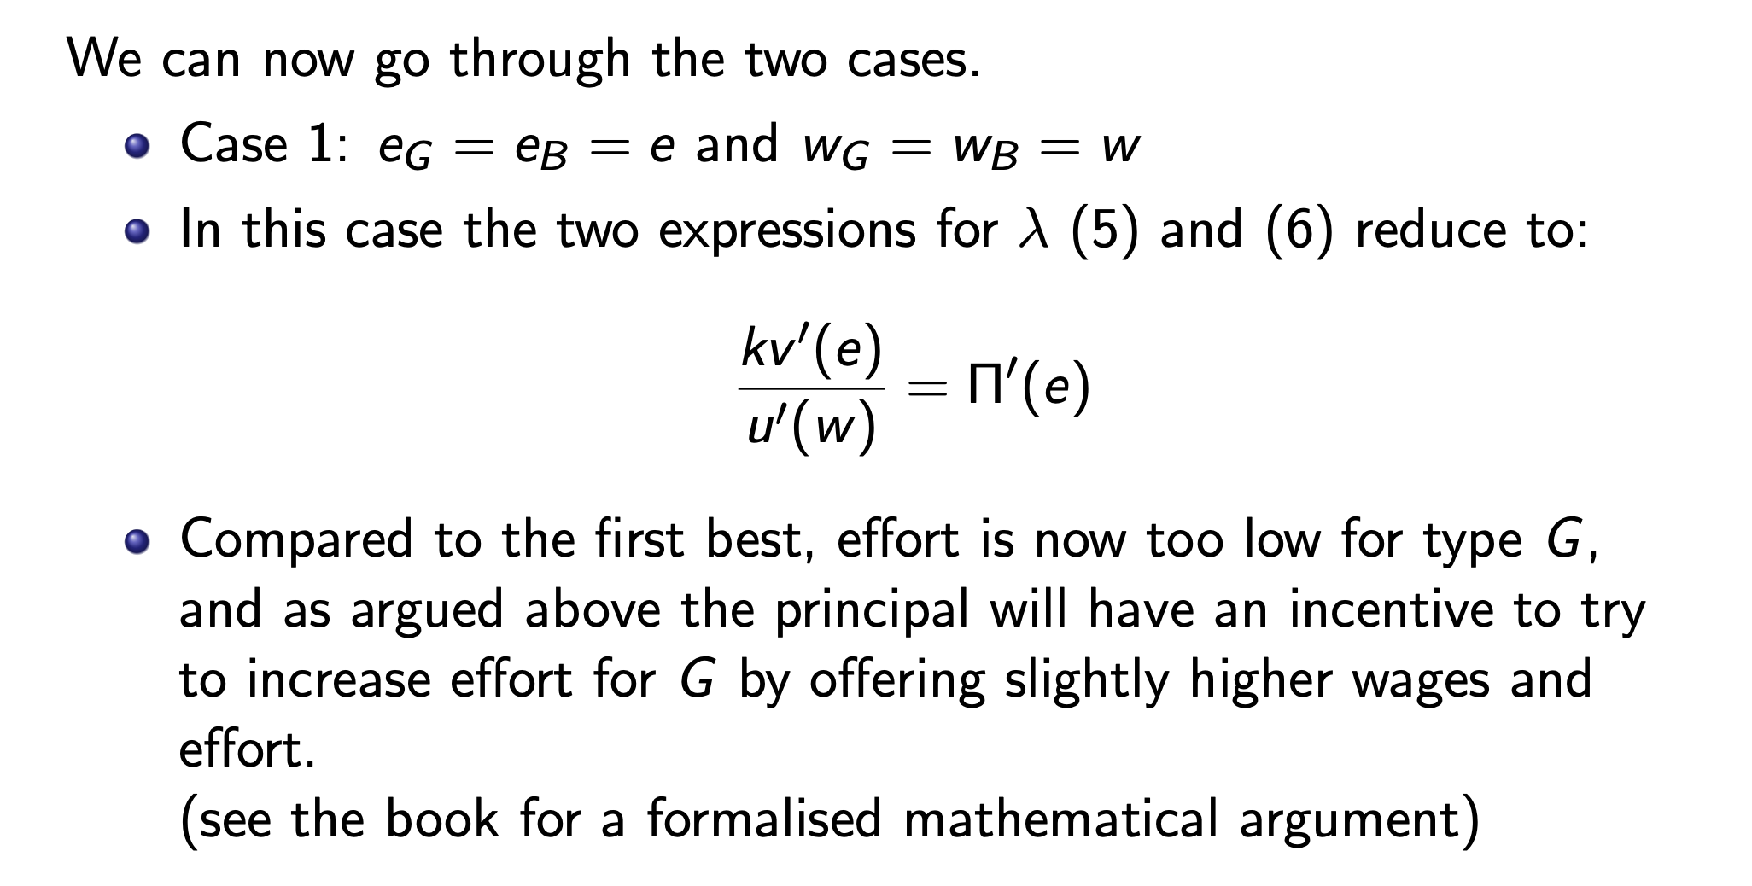
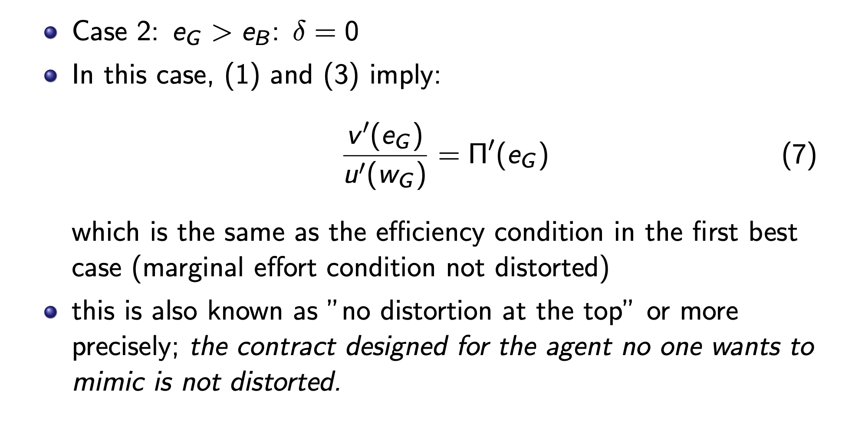
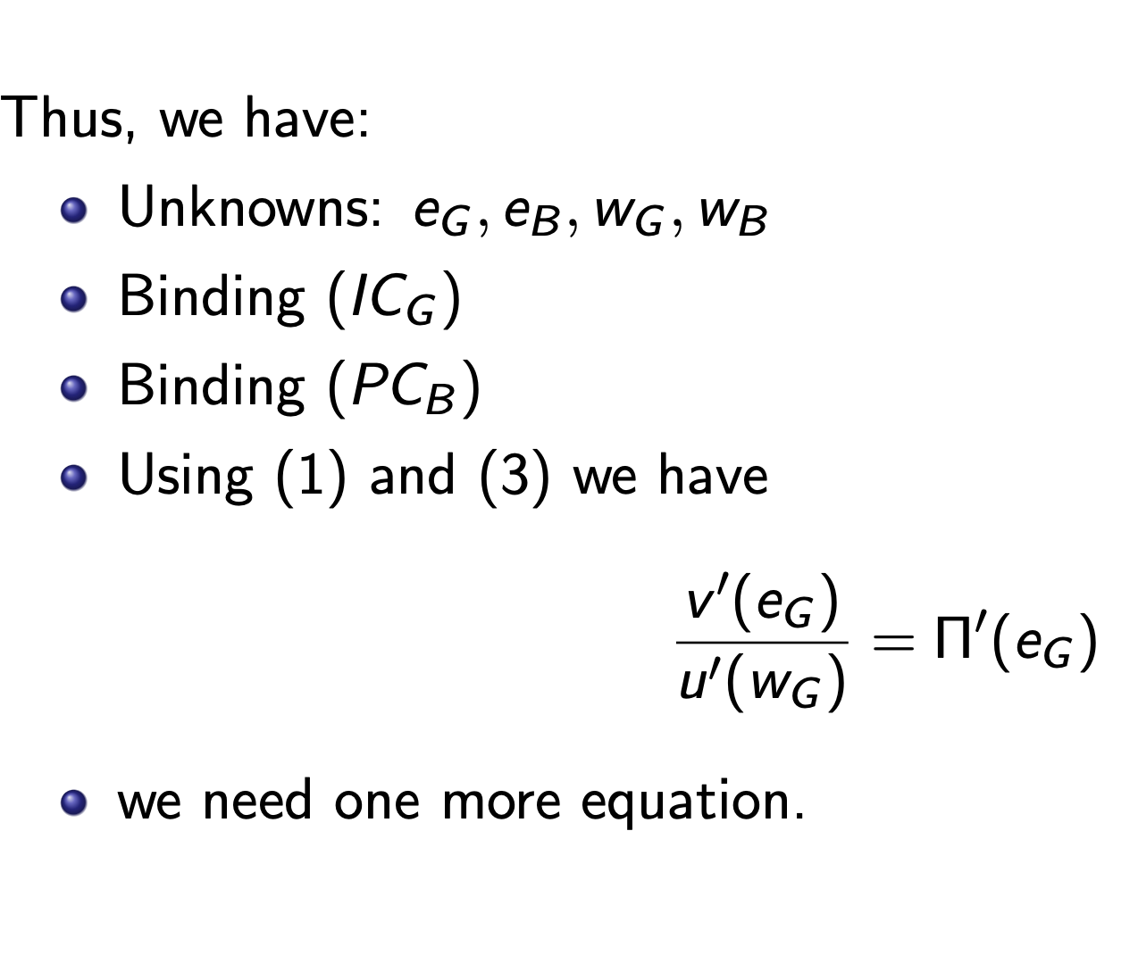
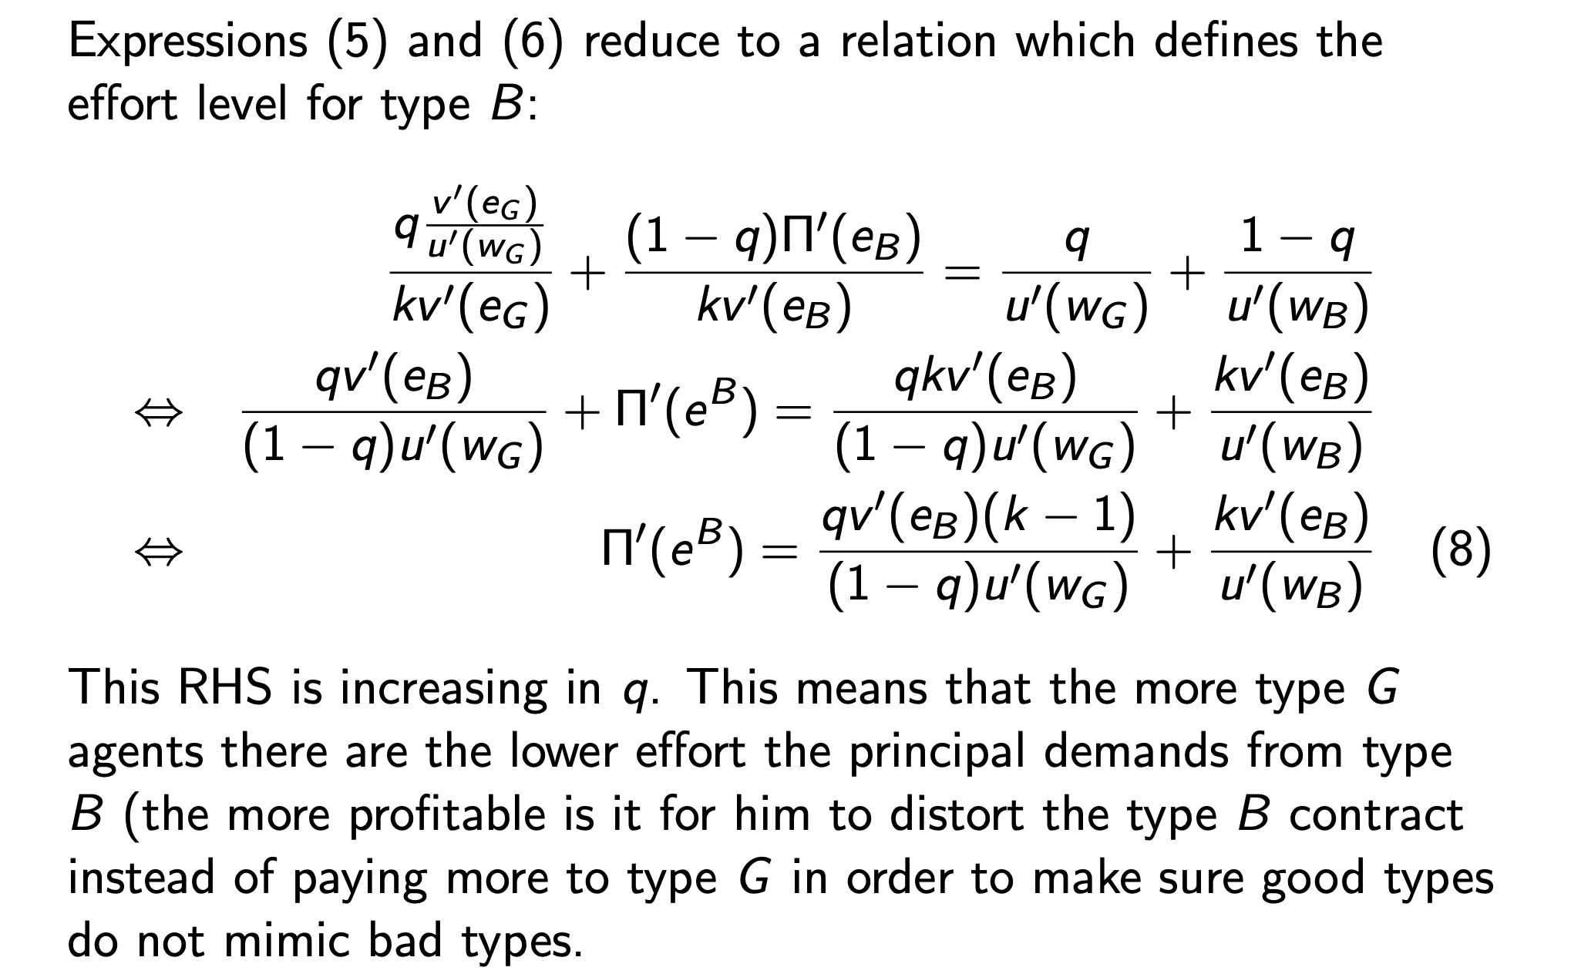
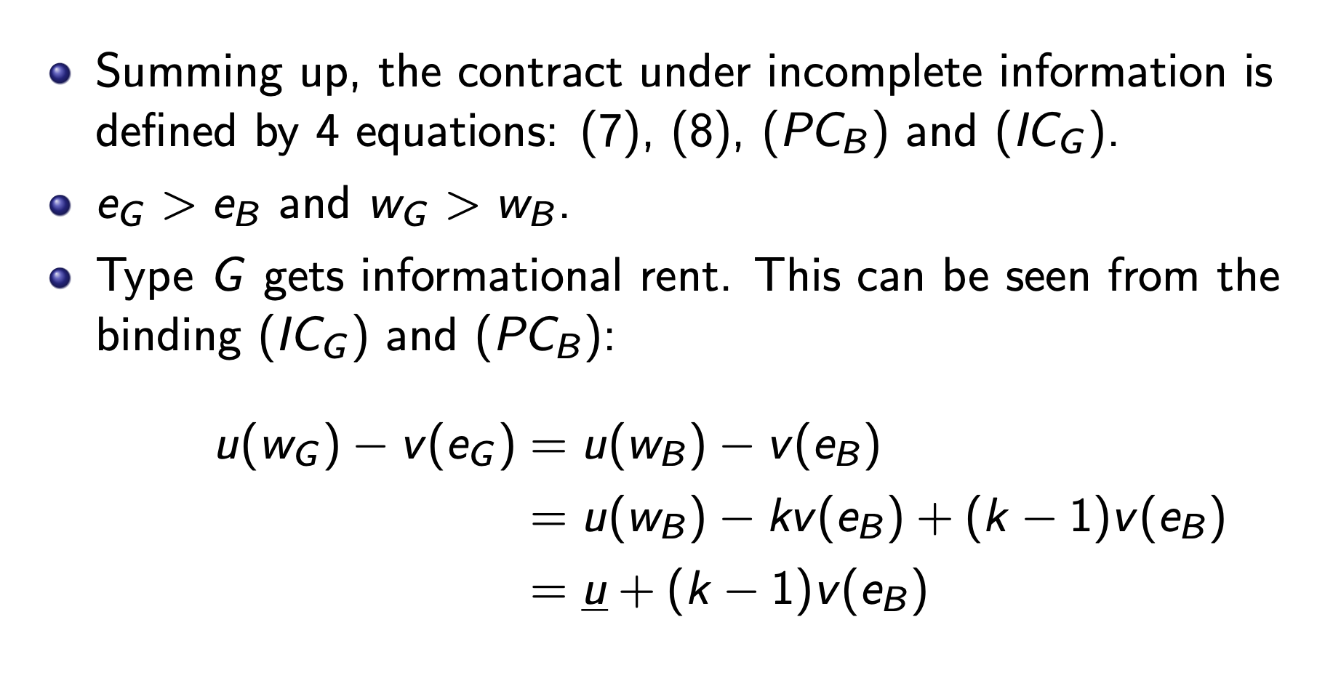
Pooling eq:
$$\max_{e,w}{Π\left(e\right)-w}$$
$$\begin{aligned}s.t u\left(w\right)-v\left(w\right)≥\overline{u}\#\left(PC_{G}\right)\end{aligned}$$
$$\begin{aligned}u\left(w\right)-k·v\left(w\right)≥\overline{u}\#\left(PC_{B}\right)\end{aligned}$$
Which is simply always the fb contract offered to B

Seperating EQ:

$$u\left(w_{G}\right)-v\left(w_{G}\right)=u\left(w_{B}\right)-v\left(w_{B}\right)$$
$$u\left(w_{B}\right)-k·v\left(e_{B}\right)=\overline{u}$$
$$\frac{v^{'}\left(e_{G}\right)}{u^{'}\left(w_{G}\right)}=Π'(e_{G})$$
This is the no distortion at the top thing
$$Π^{'}\left(e_{B}\right)=\frac{q·v^{'}\left(e_{B}\right)(k-1)}{(1-q)u'(w_{G})}+k·\frac{v^{'}\left(e_{B}\right)}{u^{'}\left(w_{B}\right)}$$
One last possibility just offer the best contract for type G this is preffered only if
$$q[Π(eSB)-wSB]+(1-q)[Π(eSB)-wSB] ≤ q[Π(eFB)-wFB]$$

Screening in labor markets

We look for a SPNE

Model:
Two types of workers:
$$θ∈\{θ_{L},θ_{H}\}$$
The employee is of type $θ_{H}$ with probability $λ$
There are 2 firms whod do not observe the agents type
The firms can make the employee do a useless task $t≥0$ and design contract pairs $(w,t)$
2 stage game:
The 2 firms simutaniously offer any number of contract pairs

The agent chooses the contract which gives him the highest utility or the outside option
If indifferent the agent chooses the action with the lowest task
If identical contracts the agent randomizes 50-50

Payoffs:
Firms:
$$Π\left(θ,w\right)=θ-w$$
Agents:
$$U\left(θ,t,w\right)=w-c\left(t,θ\right)$$

With assumptions satisfied:
$$c\left(0,θ\right)=0∀θ∈Θ$$
$$\frac{∂c}{∂t}(t,θ)>0$$
$$\frac{∂^{2}c}{∂t^{2}}\left(t,θ\right)>0$$
$$c\left(t,θ_{L}\right)>c\left(t,θ_{H}\right)∀t>0$$
$$\frac{∂c}{∂t}\left(t,θ_{L}\right)>\frac{∂c}{∂t}\left(t,θ_{H}\right)∀t>0$$
This implies that the indiffrencecurves are singlecrossing
$$w-c\left(t,θ\right)=\overline{u}$$
We set wage such that this is true
$$w(t)-c\left(t,θ\right)=\overline{u}$$
We differantiate in terms of t
$$\frac{dw}{dt}=\frac{∂c}{∂t}(t,θ)$$
Since
$$\frac{∂c}{∂t}\left(t,θ_{L}\right)>\frac{∂c}{∂t}(t,θ_{H})$$
The 2 will cross at most once on the graph this is true for all utility levels

First best: the firms know the type
We must have $\left(w_{i}^{FB},t_{i}^{FB}\right)=(θ_{i},0)$
Proof: think about it:
$$w_{i}^{FB}>θ⇒firms prefer not to hire since negative profits$$
$$w_{i}^{FB}<θ⇒by increasing wages by small enough ϵ>0 firms take all the employees and makes a profit$$
Thus not EQ
$$t_{i}^{FB}>0⇒1 company wants t_{i}^{FB}-ϵ task⇒NOT EQ$$
Fisrt best we should not have any task since its PARETO optimal

2. best
For these we have a bunch of results:
In any EQ both firms must have 0 expected profits
No pooling EQ exists
If $\left(w_{H},t_{h}\right)$ and $\left(w_{L},t_{L}\right)$ are contracts signed by the 2 types in a sperating EQ
then $w_{L}=θ_{L}, w_{H}=θ_{H}$

in any seperating EQ $t_{L}=0$

in any seperating EQ we must have $θ_{H}-c\left(t_{H},θ_{L}\right)=θ_{L}-c(0,θ_{L})$
the low type is indifferent between his own contract and the high types contract

EQ existance:
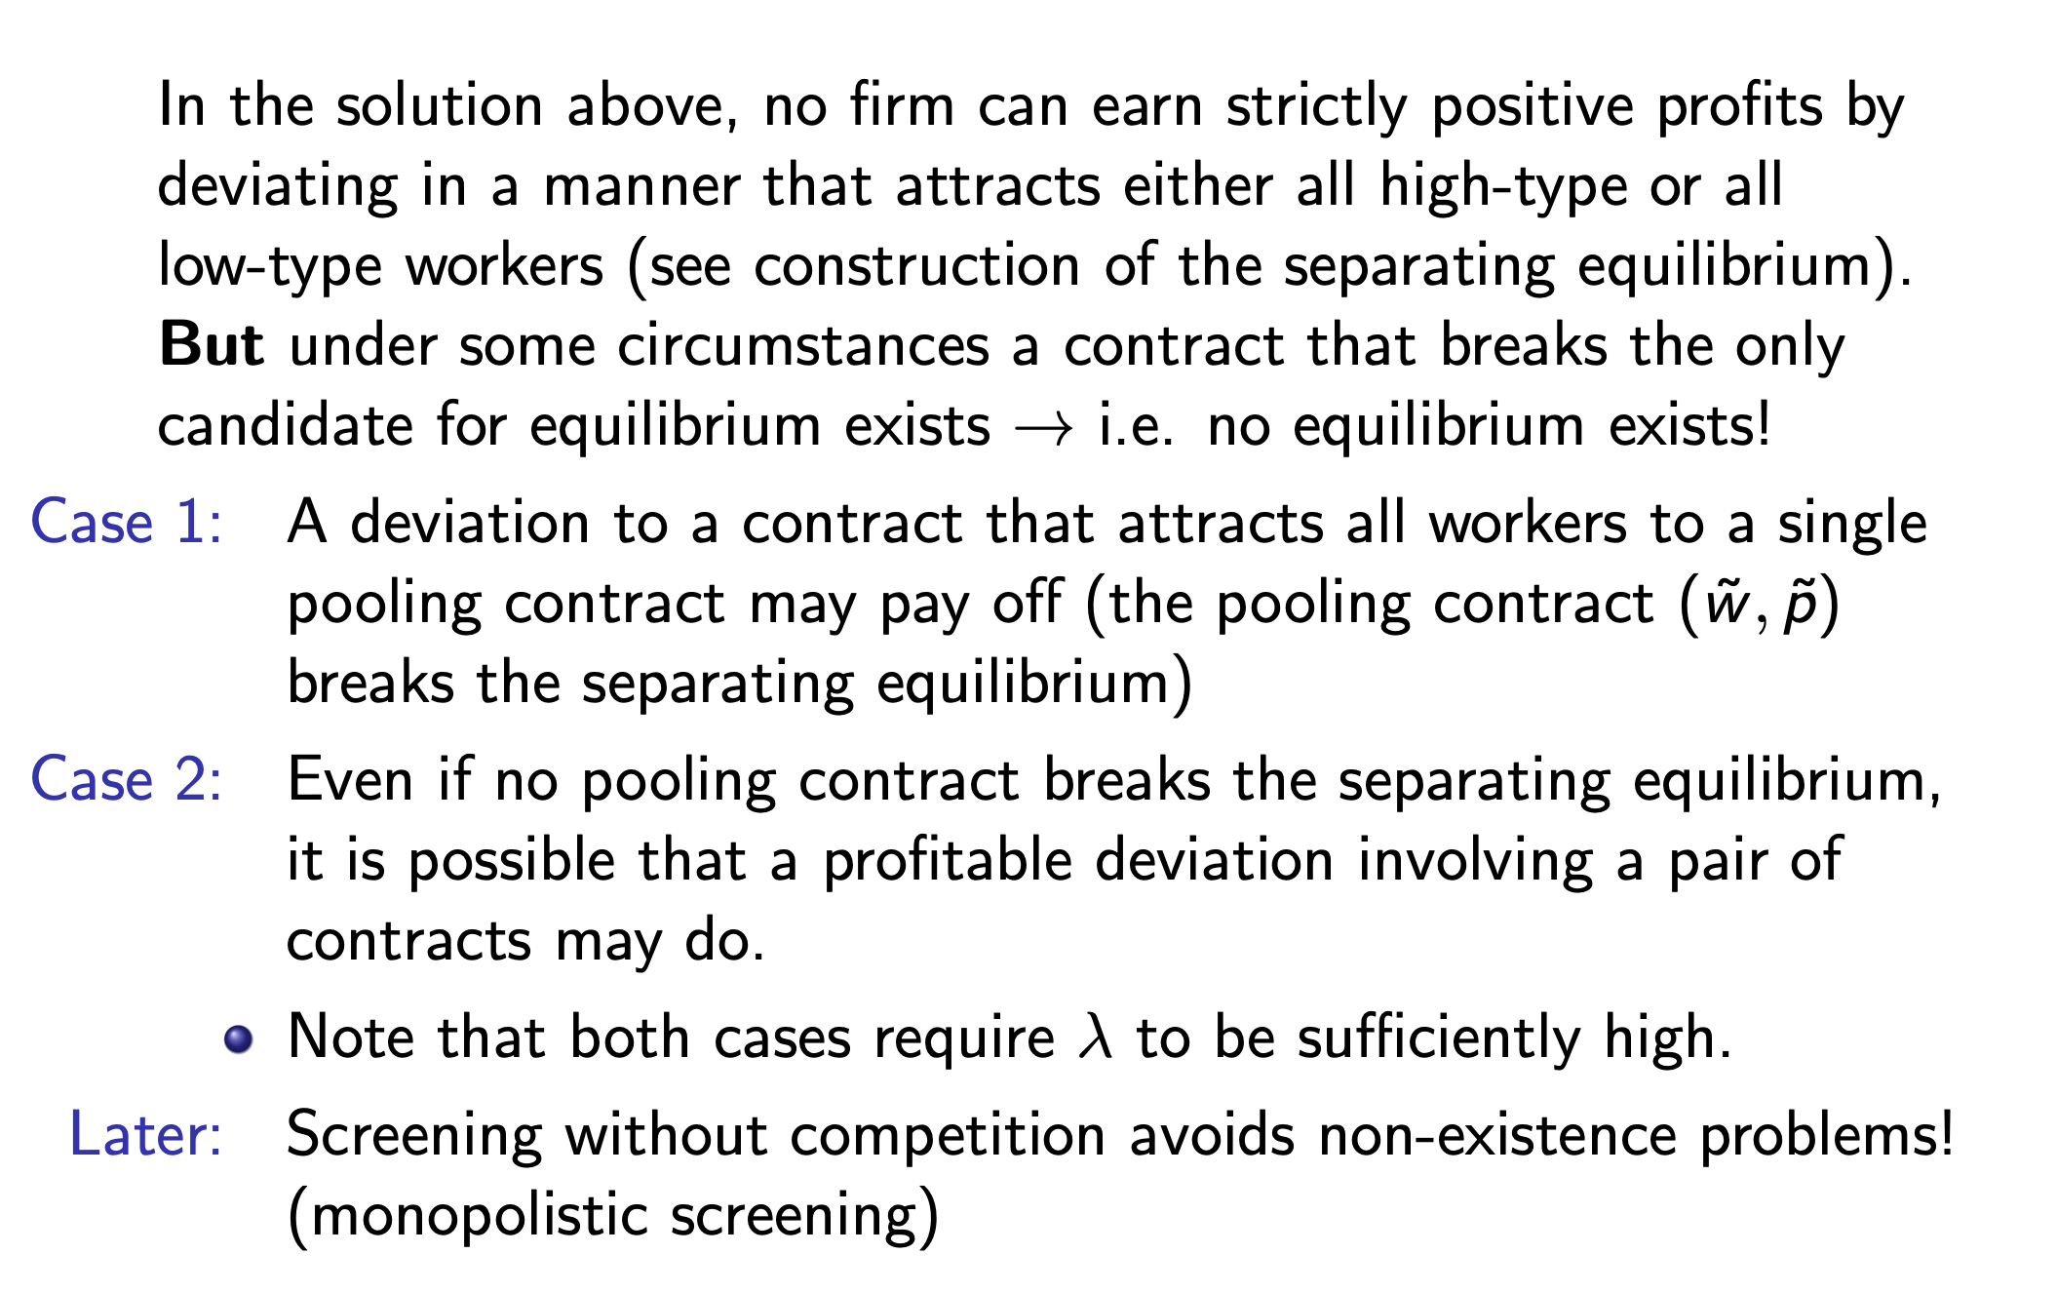
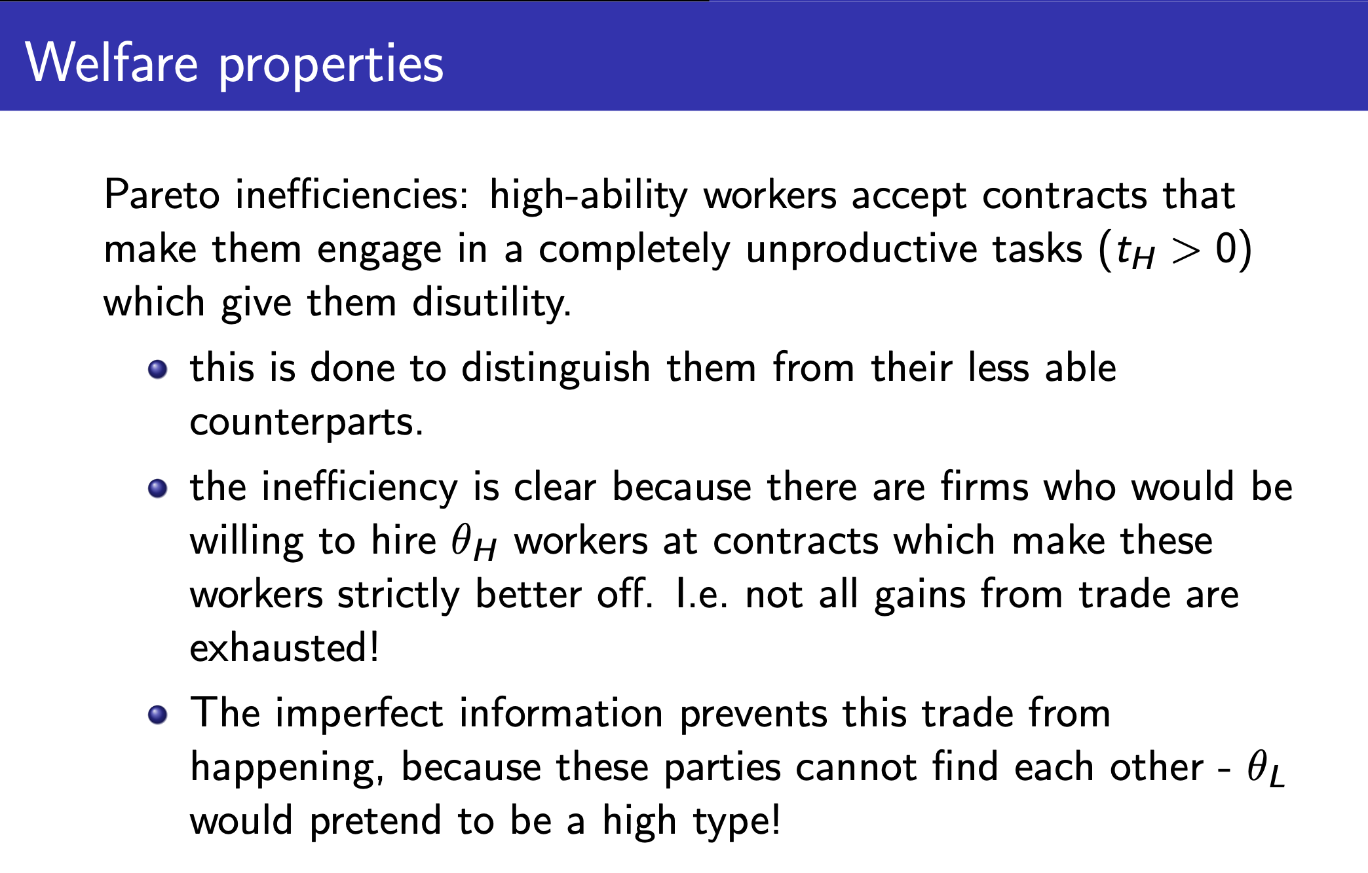
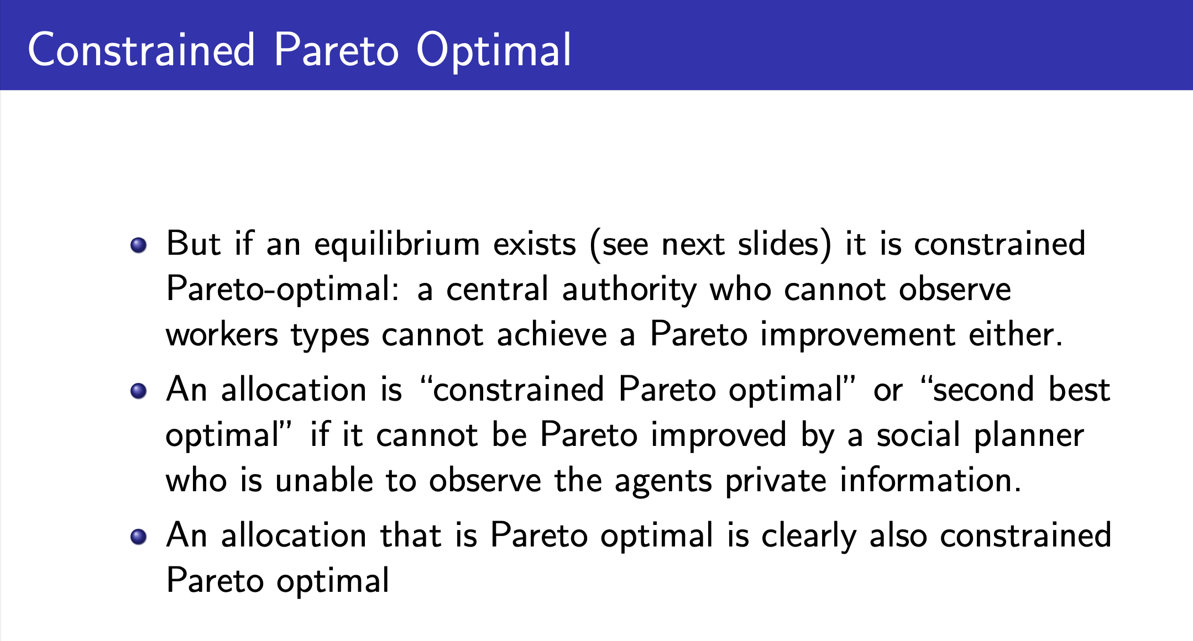

Monopositic screening
The problem is that we have a monopolist who dosen’t know the valuation of the buyer and thus needs to set quantity/price

Risk neutral monopolist with constant MC=c

Game: the monopolist offers a contract for a total price T and a quantity q
The preference it unknown but the distribution over preferences is know
With 2 types we can write it
$$θ∈Θ=\{θ_{L},θ_{H}\}$$
With $θ_{H}>θ_{L}$
With $P\left(θ=θ_{L}\right)=β$

consumer utility:
$$U\left(q,T,θ\right)=θ·v\left(q\right)-T$$
With an outside option $\overline{u}=0$
(we assume no income or budget constraints)
$$v\left(0\right)=0,v^{'}>0,v^{''}<0$$
Monopolist utility:
$$π\left(q,T\right)=T-c·q$$

First best:

$$\max_{T_{H},q_{H},T_{L},q_{L}}\left(1-β\right)·\left(T_{H}-c·q_{H}\right)+β\left(T_{L}-c·q_{L}\right)$$
$$s.t θ_{H}·v\left(q_{H}\right)-T_{H}≥0$$
$$θ_{L}·v\left(q_{L}\right)-T_{L}≥0$$
Which we can split up into maximization problems for each type:
And set up the Lagrangian
$$L=T_{A}-c·q_{A}+λ\left(θ_{A}·v\left(q_{A}\right)-T_{A}\right)$$
Foc:
$$\begin{aligned}\frac{∂L}{∂T_{A}}=1-λ=0\#\left(1\right)\end{aligned}$$

$$\begin{aligned}\frac{∂L}{∂q_{A}}=-c+λ·θ_{A}·v^{'}\left(q_{A}\right)=0\#\left(2\right)\end{aligned}$$

$$\begin{aligned}λ·\frac{∂L}{∂λ}=0\#\left(3\right)\end{aligned}$$
$$\left(1\right)⇔λ=1$$
$$\left(2\right)⇔\frac{c}{θ_{A}}=v^{'}\left(q_{A}\right)$$
$$\left(3\right)⇔θ_{A}·v\left(q_{A}\right)-T_{A}=0$$
Thus these 2 equations give us the first best solutions
$$θ_{A}·v\left(q_{A}\right)=T_{A}$$
$$\frac{c}{θ_{A}}=v^{'}\left(q_{A}\right)$$

Alternatively realise that constraint must be binding and optimize

Linear pricing
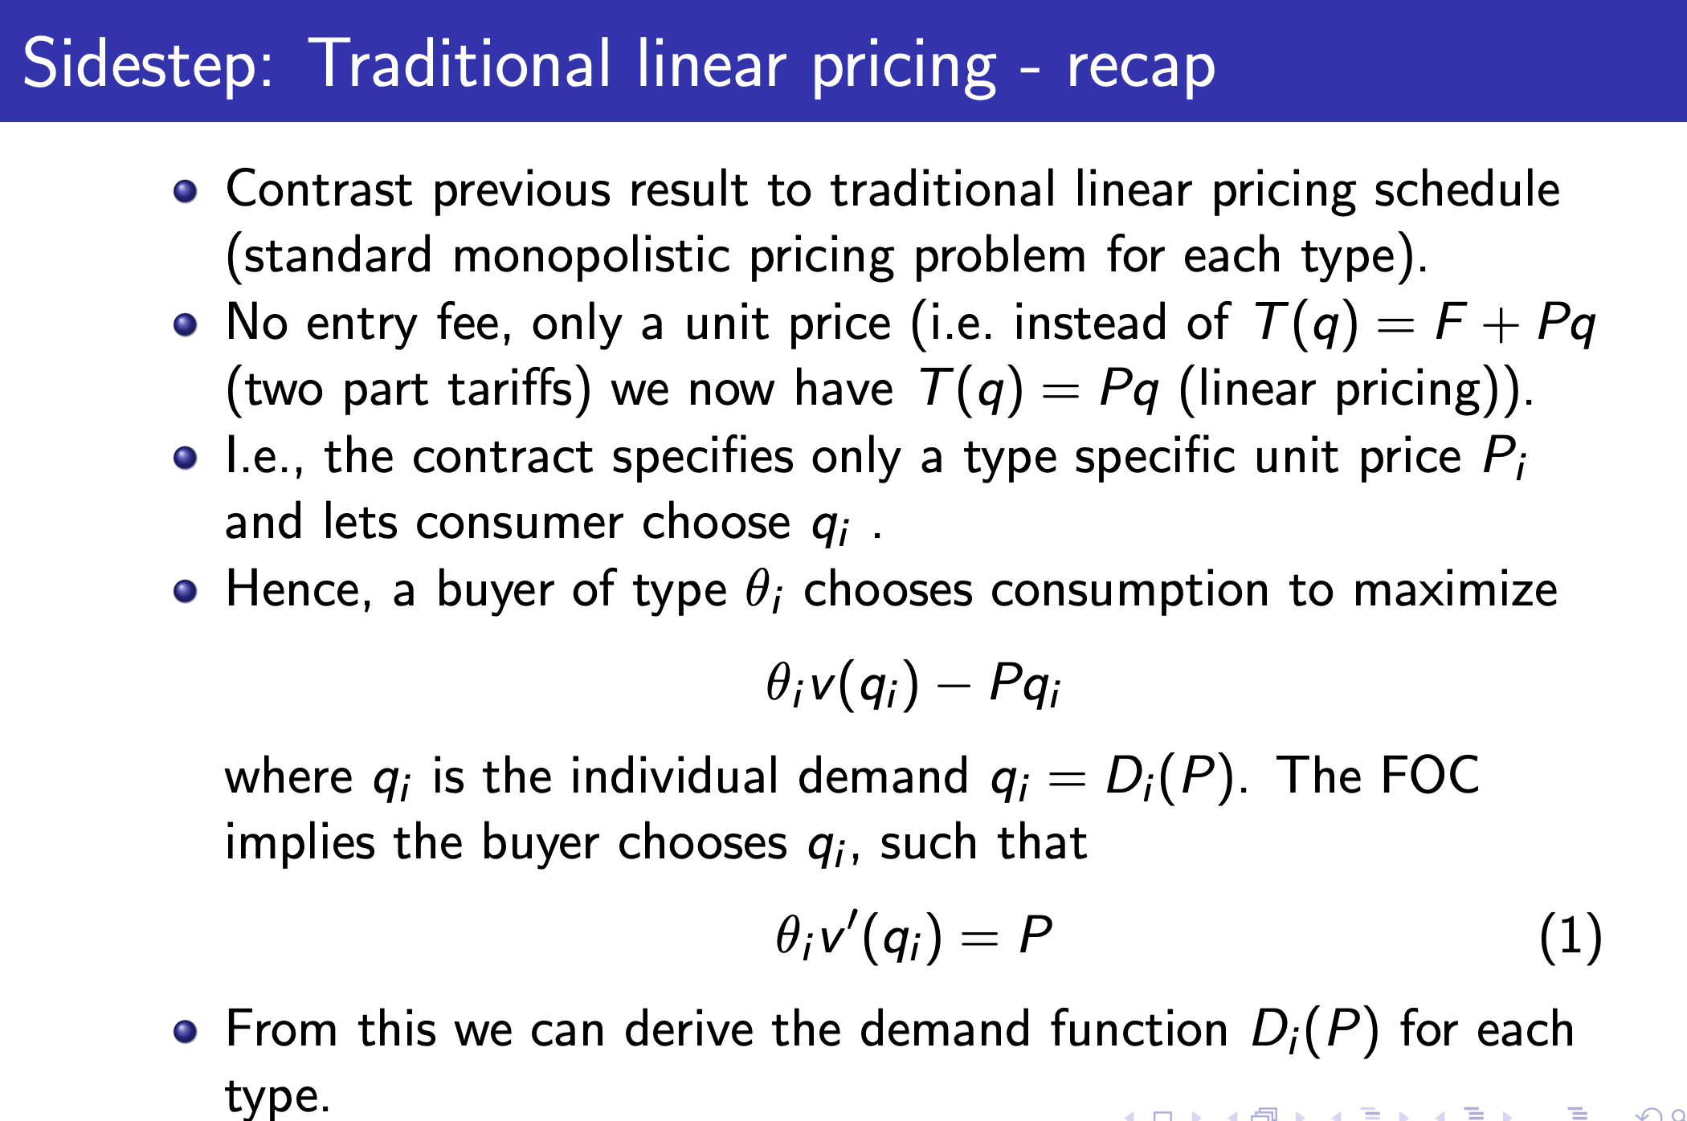
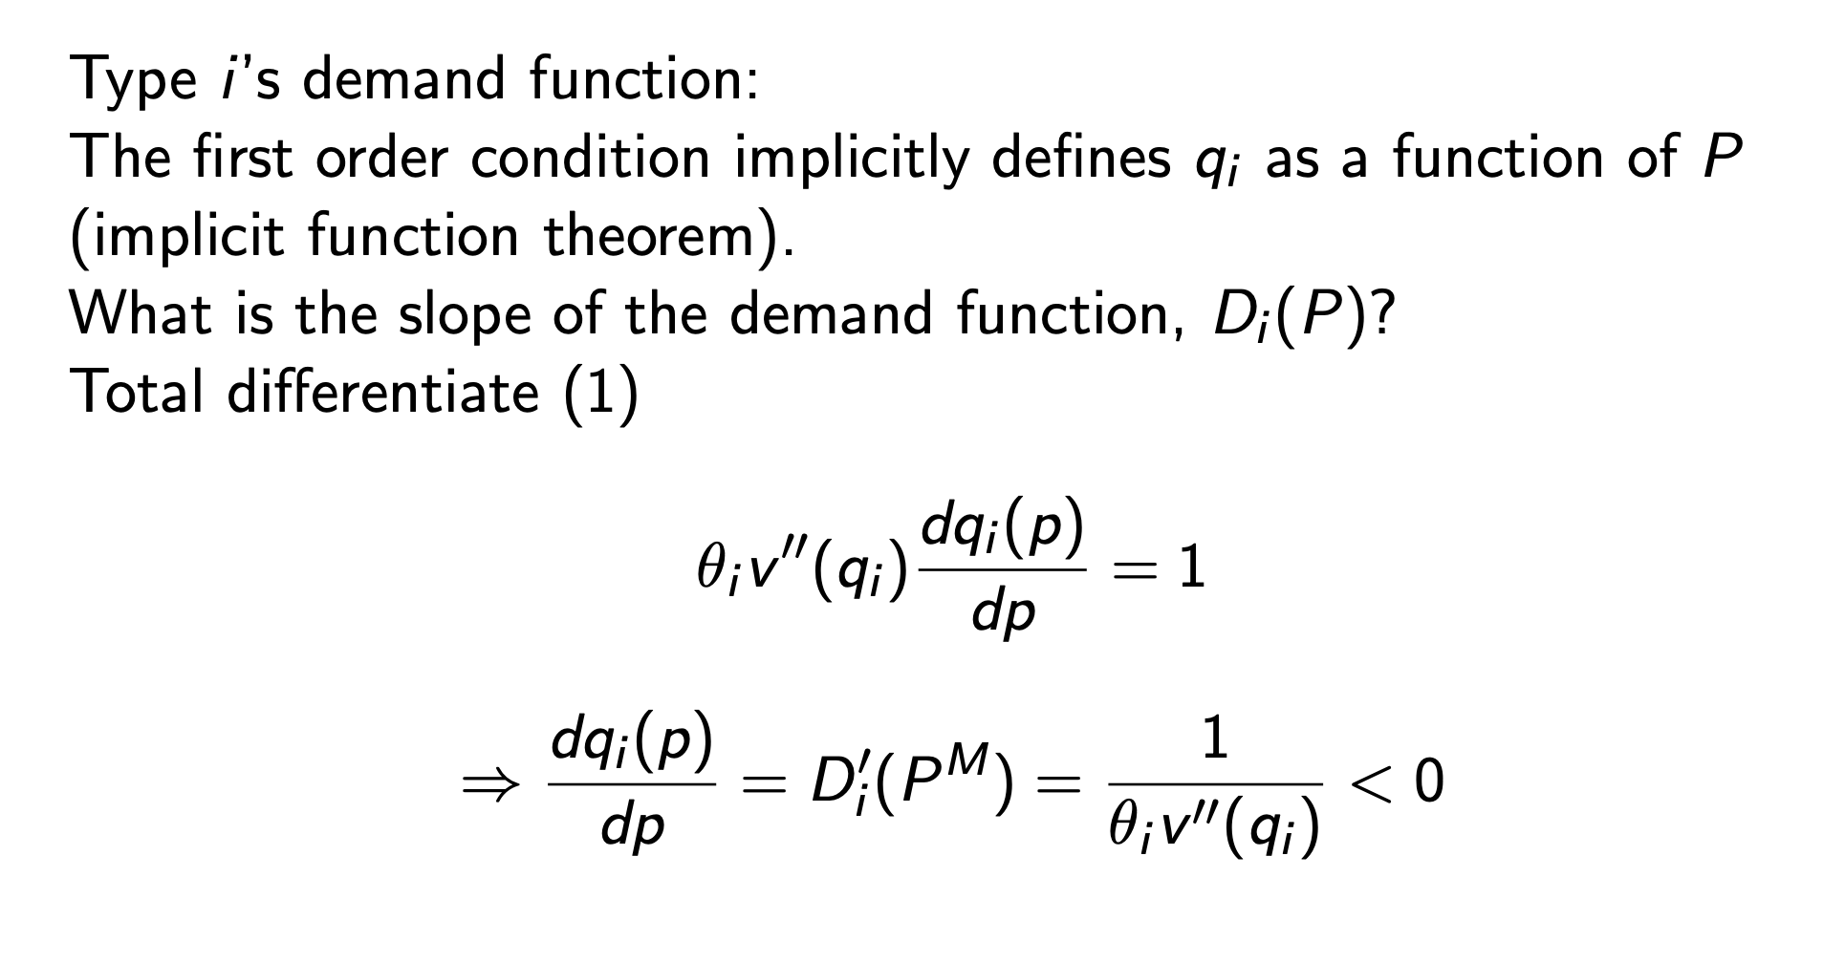
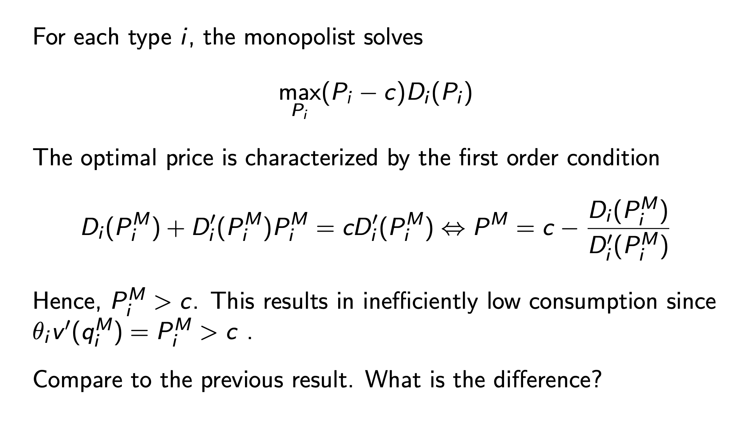

2. best
$$\max_{T_{H},q_{H},T_{L},q_{L}}\left(1-β\right)·\left(T_{H}-c·q_{H}\right)+β\left(T_{L}-c·q_{L}\right)$$
$$\begin{aligned}s.t θ_{H}·v\left(q_{H}\right)-T_{H}≥0\#\left(PCH\right)\end{aligned}$$

$$\begin{aligned}θ_{L}·v\left(q_{L}\right)-T_{L}≥0\#\left(PCL\right)\end{aligned}$$

$$\begin{aligned}θ_{H}·v\left(q_{H}\right)-T_{H}≥θ_{H}·v\left(q_{L}\right)-T_{L}\#\left(ICH\right)\end{aligned}$$

$$\begin{aligned}θ_{L}·v\left(q_{L}\right)-T_{L}≥θ_{L}·v\left(q_{H}\right)-T_{H}\#\left(ICL\right)\end{aligned}$$
We make this into unconstrained optimization
$$\left(ICH\right),\left(PCL\right)⇒\left(PCH\right)$$
$$\left(PCL\right) must bind$$
Otherwise increase $T_{L},T_{H}$ by the same $ϵ>0$

$$\left(ICH\right) must bind$$
Otherwise increase $T_{H}$(since PCH can be ignored)
$$\left(ICL\right) is slack$$
$$\left(ICH\right) binds⇔θ_{H}\left(v\left(q_{H}\right)-v\left(q_{L}\right)\right)=T_{H}-T_{L}$$
Since $θ_{L}<θ_{H}$
$$θ_{L}\left(v\left(q_{H}\right)-v\left(q_{L}\right)\right)<θ_{H}\left(v\left(q_{H}\right)-v\left(q_{L}\right)\right)=T_{H}-T_{L}$$
$$⇔\left(ICL\right) is slack$$

This gives us the final optimization problem
$$\max_{q_{H},q_{L}}{β\left(θ_{L}v\left(q_{L}\right)-c·q_{L}\right)+\left(1-β\right)·(θ_{H}·v\left(q_{H}\right)-\left(θ_{H}-θ_{L}\right)v\left(q_{L}\right)-c·q_{H})}$$

Adverse selection and screening (continous type)
Competitive market
Each firm have CRS technology
Price of output is 1
There is a continoum of workers with mass N
Workers differ in type
$$θ∈Θ=\left[θ_{1},θ_{2}\right]$$
The distribution over $Θ$ is reprecented by CDF F with density
$$f\left(θ\right)>0∀θ∈Θ$$
A type $θ$ has an outside option $r(θ)$
Workers are maximizers

The firms utility:
$$Π\left(θ,w\right)=θ-w$$

Efficient allocations
$$sum of worker utility=N·\int_{θ_{1}}^{θ_{2}}{\left[I\left(θ\right)·θ+\left(1-I\left(θ\right)\right)r\left(θ\right)\right]f\left(θ\right)dθ}$$
This is maximised if and only if $I\left(θ\right)=1 if θ≥r\left(θ\right) and 0 otherwise$
Competition pushes firm utility to 0

Thus types working must be
$$\left\{θ:r\left(θ\right)≤θ\right\}$$

First best:
We have a function $w^{⋆}(θ)$ which gives different wages to each type
We must have $w^{⋆}\left(θ\right)=θ$ otherwise firms have profit
Thus
$$\left\{θ:r\left(θ\right)≤w^{⋆}\left(θ\right)=θ\right\}$$
Which is everyone who works in PE state seen before

2. best
Firms don’t know $θ$ but workers do

Thus workers become 1 good instead of infinitly many

Labour supply:
A worker is willing to work if $r\left(θ\right)≤w$
This gives us the set of working workers
$$Θ\left(w\right)=\{θ:r\left(θ\right)≤w\}$$

Labour demand:
Let $μ$ denote the firms belief of average productivity
Labour demand is then given
$$z\left(w\right)=\left\{\begin{aligned}0 if μ<w \\ \left[0,∞\right]if μ=w \\ ∞ if μ>w\end{aligned}\right.$$
$0 if μ<w$ then they expect to make a loss every time they hire a worker
$\left[0,∞\right]if μ=w$ they have expected profit 0
$∞ if μ>w$ they expect to make a profit
In eq expectations must be right
$$μ\left(w\right)=E[θ|θ∈Θ\left(w\right)\}$$
Demand equals supply if
$$μ\left(w\right)=w$$

EQ:
In an eq we have
$$Θ^{⋆}=\left\{θ | r\left(θ\right)≤w^{⋆}\right\}$$
$$w^{⋆}=E[θ|θ∈Θ^{⋆}]$$
Comments:
This eq requres firms are rational
If $Θ^{⋆}=Ø$ firms use the unconditional expectation $E\left[θ | θ∈Θ^{⋆}\right]=E[θ]$

Not always efficient:
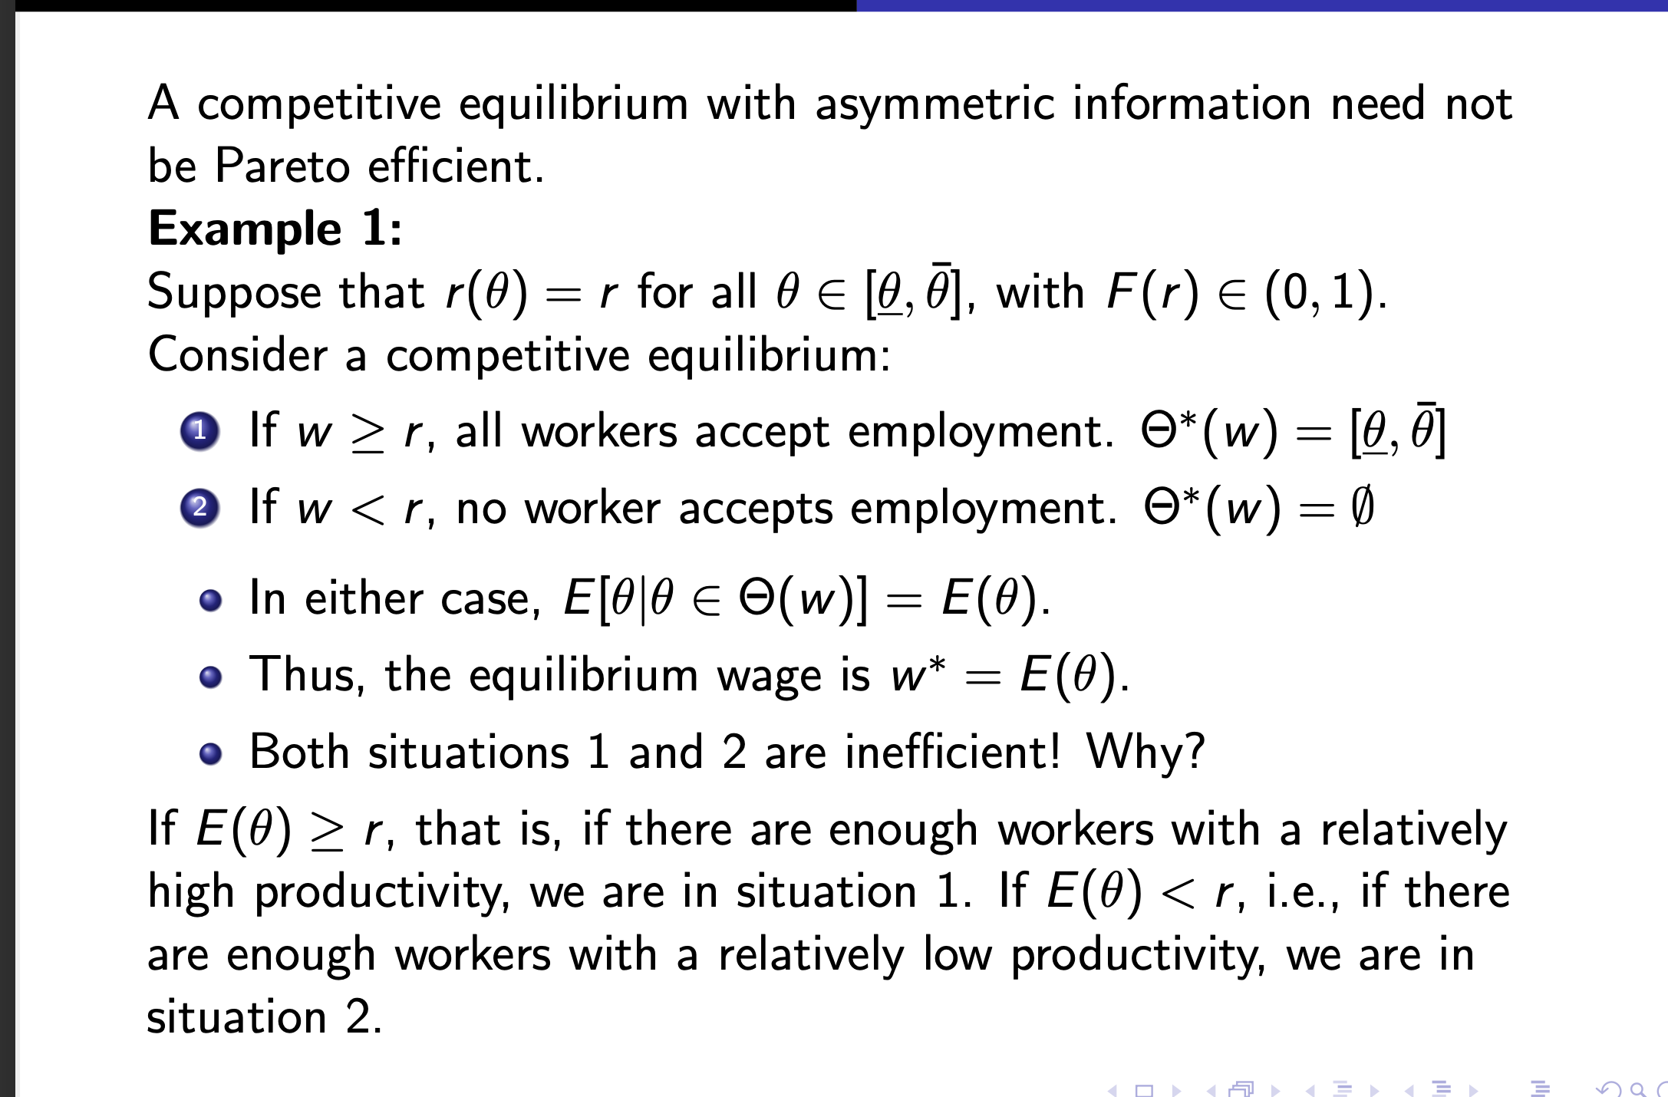
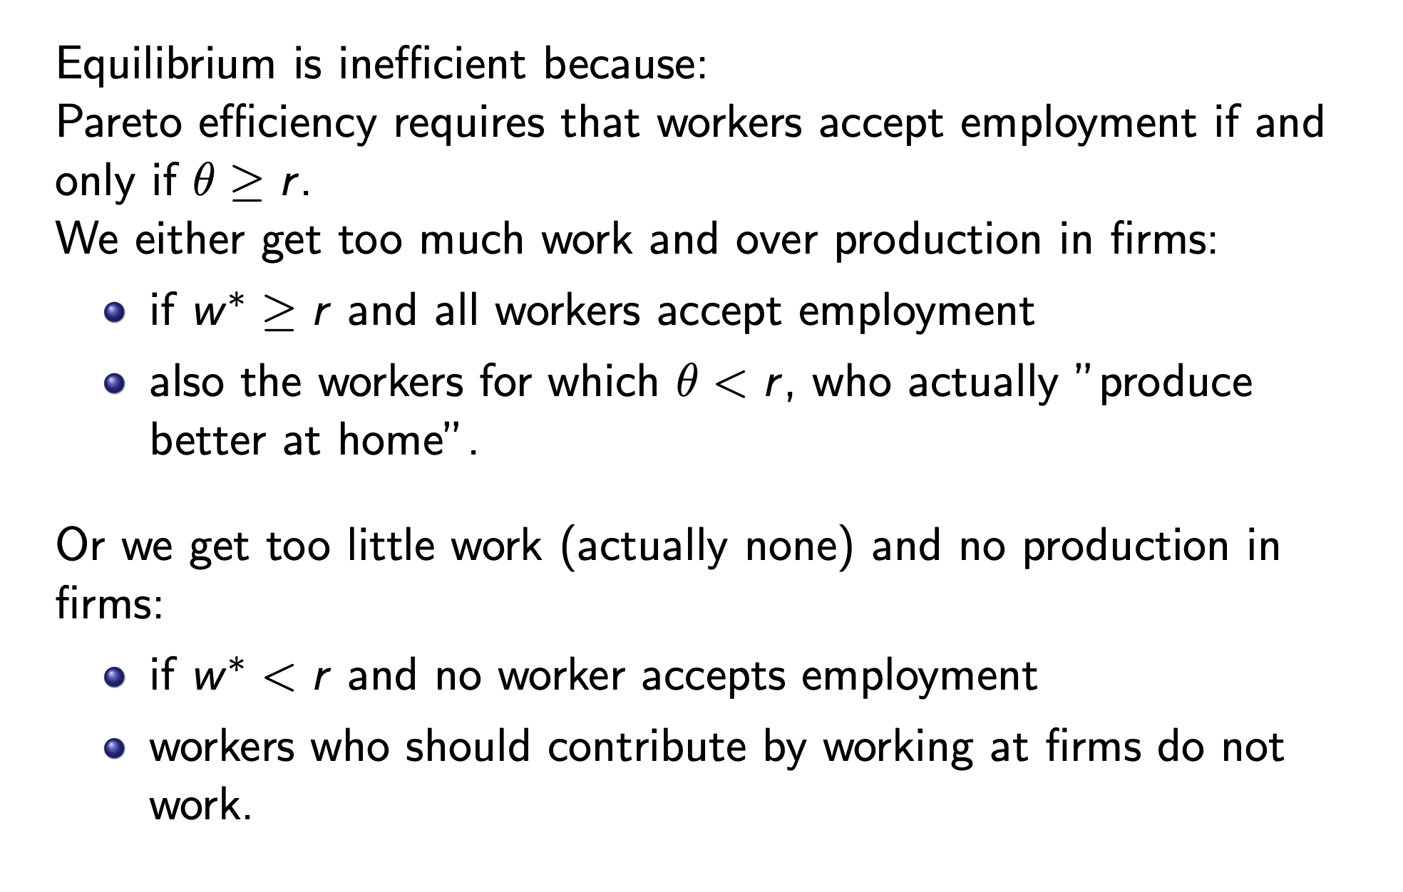
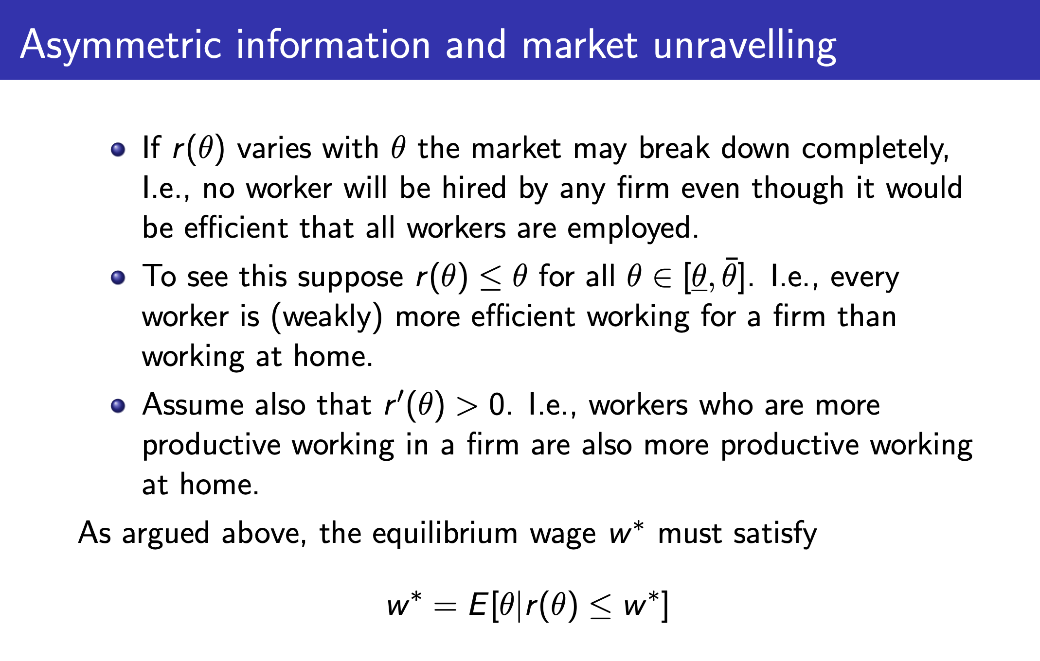
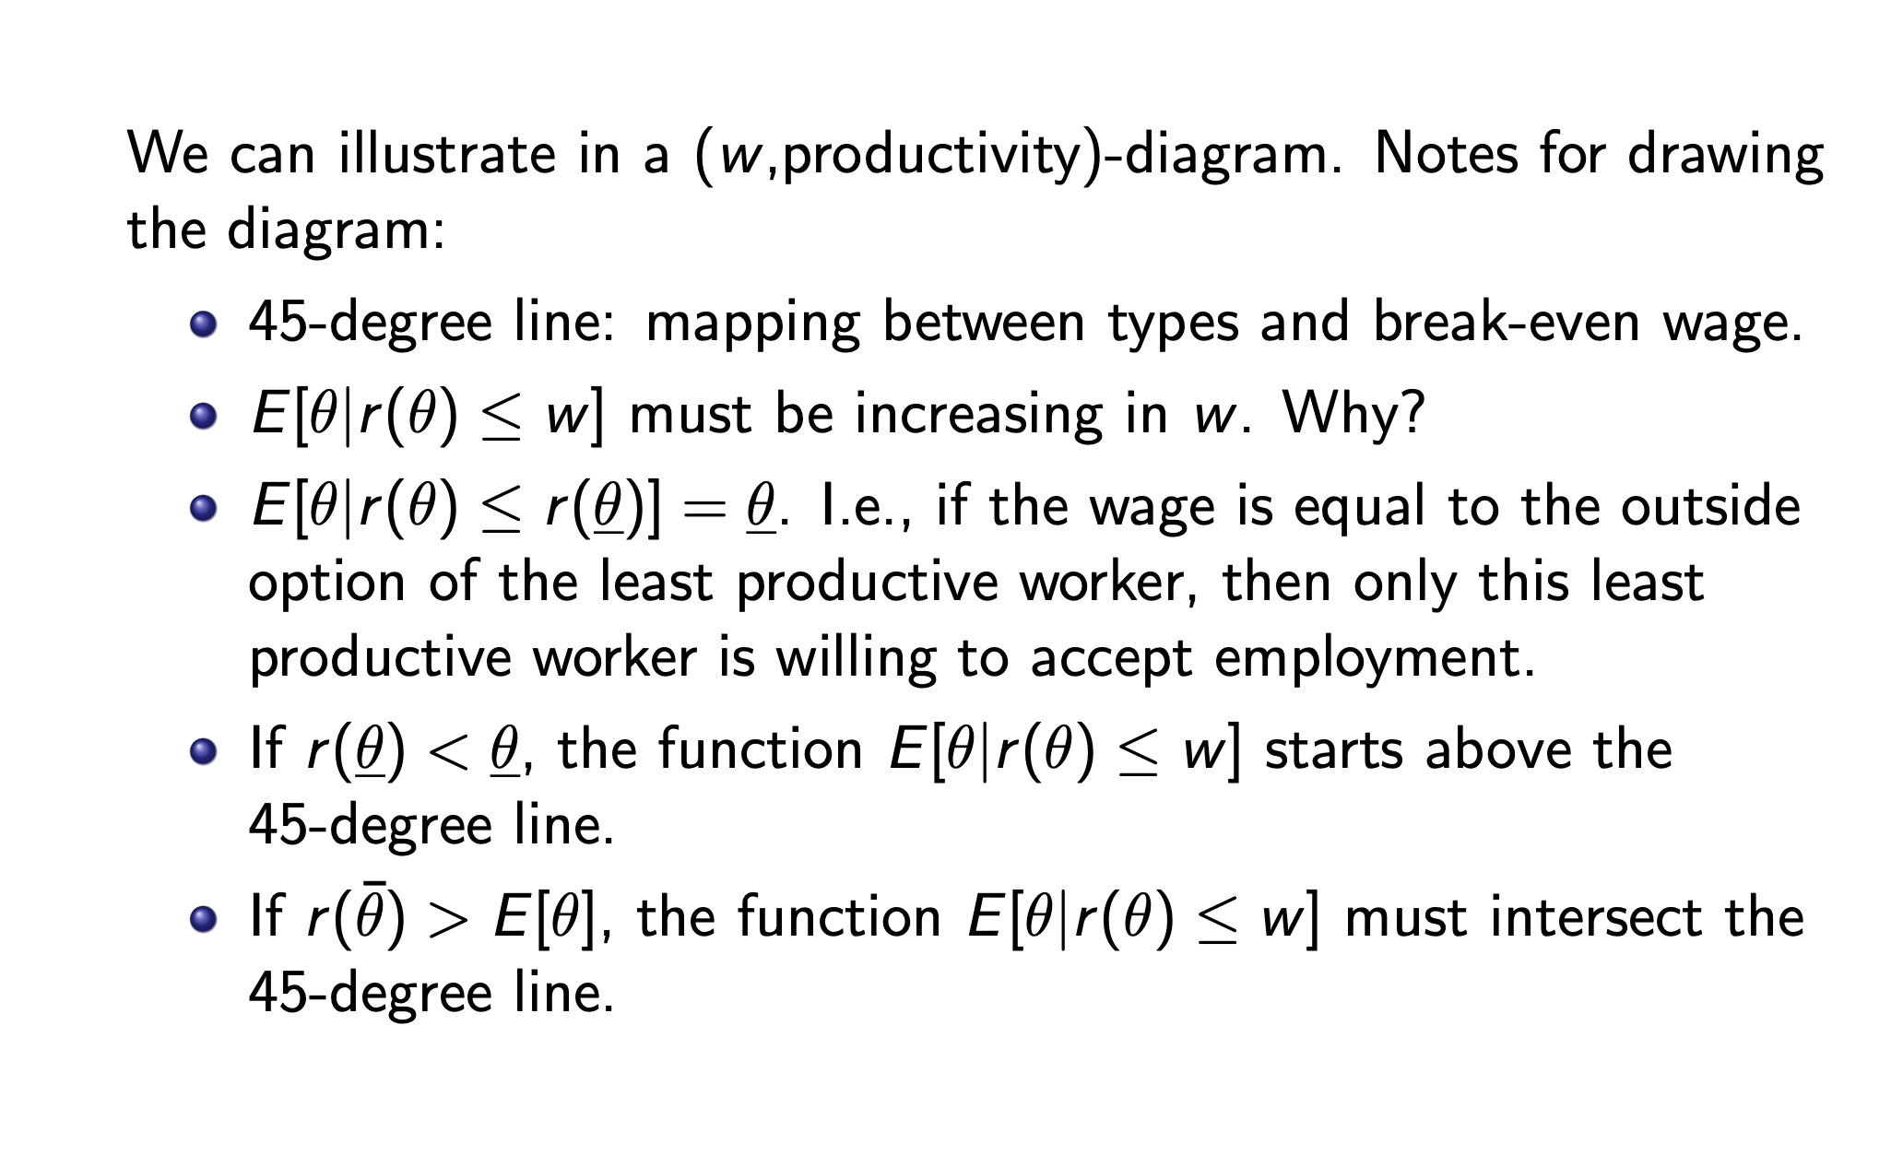
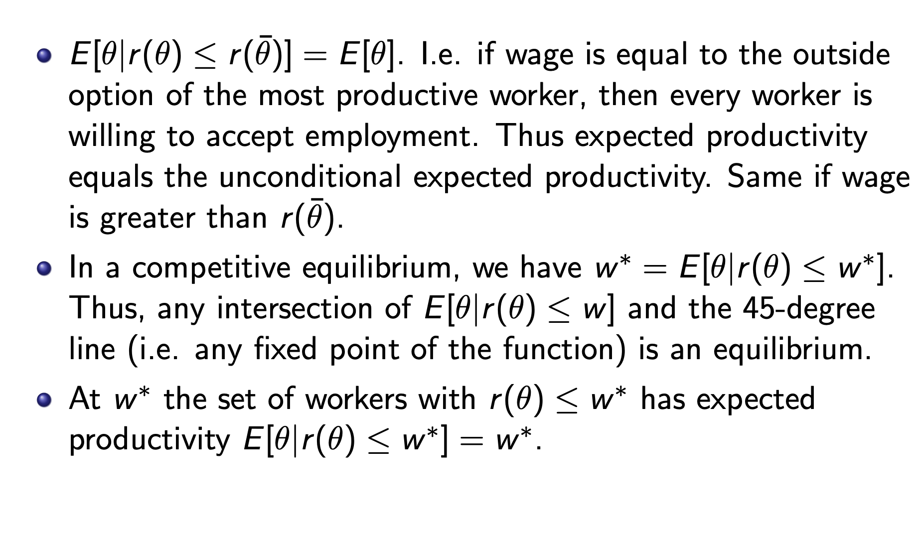
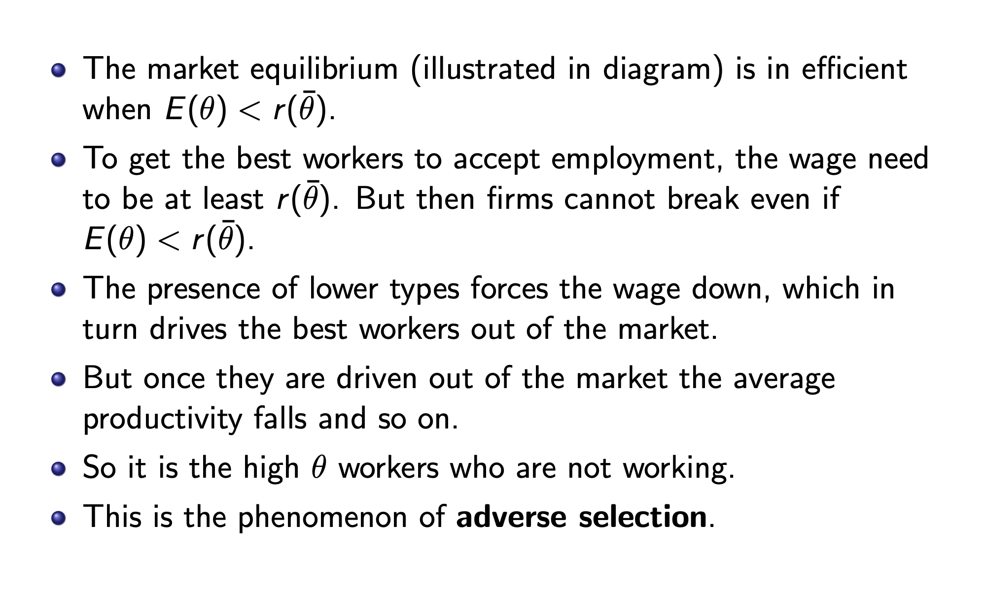
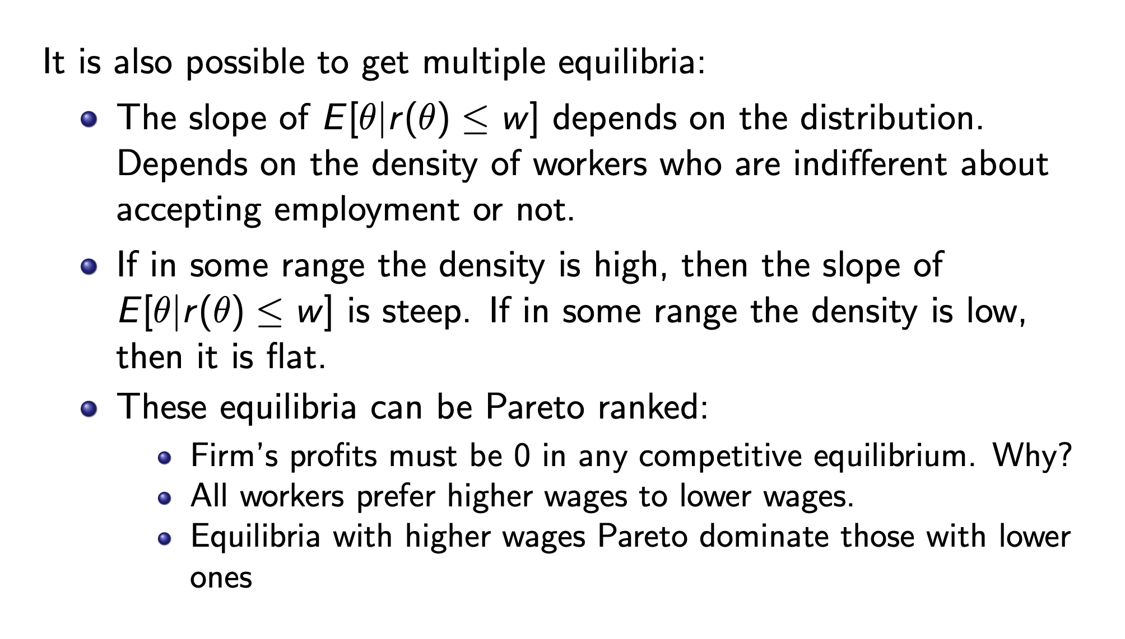

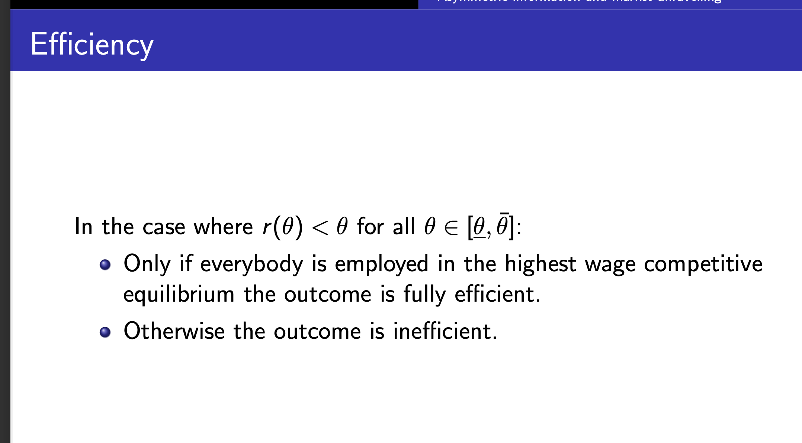
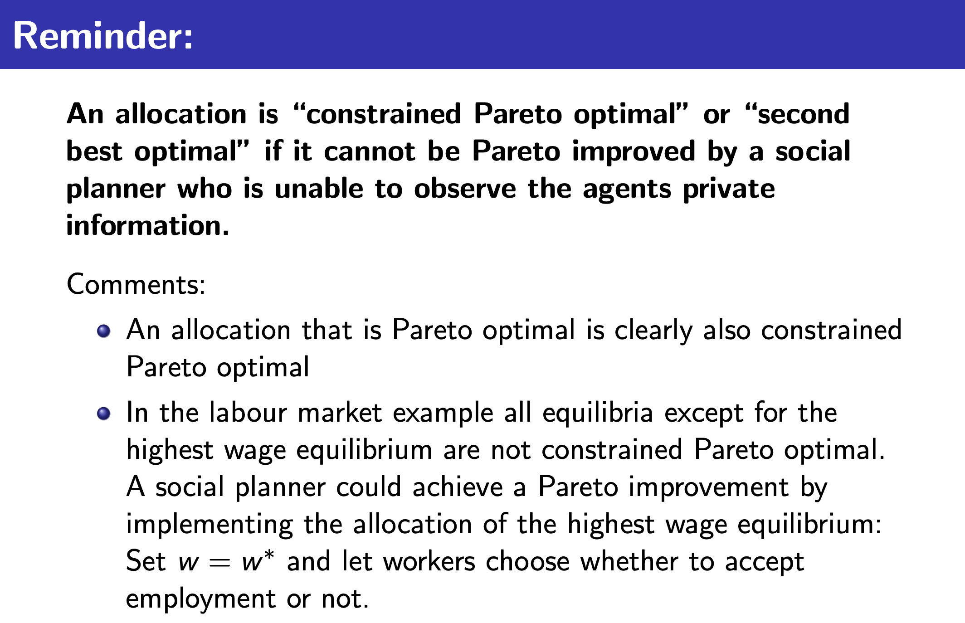
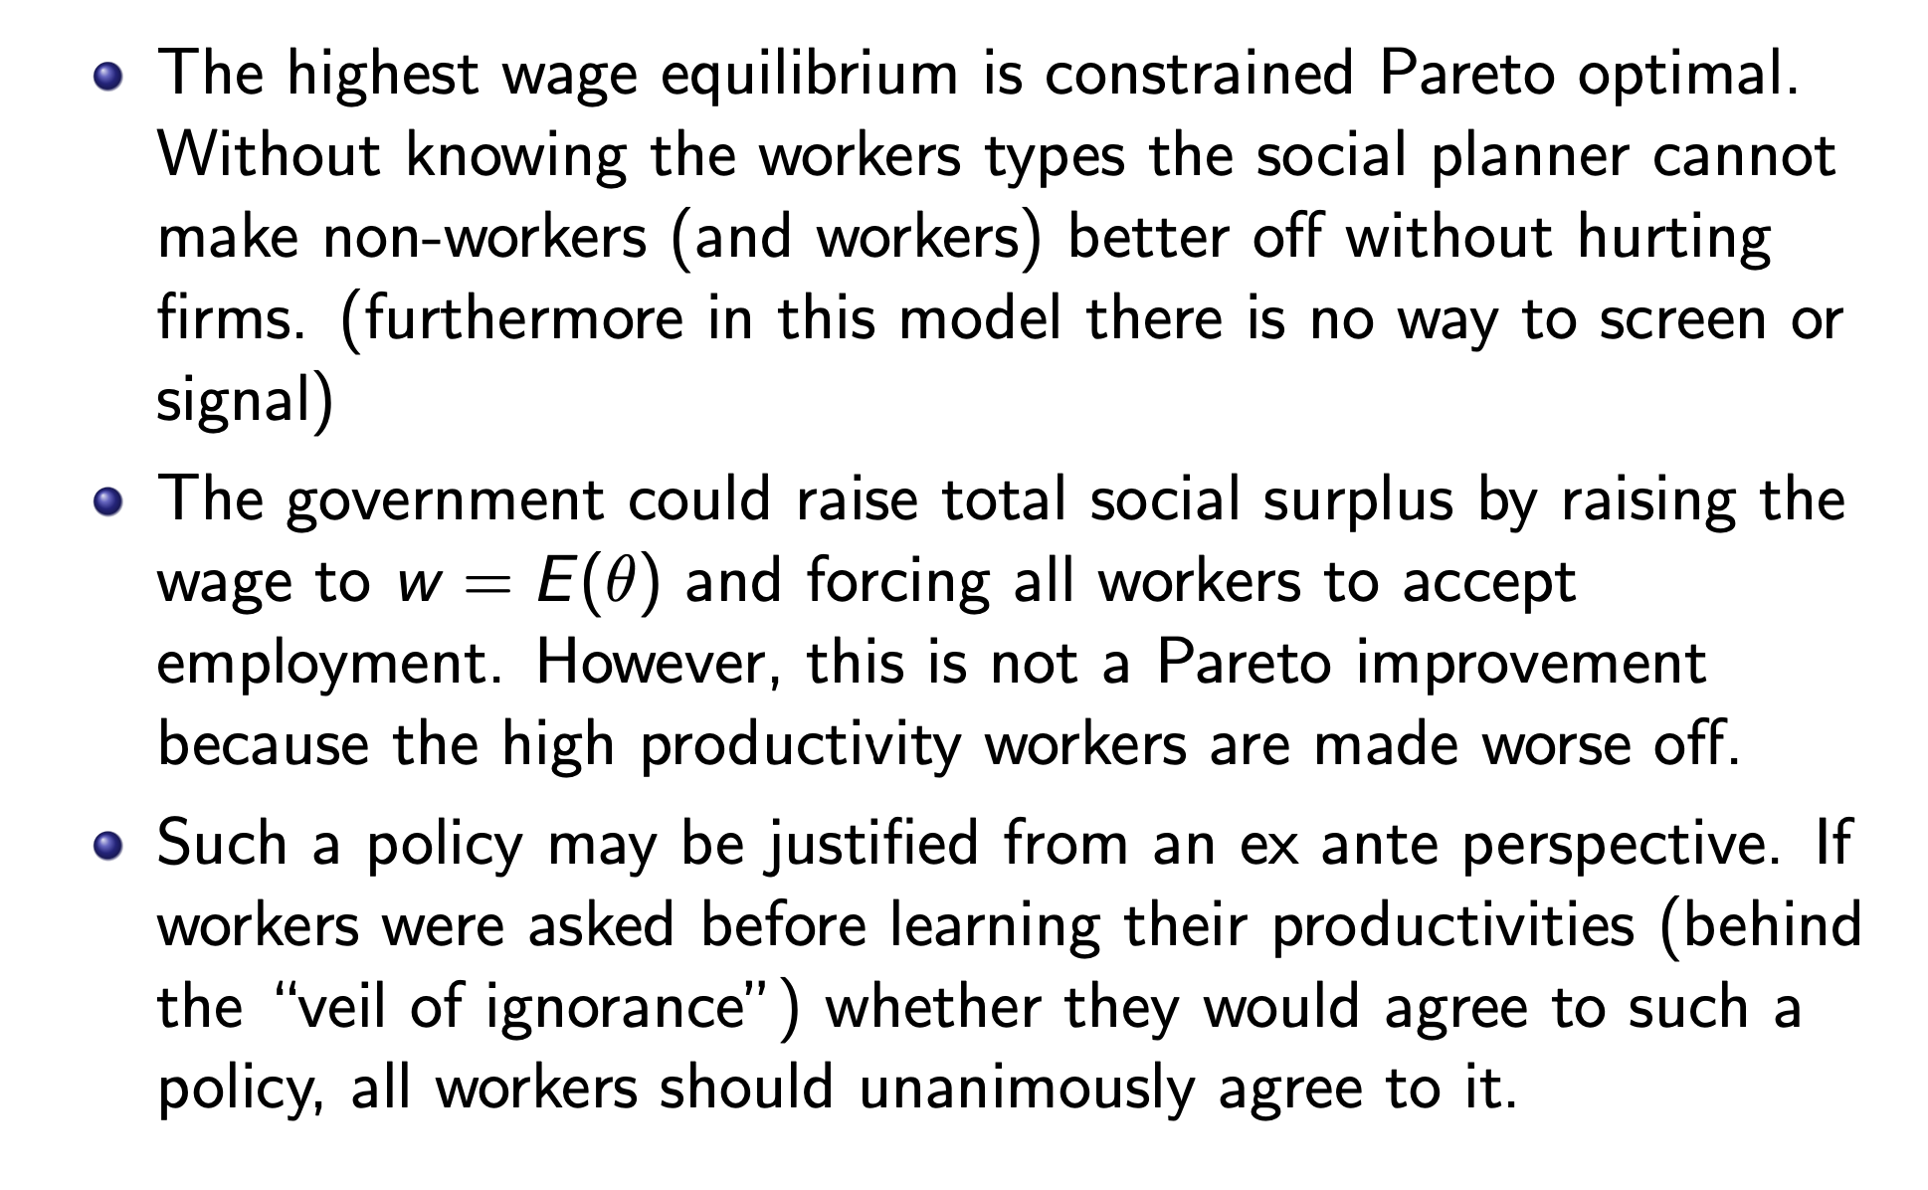

Signaling
Dynamic games of incomplete information thus we need to use PBE(perfect baysian EQ)
Beliefs are important and need to be correct in any EQ
Signalling game: remember
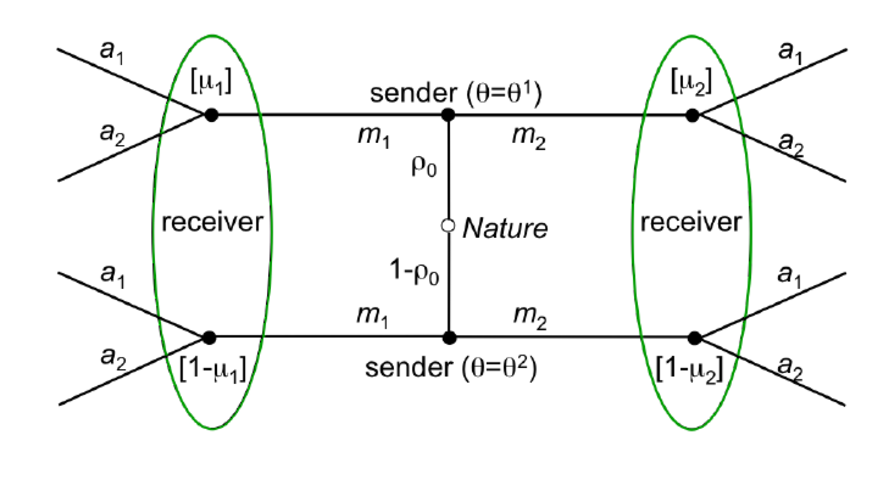

EQ types:
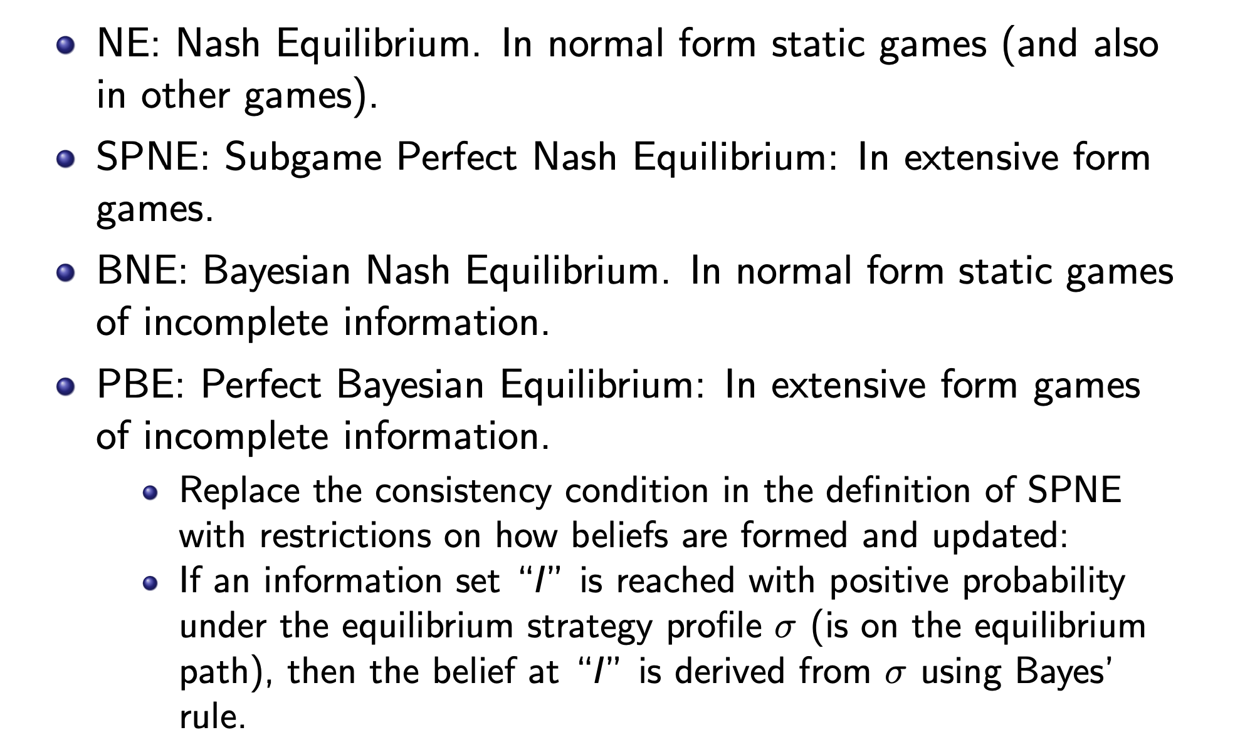

Signaling in labor markets
A single worker can be of 2 types
$$θ_{H}>θ_{L}≥0$$
2 firms for competition
The worker can get an education e which is observable but not directly productive
The worker has outside option $r\left(θ_{H}\right)=r\left(θ_{L}\right)=0$
A workers utility looks like
$$U\left(θ,w,e\right)=w-c\left(e,θ\right)$$
With
$$c\left(0,θ\right)=0∀θ∈Θ$$
$$\frac{∂c}{∂e}(e,θ)>0$$
$$\frac{∂^{2}c}{∂e^{2}}\left(e,θ\right)>0$$
$$c\left(e,θ_{L}\right)>c\left(e,θ_{H}\right)∀e>0$$
$$\frac{∂c}{∂e}\left(e,θ_{L}\right)>\frac{∂c}{∂e}\left(e,θ_{H}\right)∀t>0$$
Which implies the single crossing property between the 2 types indifference curves
$$\overline{u}=w-c\left(e,θ\right)$$
Set $w(e)$ such that this is true
$$\overline{u}=w(e)-c\left(e,θ\right)$$
$$0=\frac{dw}{de}-\frac{∂c}{∂e}\left(e,θ\right)⇔\frac{dw}{de}=\frac{∂c}{∂e}\left(e,θ\right)$$
Since
$$\frac{∂c}{∂e}\left(e,θ_{L}\right)>\frac{∂c}{∂e}\left(e,θ_{H}\right)$$
We know low type has steeper indifference curves thus the single crossing property
A low type needs marginally more wage to take marginally more education
2 firms with utility
$$Π\left(θ,w\right)=θ-w$$
Game:
Nature draws workers type $θ∈\{θ_{H},θ_{L}\}$
The worker learns $θ$ and chooses education level $e≥0$ (the worker signals his type with the level of education)
The firms observe e but not $θ$ the firms simutaniously make a wage offer
The worker takes the highest of the 2 offers and the outside option (he prefers to work, if wages are equal he randomizes 50-50)

In an EQ we need to define strategies
$$e\left(θ\right) and when to accept an offer$$
$$w_{i}\left(e\right) for i=1,2$$

First best
$$w_{i}\left(θ\right)=θ$$
$$e_{i}=0$$
For $i=1,2$
Otherwise firsm increase wage worker will decrease education

2. best
Type is now non observable for the firms
But education is

We denote $μ(θ)$ as the belief of the worker being of high type given education e
When solving the eq we specify how this one looks
PBE
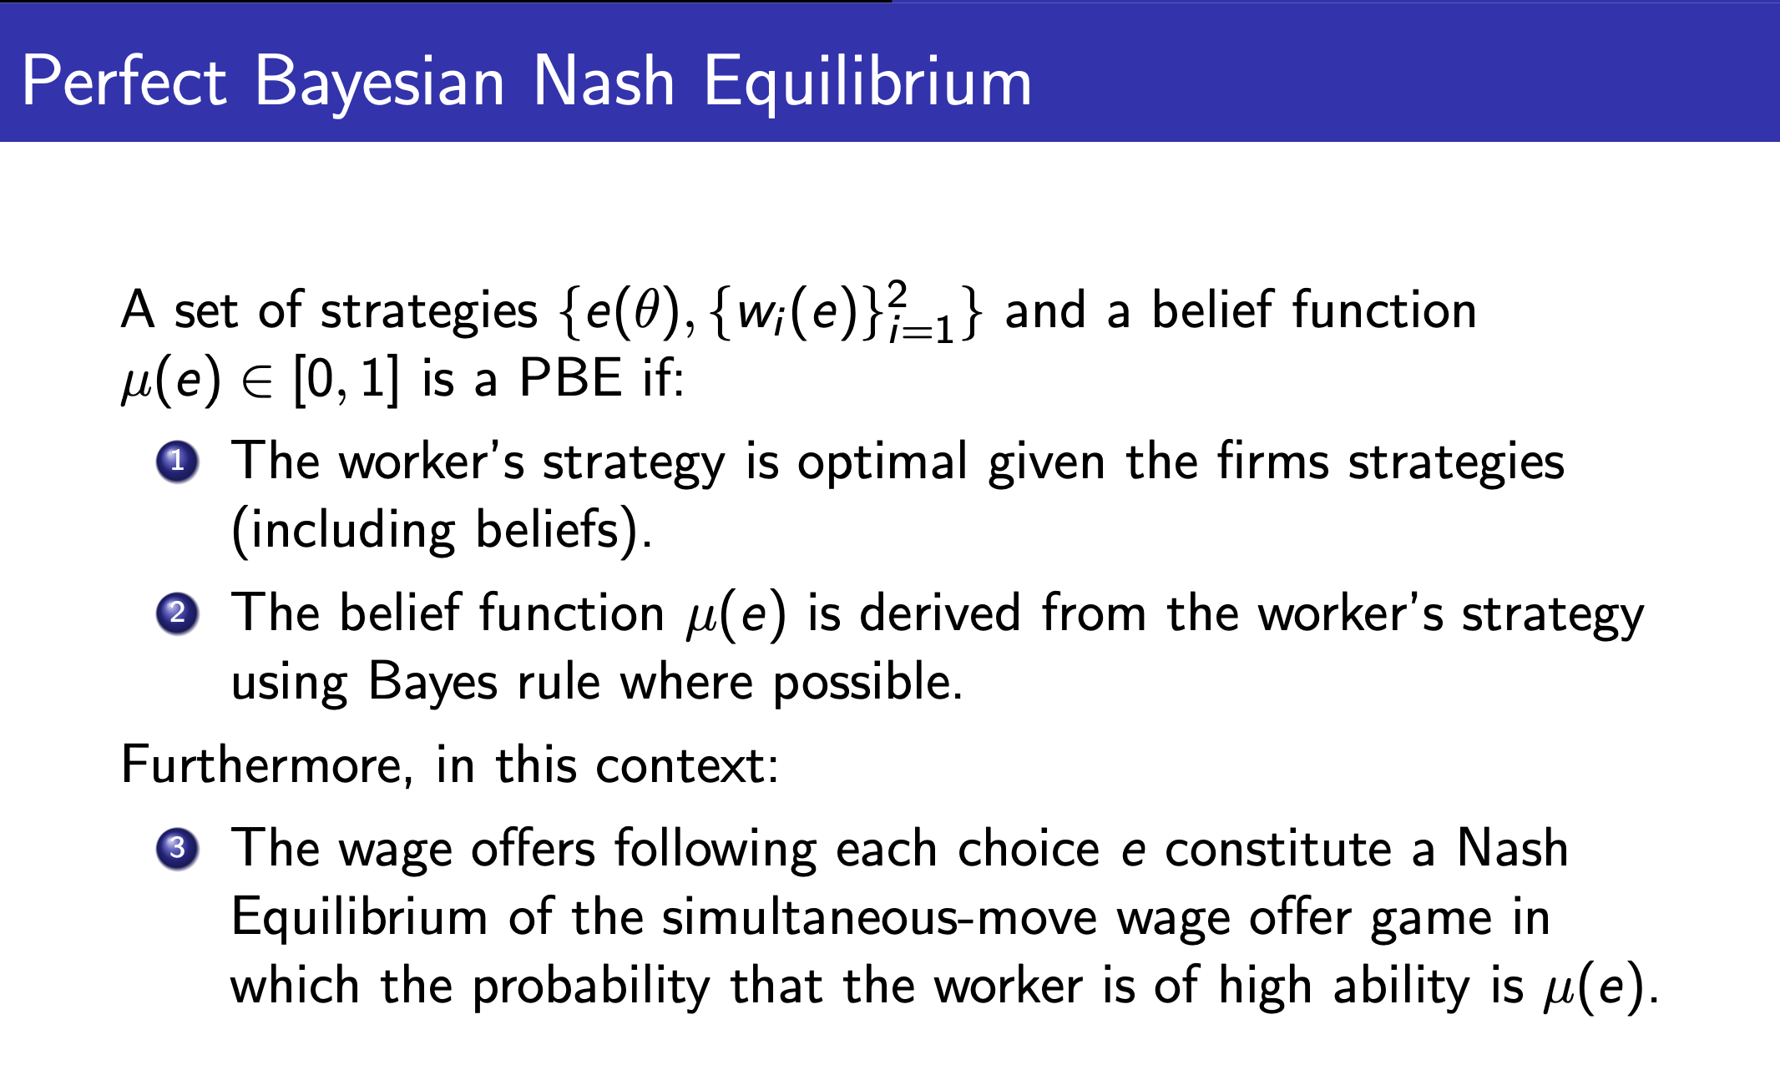
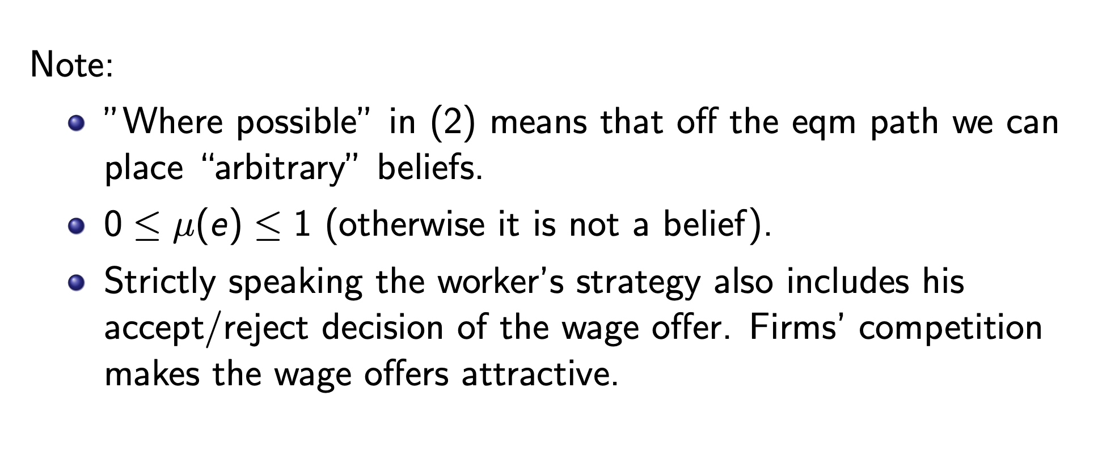
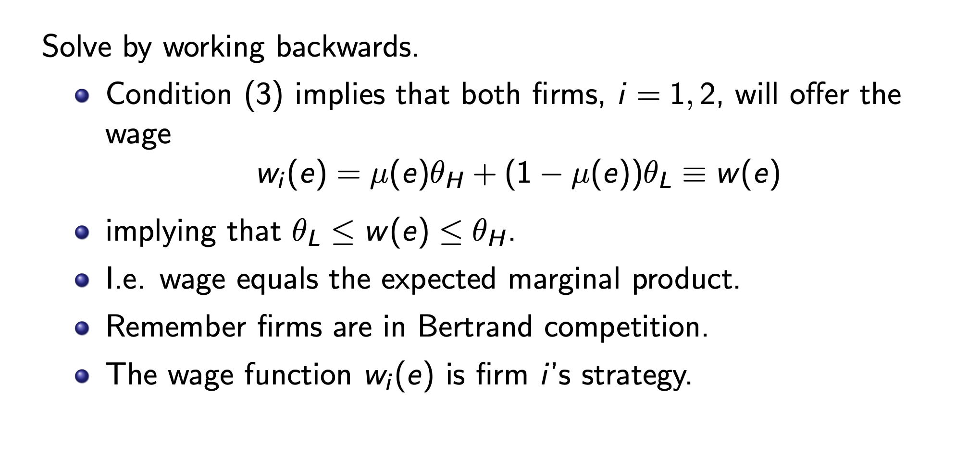

2 types of eq

Seperating: $e^{⋆}\left(θ_{H}\right)≠e^{⋆}(θ_{L})$
Pooling $e^{⋆}\left(θ_{H}\right)=e^{⋆}(θ_{L})$

Seperating:
In any seperating EQ
$$w^{⋆}\left(e^{⋆}\left(θ_{H}\right)\right)=θ_{H}, w^{⋆}\left(e^{⋆}\left(θ_{L}\right)\right)=θ_{L}$$

In any seperating EQ
$$e^{⋆}\left(θ_{L}\right)=0$$

An EQ could be:
With 2 contrancts
$$\left(0,θ_{L}\right),(θ_{H},\hat{e})$$
With

$$θ_{L}=θ_{H}-c(θ_{L},\hat{e})$$
Giving the EQ strategies:
$$e^{⋆}\left(θ\right)=\left\{\begin{aligned}0 if θ=θ_{L} \\ \hat{e} if θ=θ_{H}\end{aligned}\right.$$
For the worker
$$w^{⋆}\left(e\right)=\left\{\begin{aligned}θ_{H} if e≥\hat{e} \\ θ_{L} if e<\hat{e}\end{aligned}\right.$$
For the firms and beliefs
$$μ\left(e\right)=\left\{\begin{aligned}1 if e≥\hat{e} \\ 0 if e<\hat{e}\end{aligned}\right.$$

We can have another EQ
with
$$θ_{L}=θ_{H}-c(θ_{H},e^{'})$$
$$e^{⋆}\left(θ\right)=\left\{\begin{aligned}0 if θ=θ_{L} \\ e^{'} if θ=θ_{H}\end{aligned}\right.$$
$$w^{⋆}\left(e\right)=\left\{\begin{aligned}θ_{H} if e≥e' \\ θ_{L} if e<e'\end{aligned}\right.$$
$$μ\left(e\right)=\left\{\begin{aligned}1 if e≥e' \\ 0 if e<e'\end{aligned}\right.$$

In essence there can be basically
And any $e∈[\hat{e},e^{'}]$ will be a valid EQ
Even for a choosen e there will be infinitely many beliefs $μ$ to support them and thus in essence infinitely many PBE
We can pareto rank these EQ

Any $e>\hat{e}$ is pareto dominated since its strictly worse for the high type withour any benefit to the Principal

Pooling EQ
$\left(e,w\right)=\left(e^{'},E\left[θ\right]\right)$ with$e^{'}∈\left[0,e_{p}\right]$ satisfies $θ_{L}=E\left[θ\right]-c\left(θ_{L},e_{p}\right)$
$$w\left(e\right)=\left\{\begin{aligned}E\left[θ\right] if e≥e' \\ θ_{L} if e<e'\end{aligned}\right.$$
$$μ\left(e\right)=\left\{\begin{aligned}λ if e≥e' \\ 0 if e<e'\end{aligned}\right.$$

Welfare compared:
Signaling is never Pareto since it only looses utility
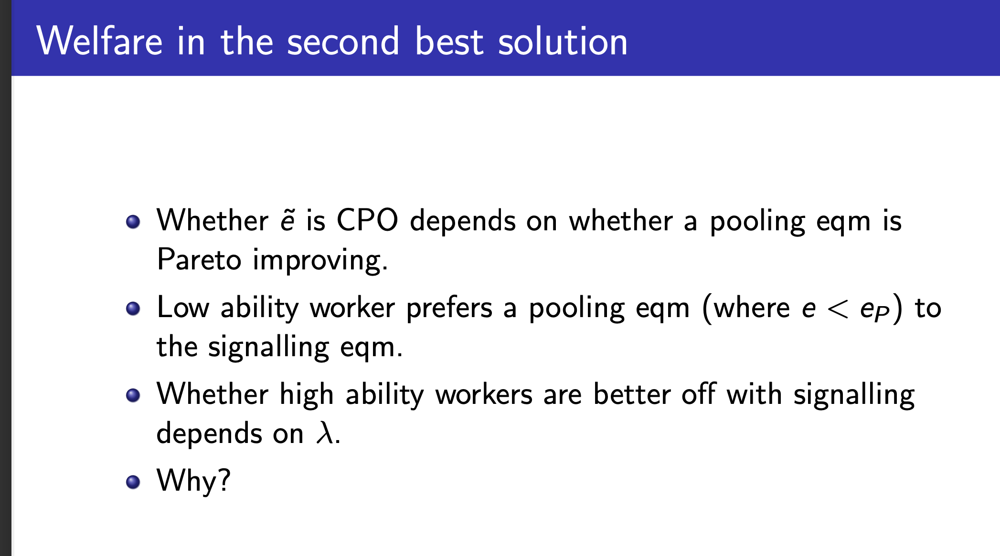
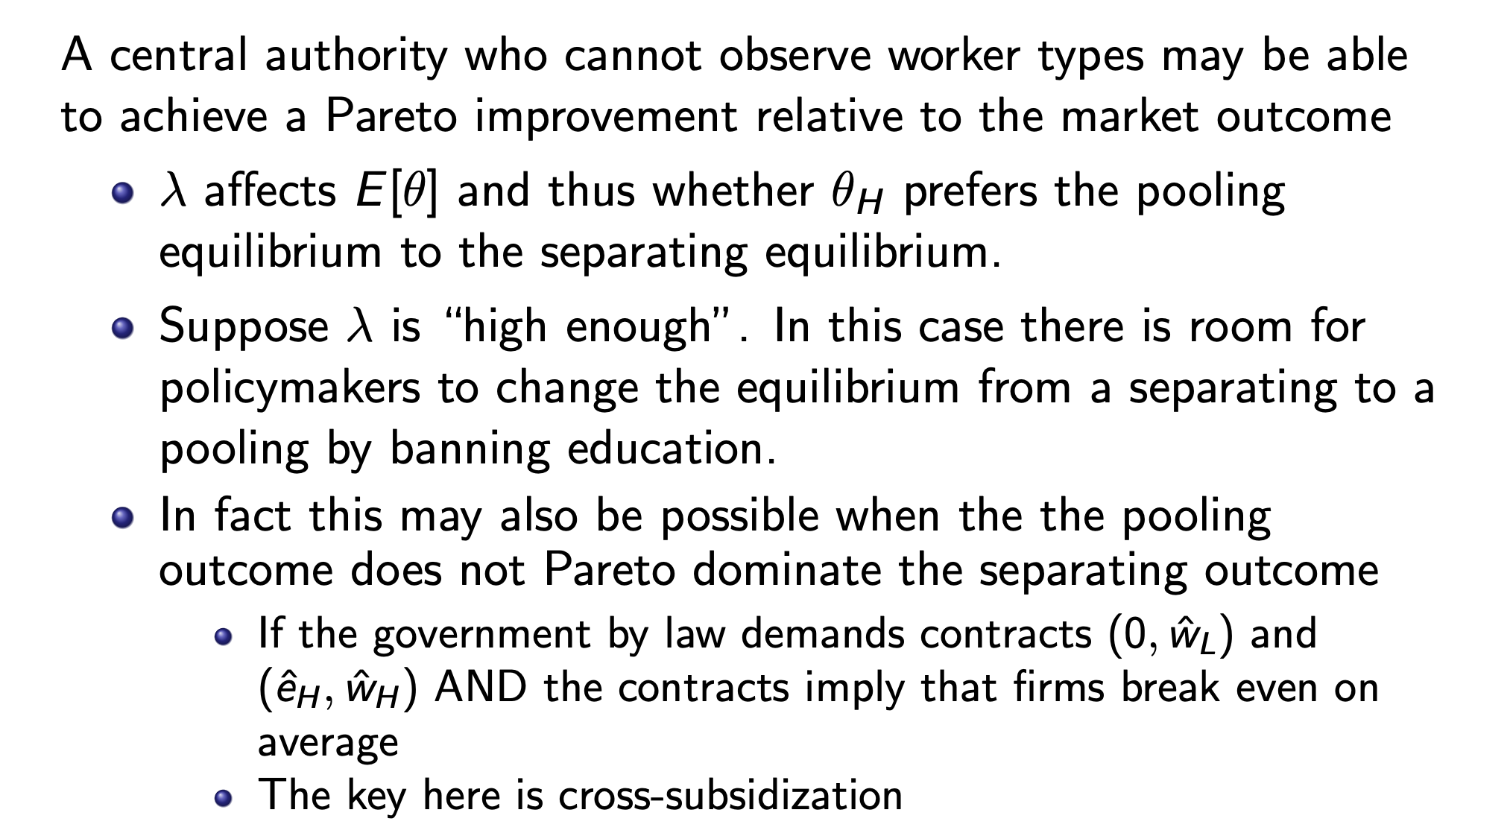

Refinements:
Dominance criterion
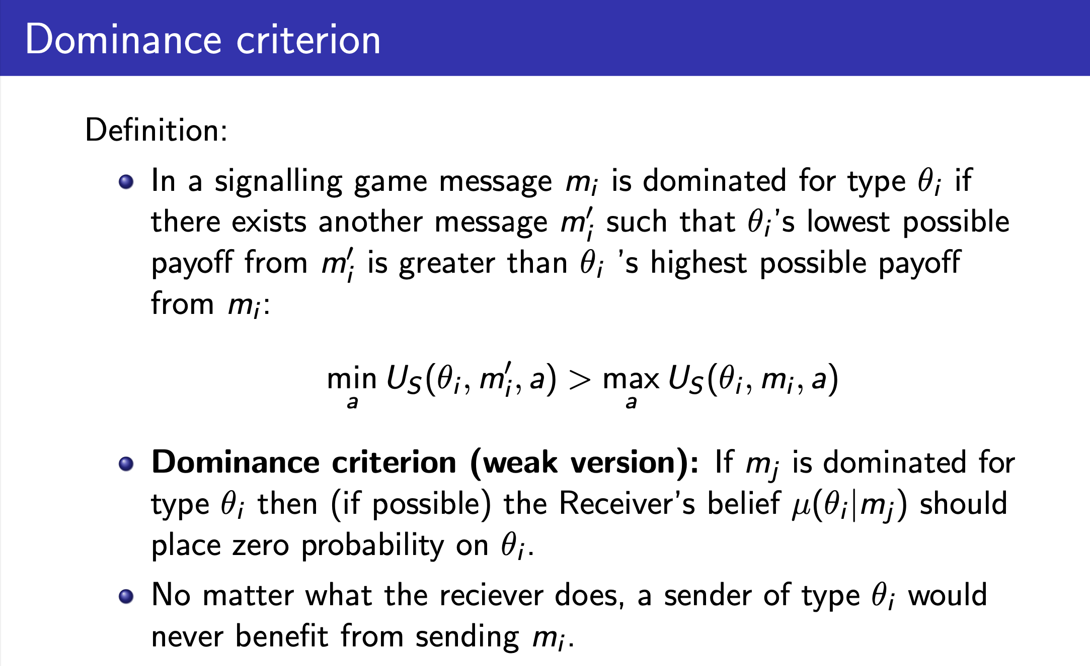
Its basically just saying that the player will never take a dominated action and that this is reflected in the firms beliefs

If we have 2 players and $m_{j}>m_{i}$ for player 1 but not player 2 then
$$μ\left(θ_{1} | m_{i}\right)=0$$
If both are dominated or none dominated the criterion says nothing

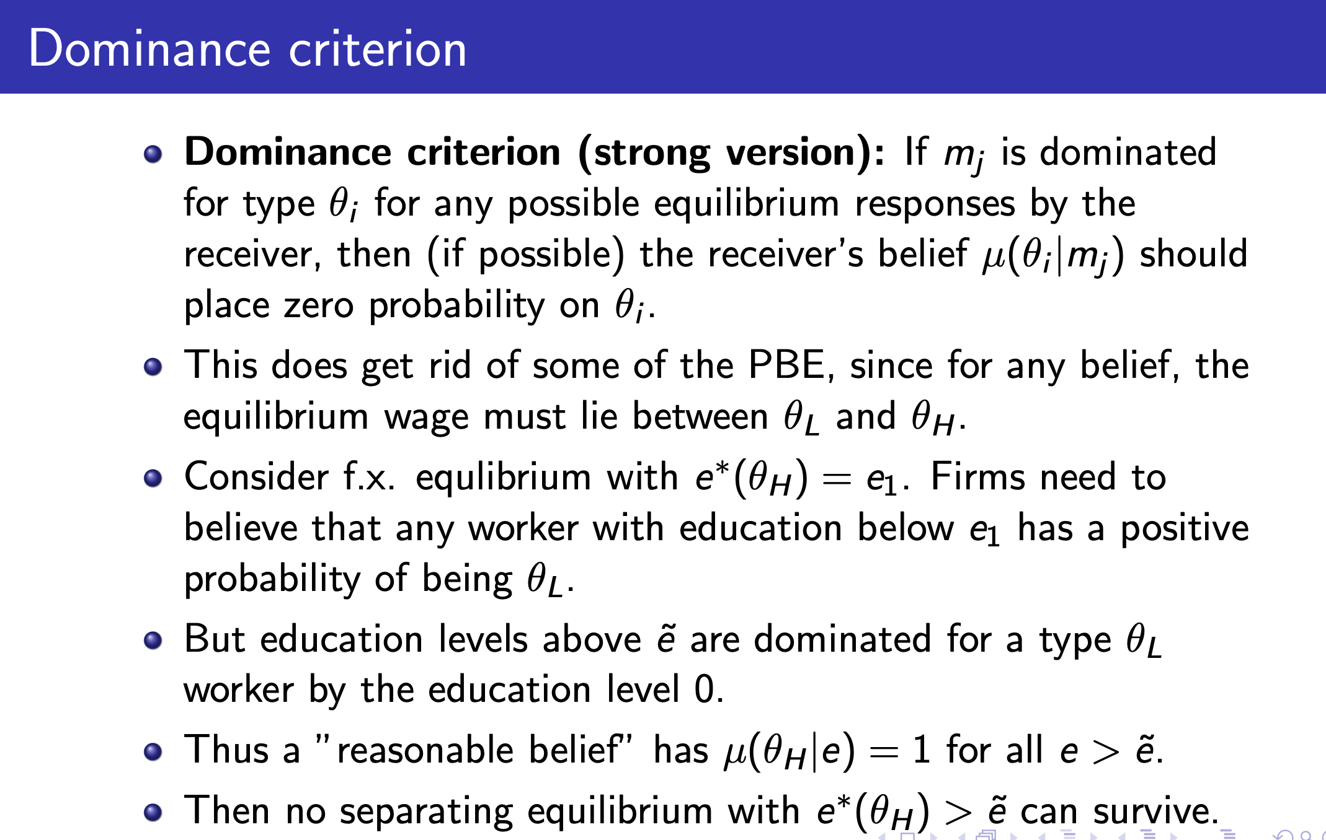

Intuitive criterion:
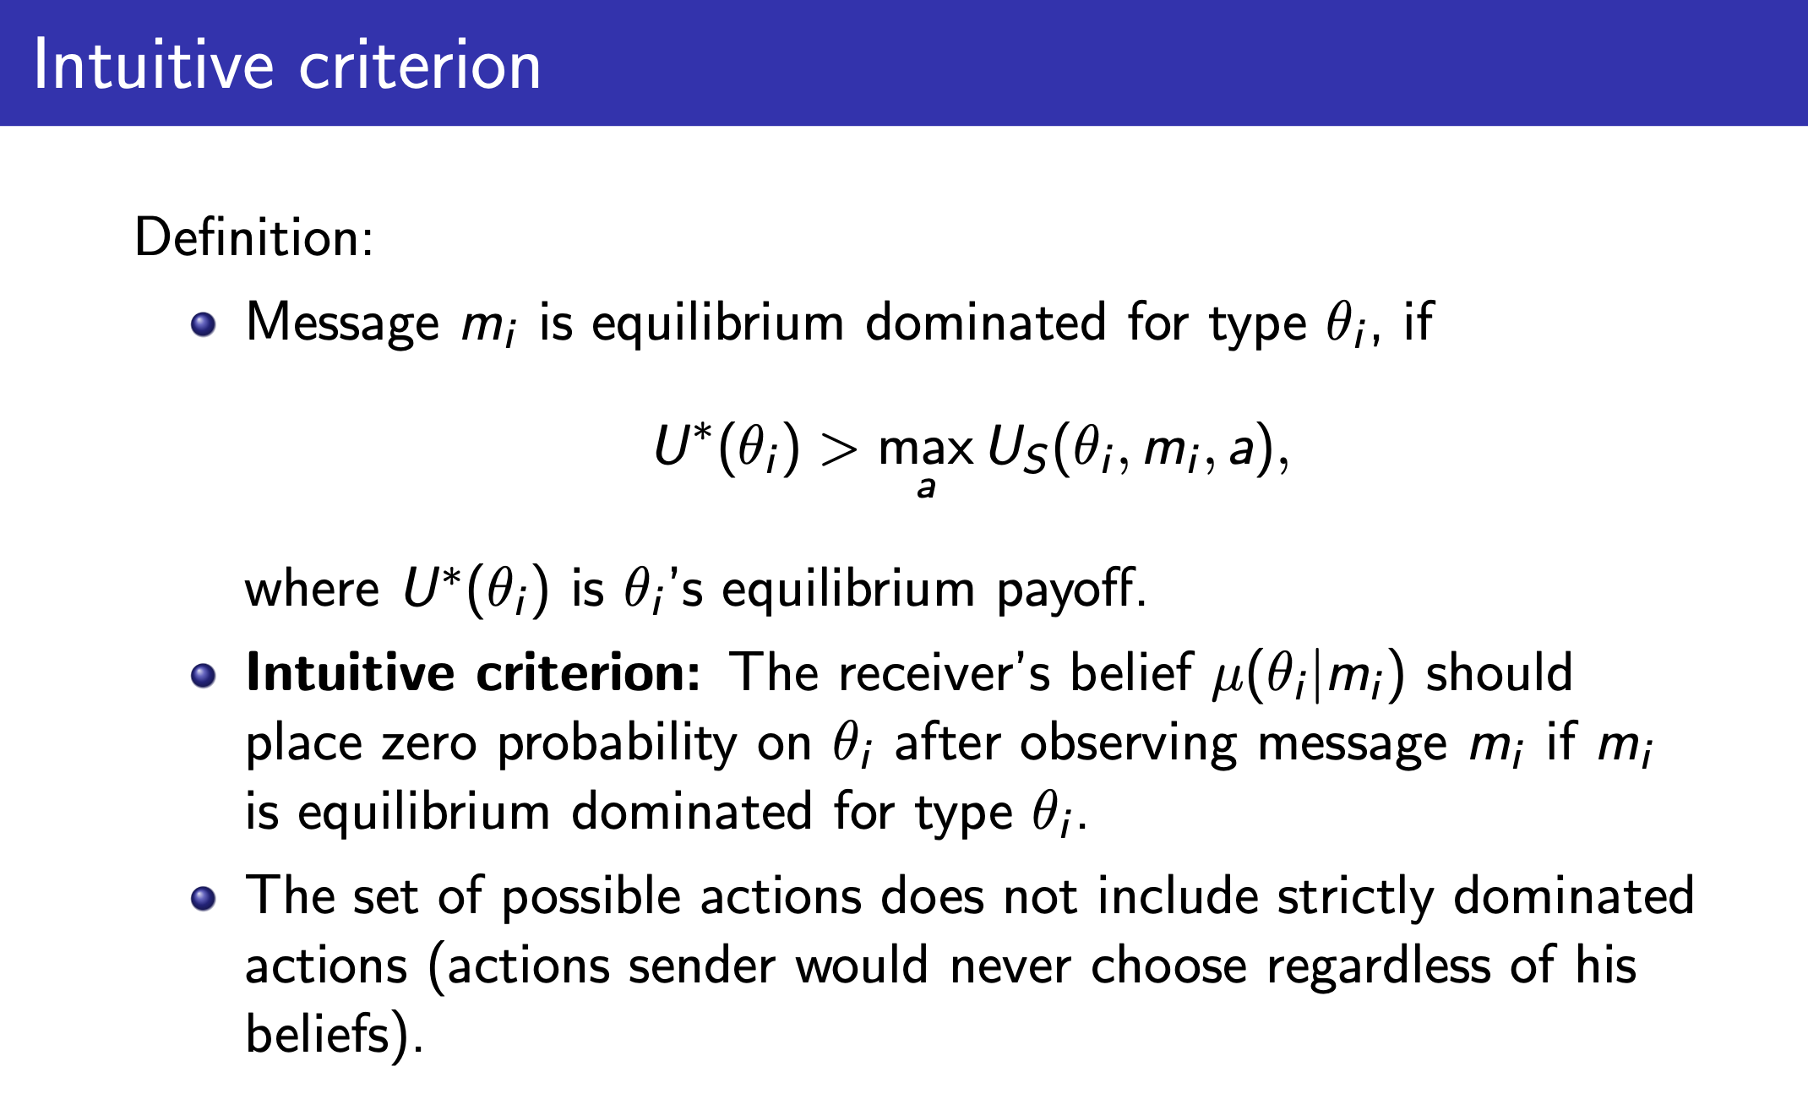
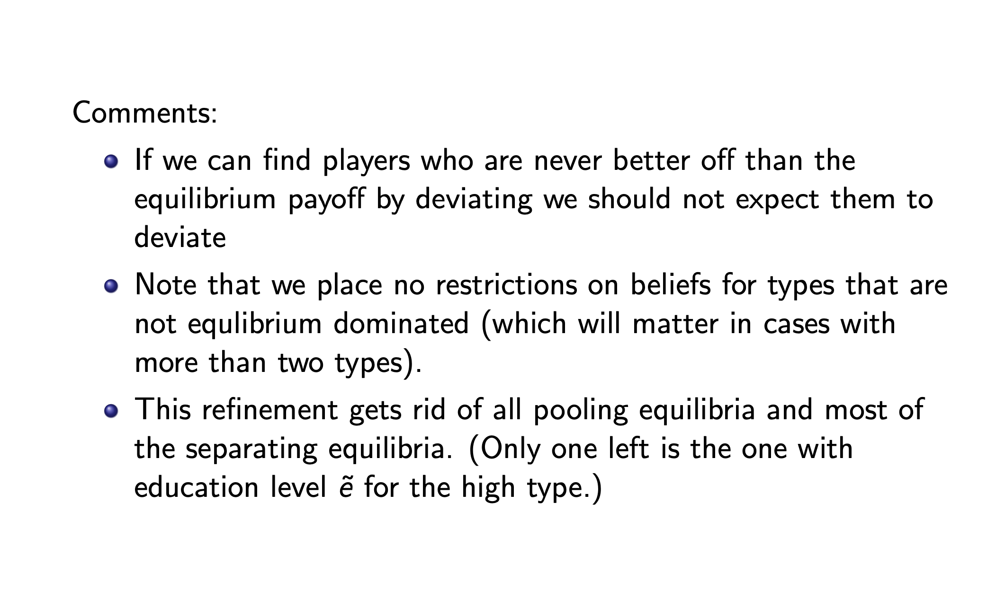

Signaling in financial markets

Setup:
Firms and investors are all risk neutral
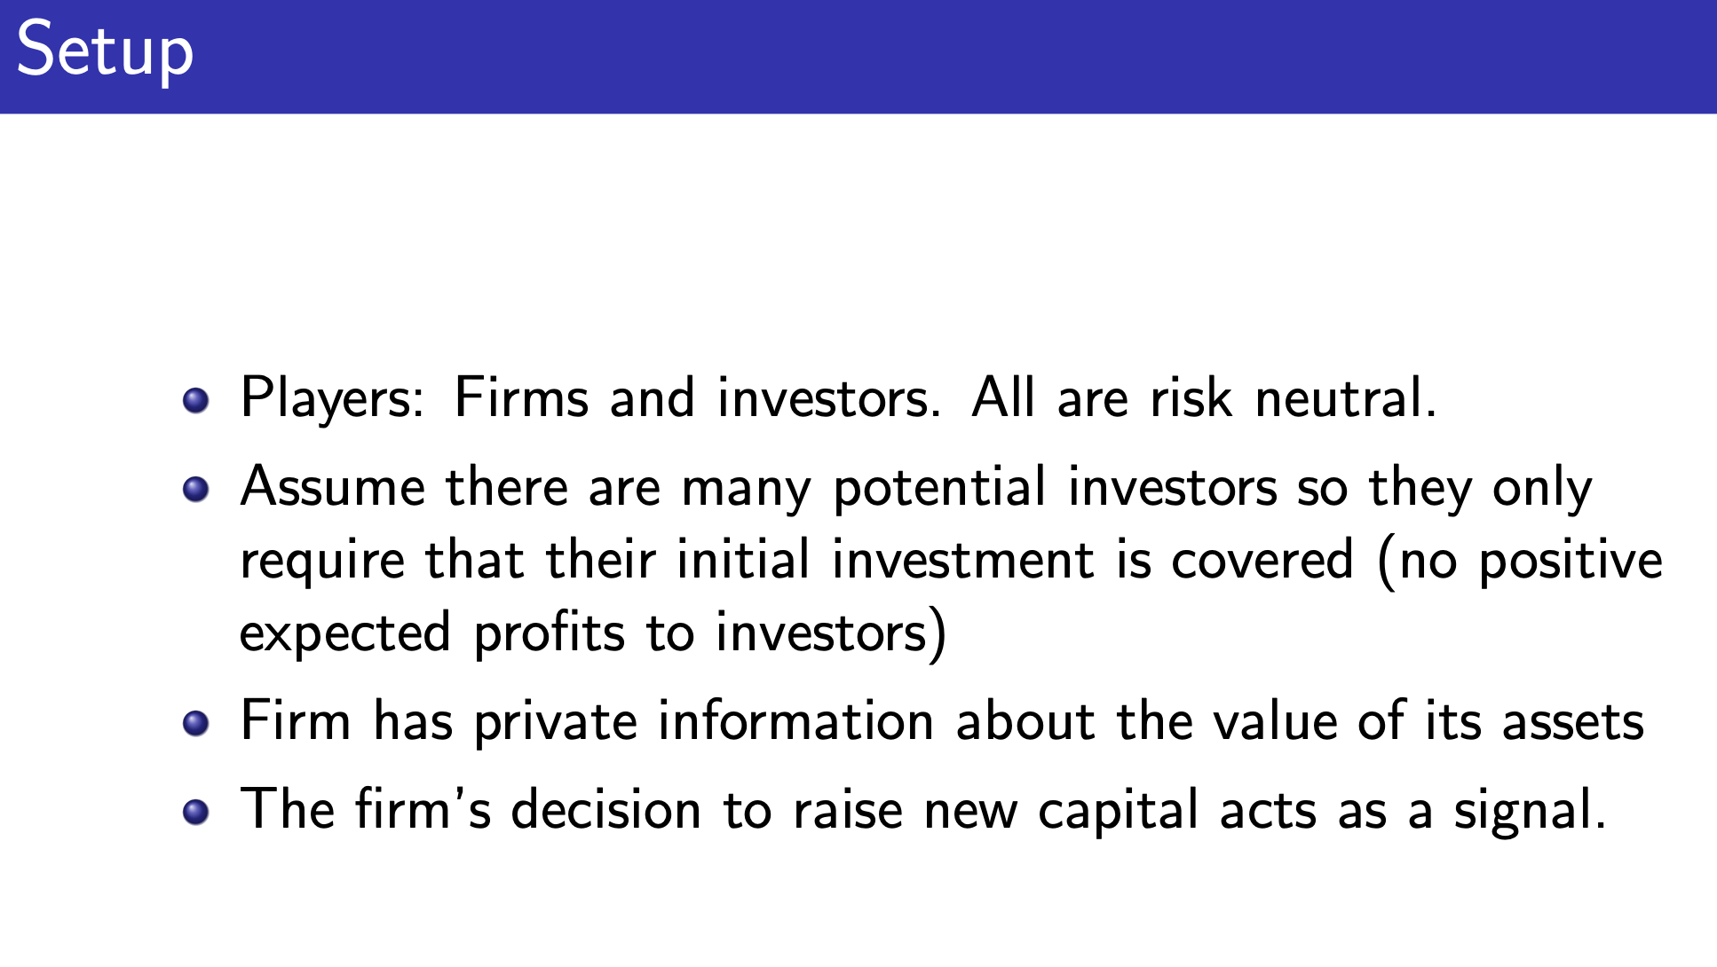
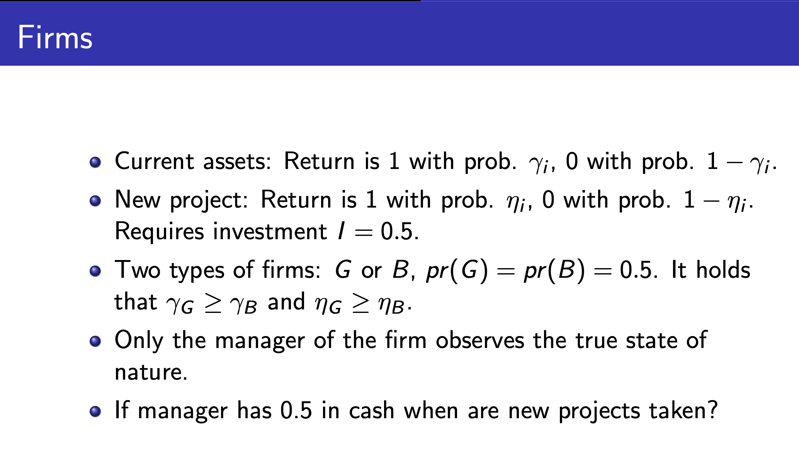
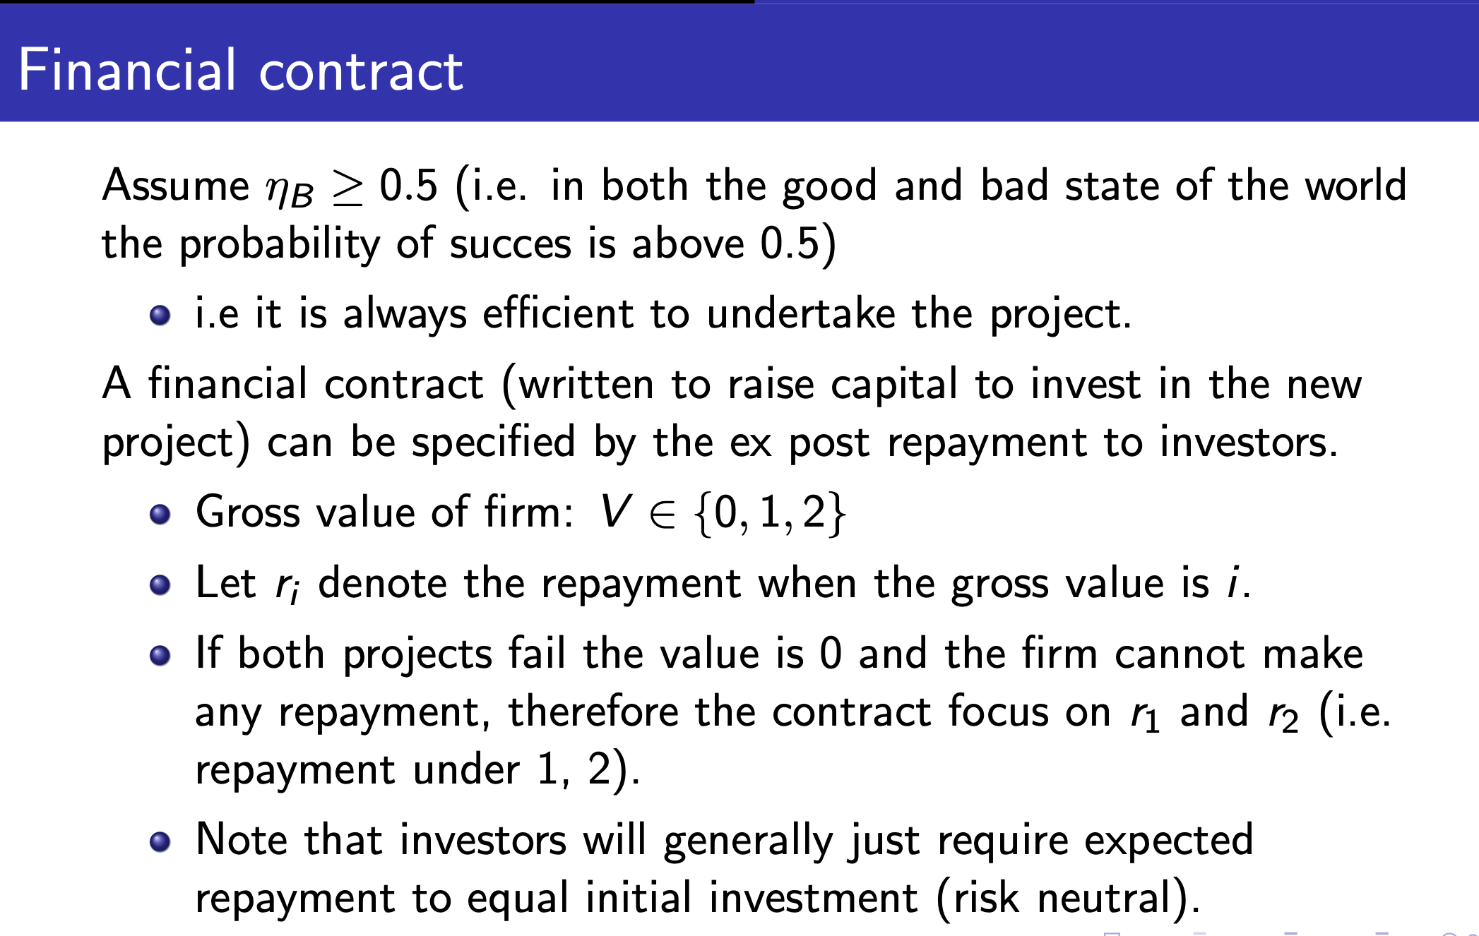
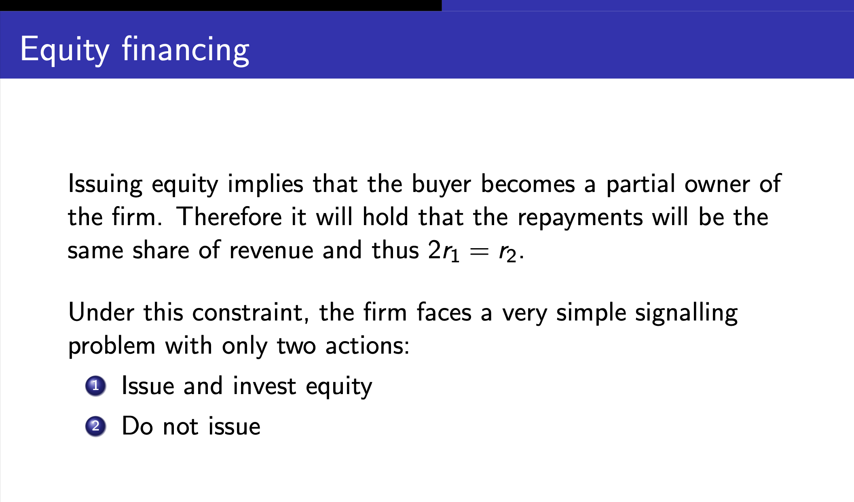
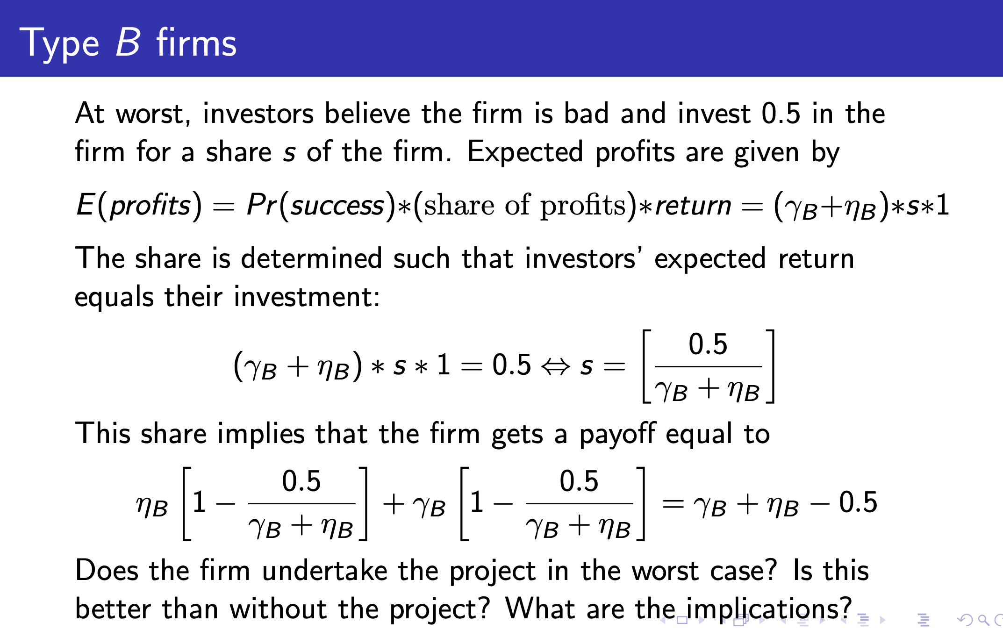
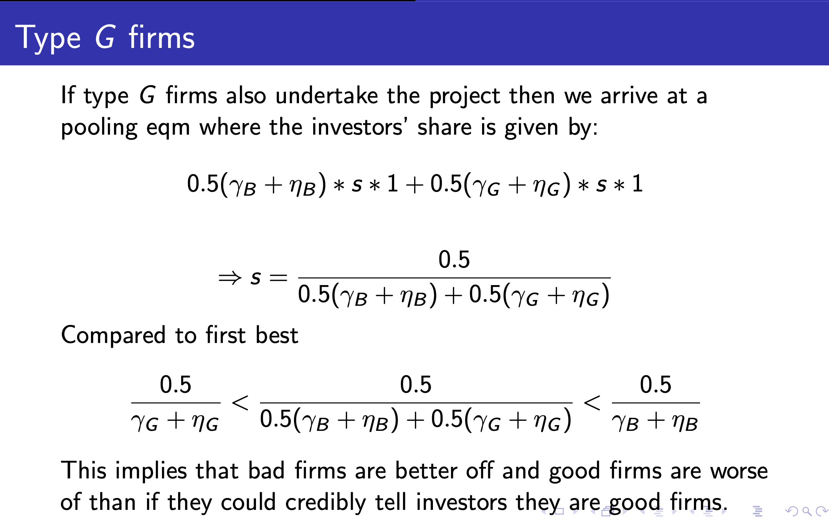
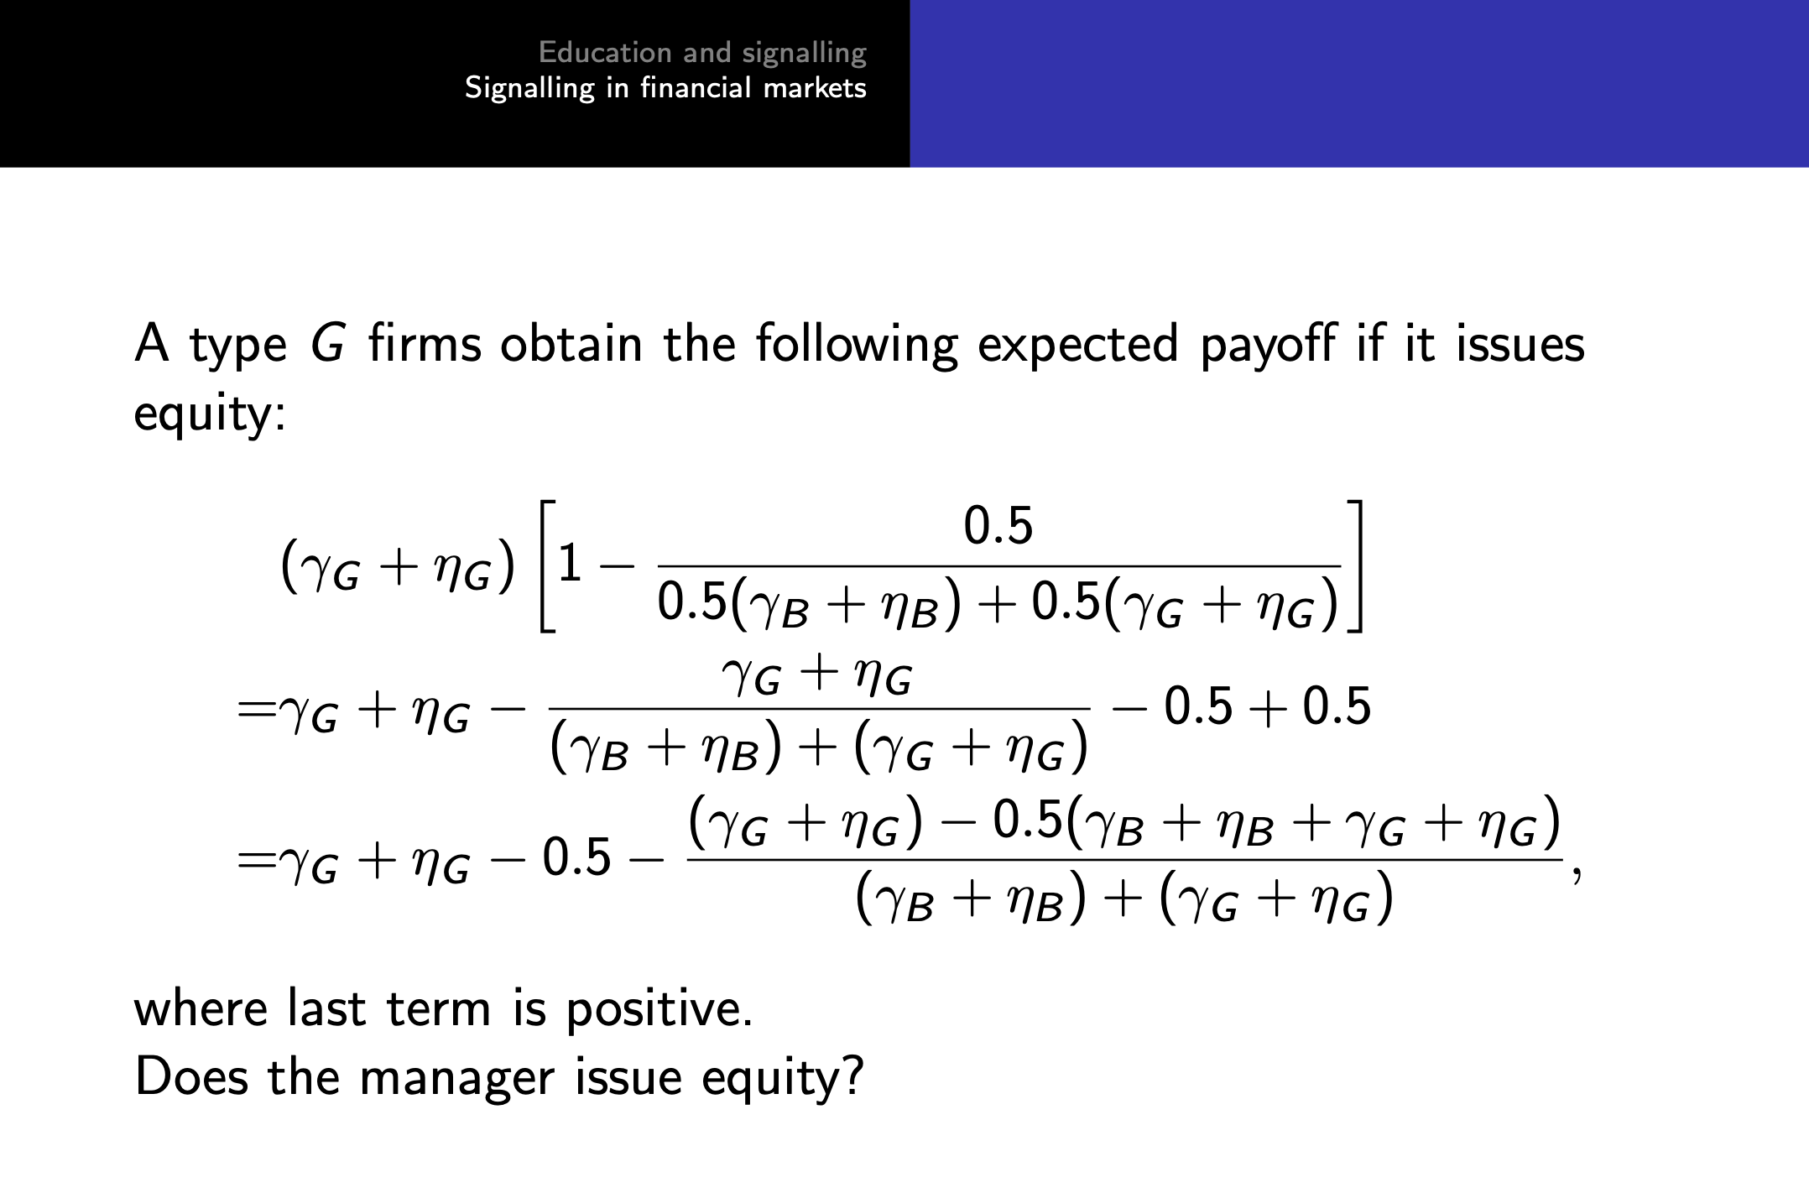
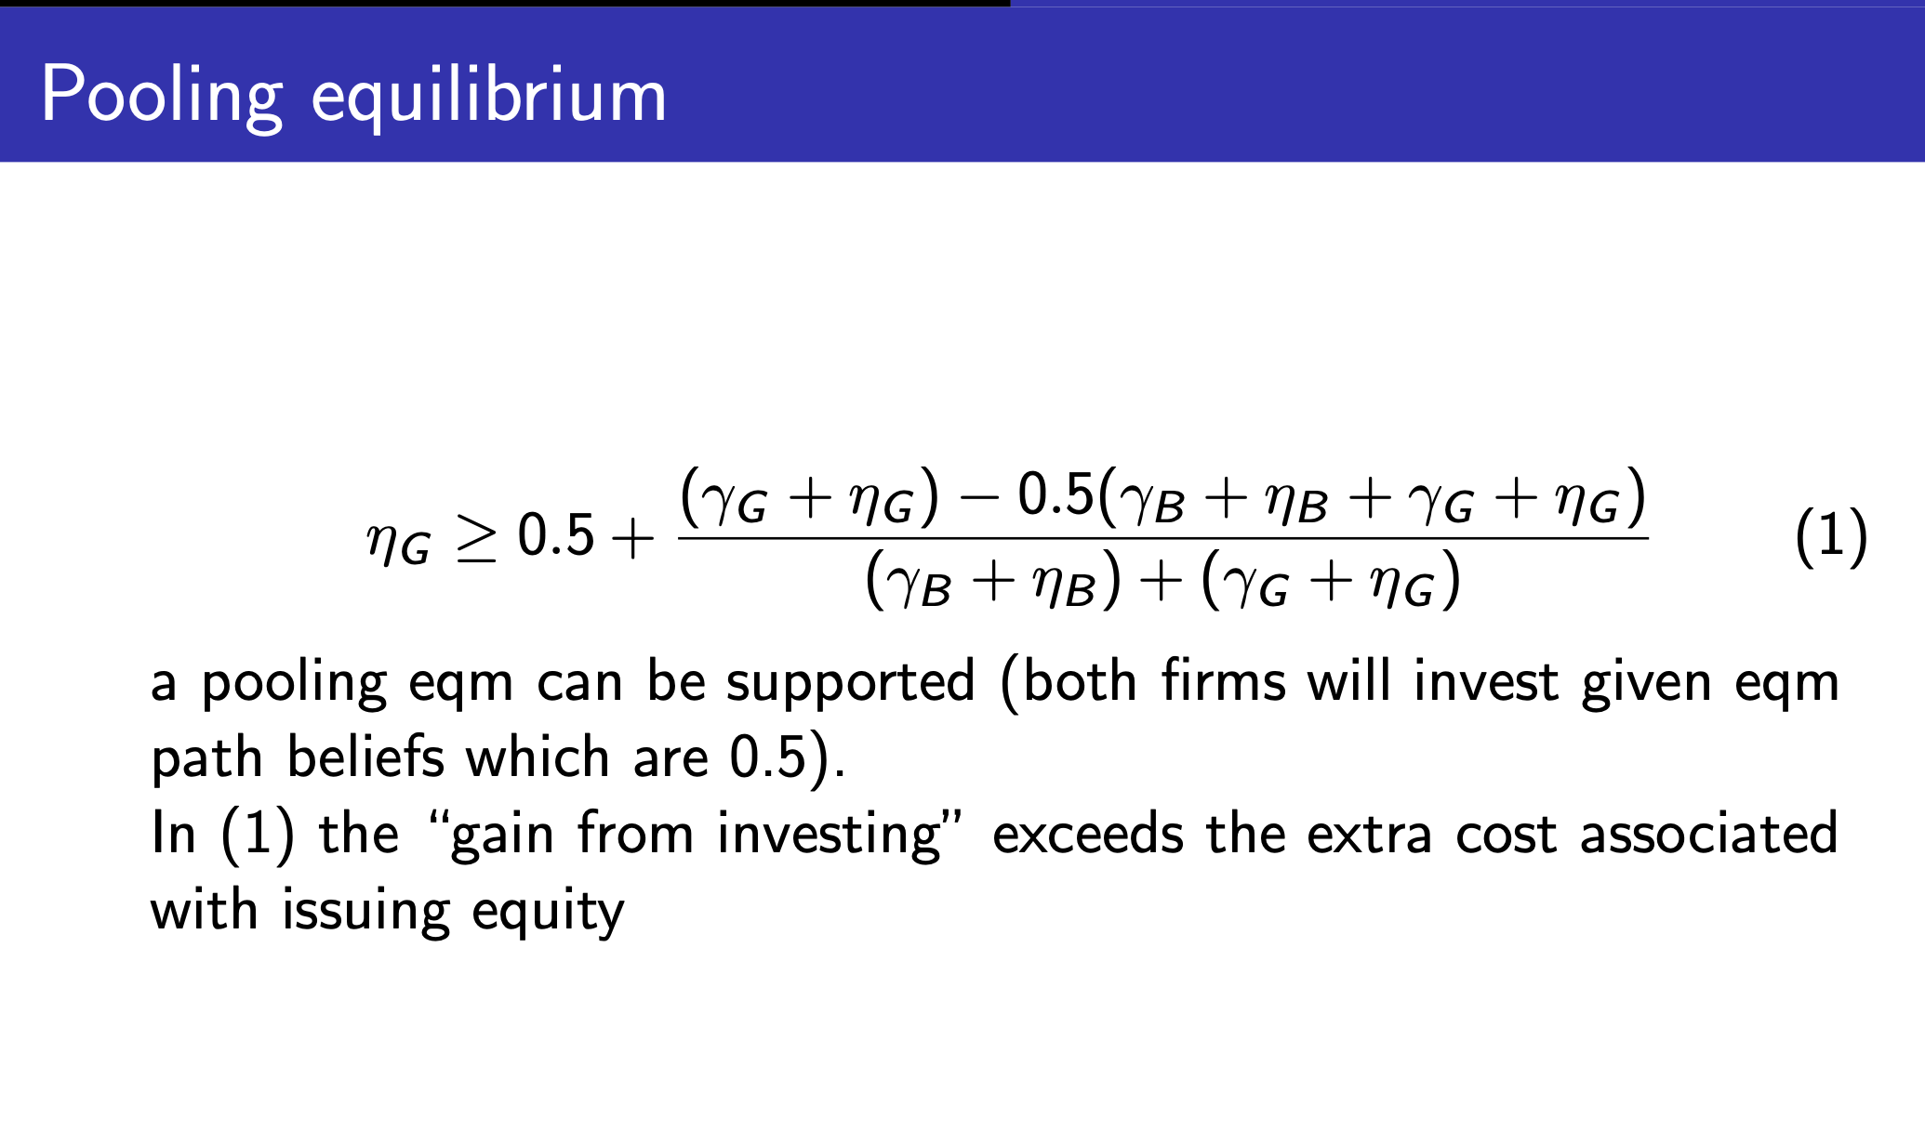
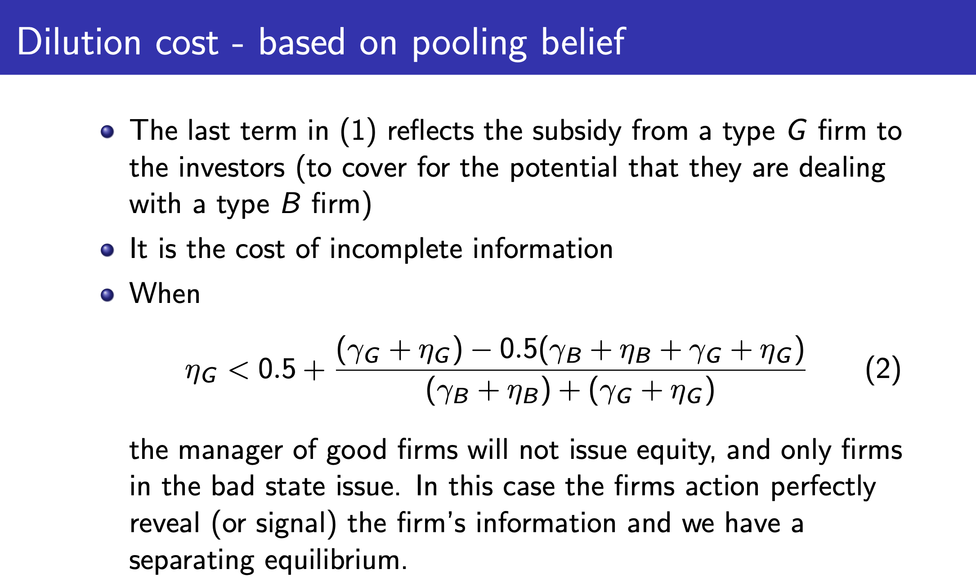
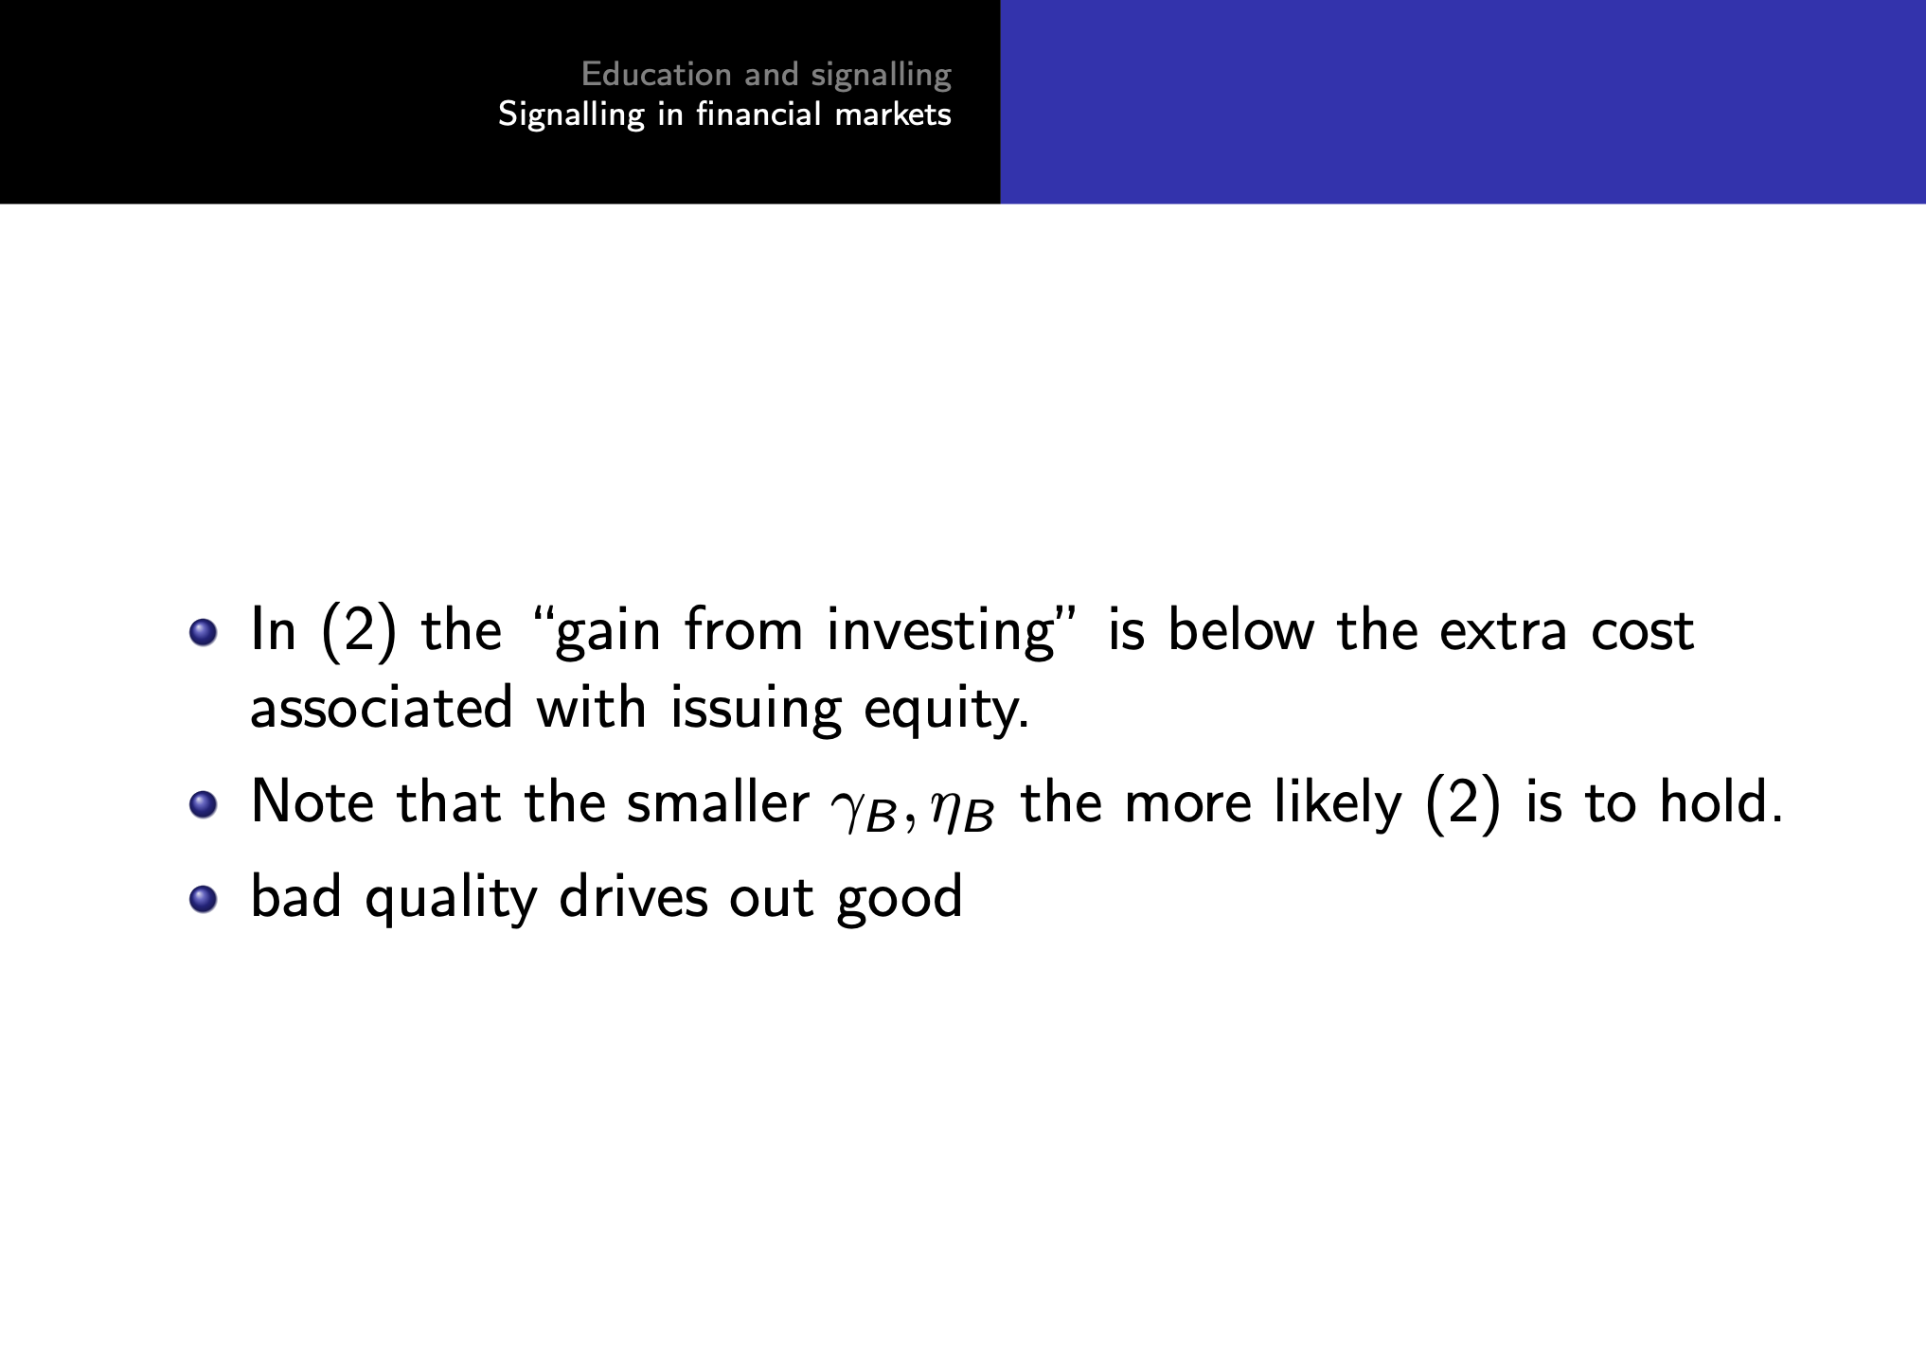
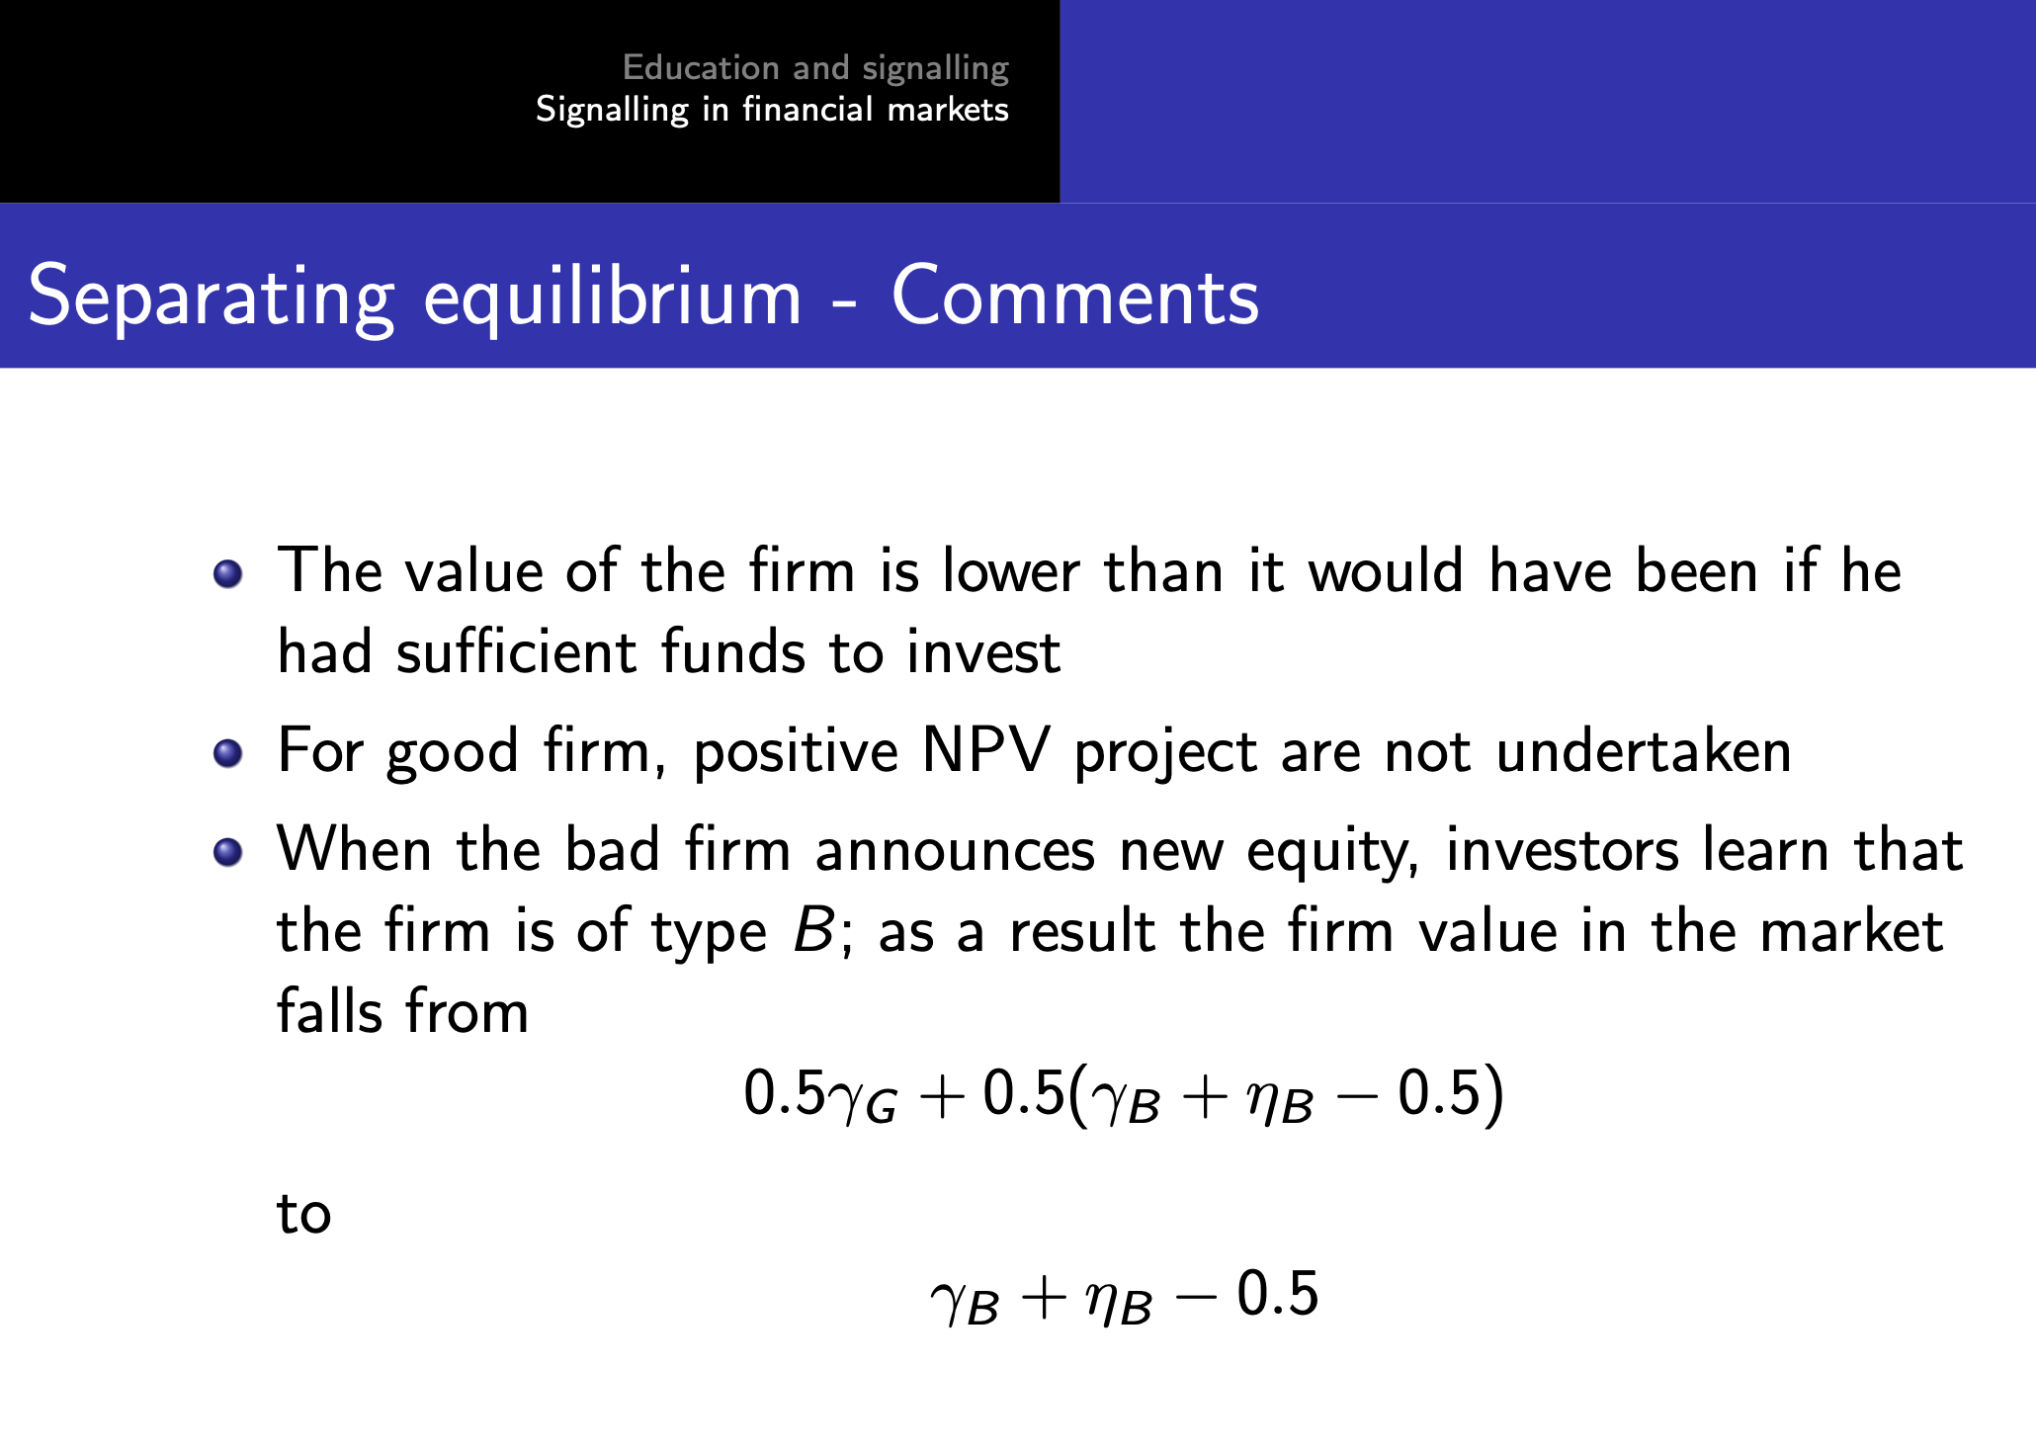
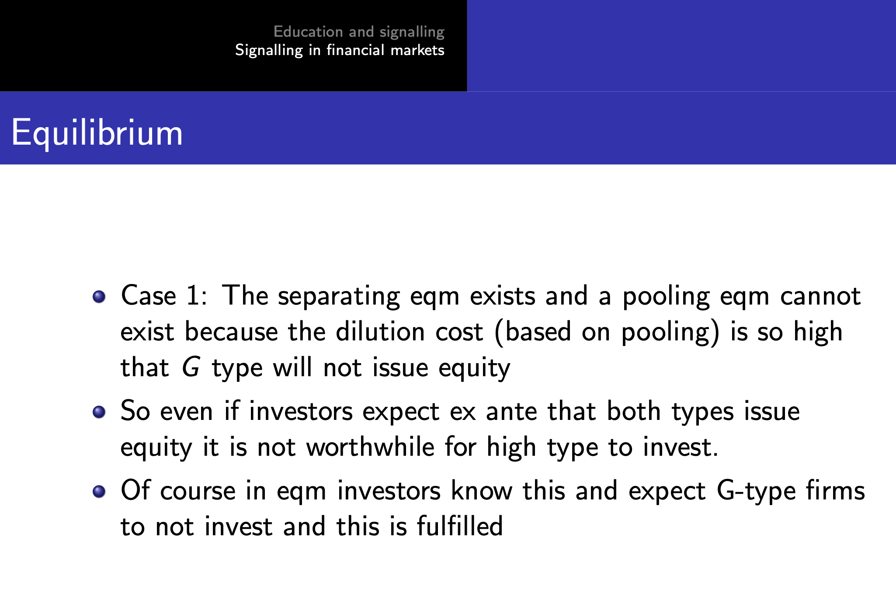
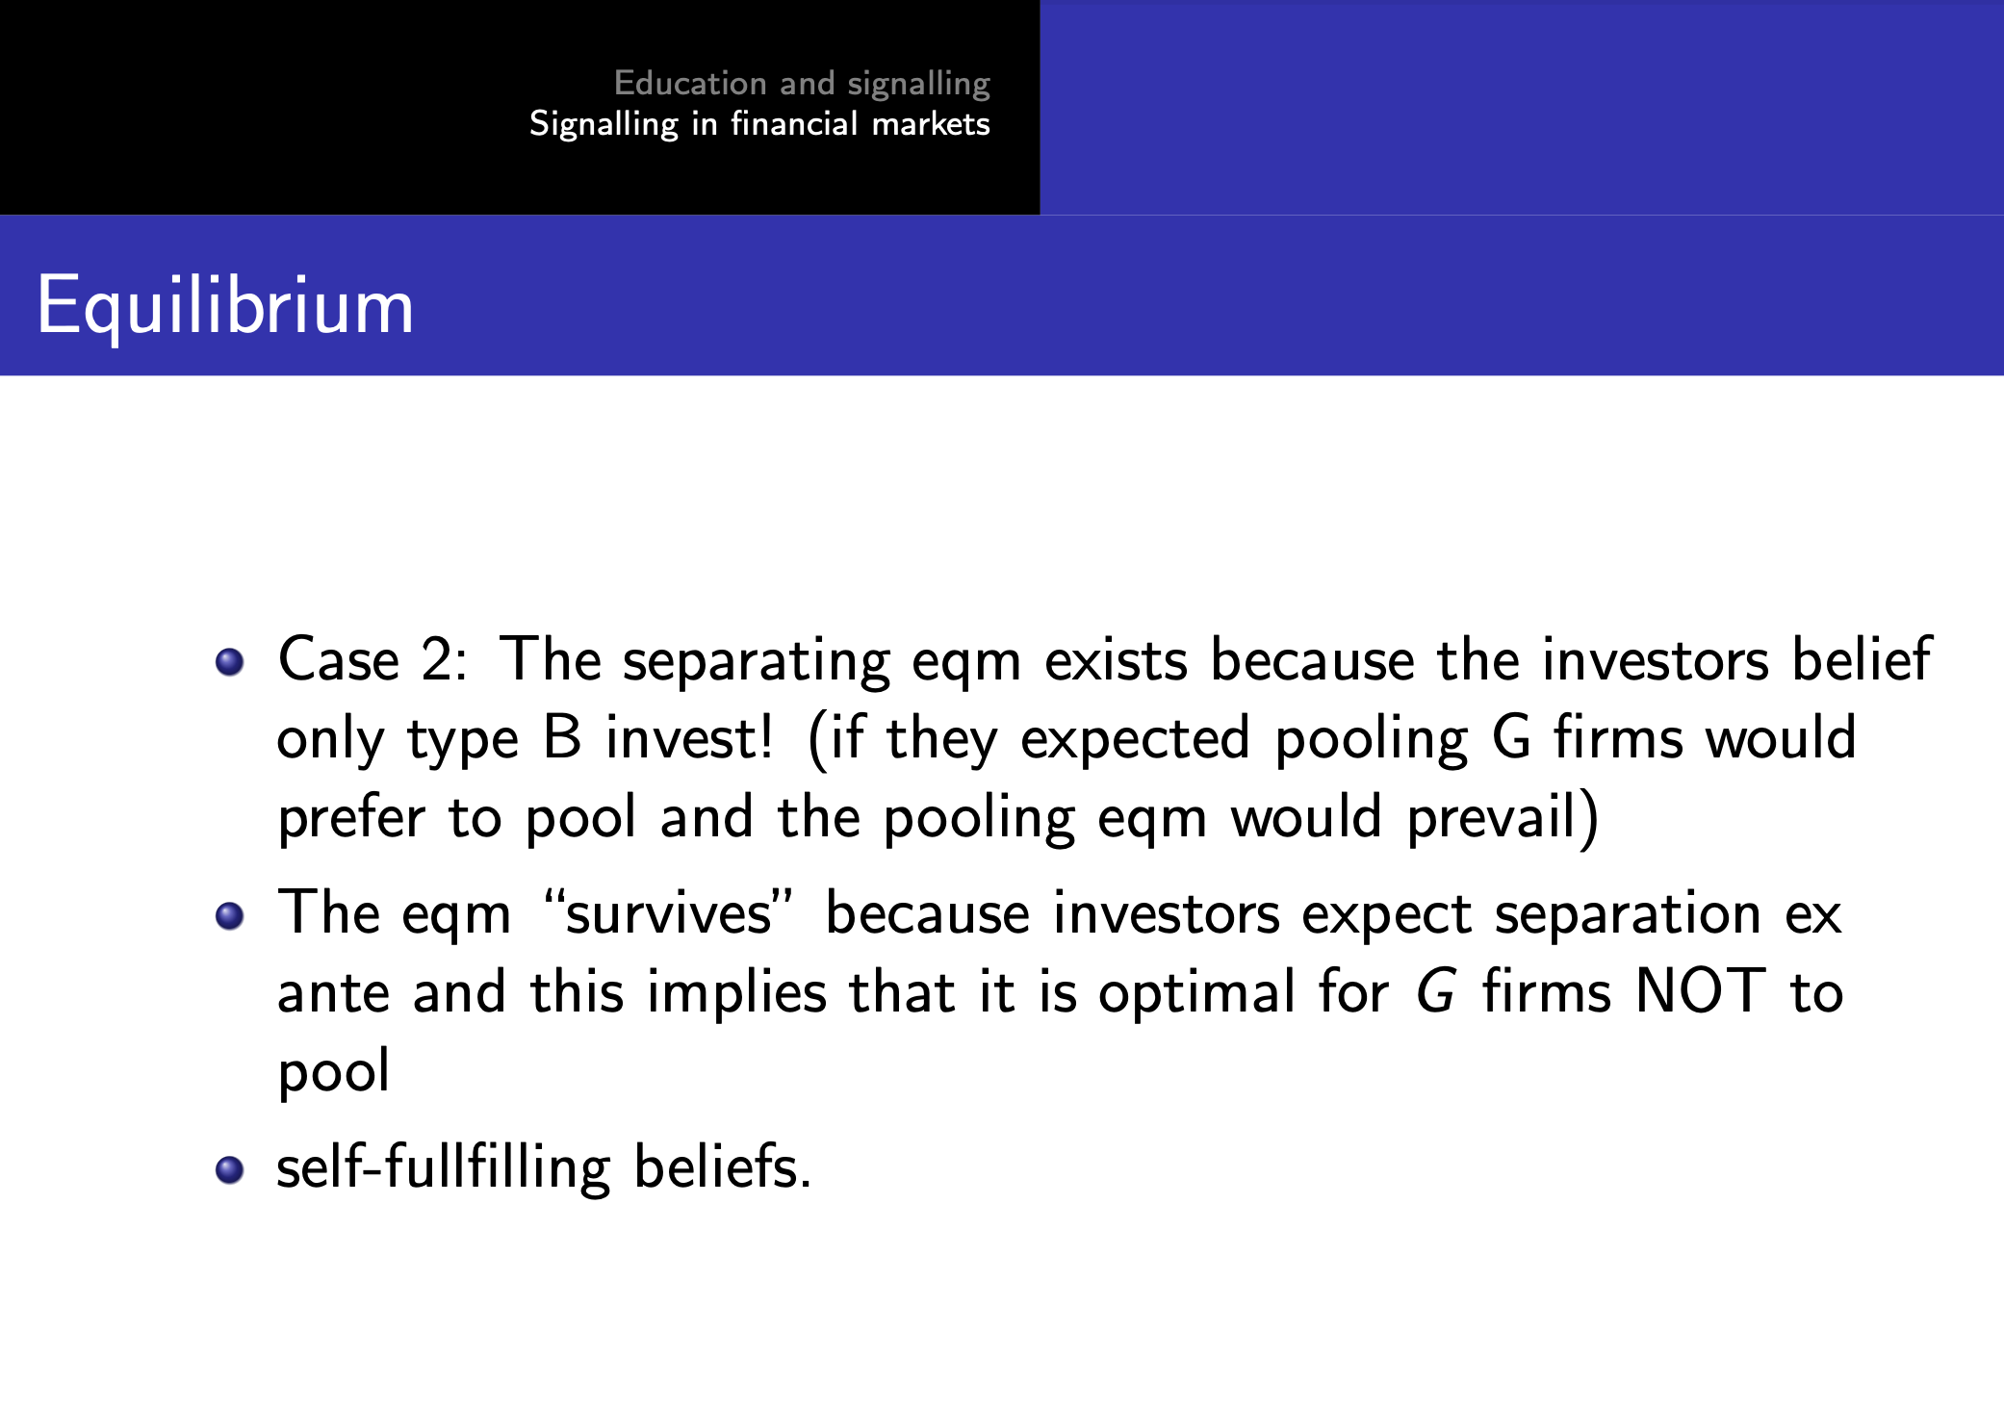
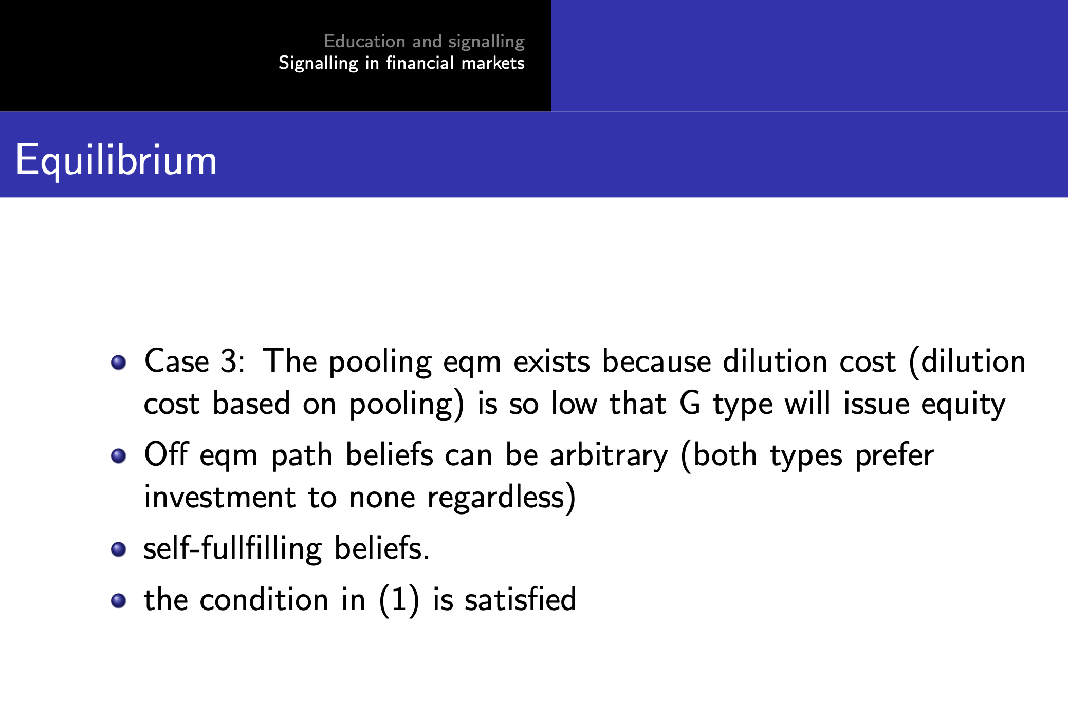

Svære opgaver
Eksamen 2019 opgave 3.f-g

